Notes from Planning Group Meeting
Amador Calaveras Consensus Group (ACCG)
Calaveras Ranger District, Stanislaus National Forest (STF)
Pat McGreevy & Jill Micheau

The ACCG Planning Group met on 31-May-2017 at the Calaveras Ranger District, Hathaway Pines. The main topic was the District’s Fire Prevention Program and included site visits to the Irish/O’Manuel Fuel Break and a Tree Mortality mitigation operation on its boundary with the Meadowmont Subdivision in Arnold. The District’s hosts were Jon Lucas, fuels manager, and Dave Vosti, forester.

This report closes with a comment about the use of USFS Steven’s funds in Arnold.

PART I. CALAVERAS RANGER DISTRICT FIRE PREVENTION PROGRAM
Fuel Break System
The District maintains an extensive system of fuel breaks from northern Tuolumne County to the North Fork Mokelumne River in Calaveras County. Most of these fuel breaks are ~300-foot-wide buffers along roads while others are fuel reduction projects at the landscape level. The linear fuel breaks often cross properties owned SPI, BLM, Big Trees State Park and private stakeholders, so collaboration is essential. In Arnold, this collaboration has led to a fire protection plan with fuel breaks and landscape restorations along the WUI that will surround the community’s 4,900 homes when complete (Fig 1 Arnold Map). While this report focuses on the USFS, Calaveras Big Trees State Park is implementing a 6,500 ac landscape restoration guided by GTR 220 while SPI is implementing timber and salvage harvest plans on the Arnold WUI.

Maintenance Cycle
In the Arnold area, it takes about five years for understory fire fuel, brush and saplings to reach a height of five feet, the trigger indicating the need for understory maintenance. Since the functionality of fuel breaks degrades with further growth, one should plan on treating the understory every 5-7 years.

Maintenance Operations
Environmental studies (NEPA) are necessary before treatment. Fuel break maintenance on USFS land includes prescribed fire, mastication and hand treatment. While herbicides are used to control hazardous plants on USFS land, they are not used for the maintenance of fuel breaks.

Hand Crews: The cost for hand crews is $2,500/ac, but this estimate increases with slope and the density of brush. It also varies with the disposition of the slash which is hauled to a product yard, stacked in 4’x4’ piles and burned during the wet season, or chipped. The chips are broadcast on-site or hauled to a biomass facility. The District contracts locally for hand crews to cut and pile, but also uses CAL FIRE CDC (California Department of Corrections) inmate crews for brushing and burning. On average, a CDC hand crew with 13-15 workers can clear 1 ac/day on level ground and ½ ac/day on slopes >35%.

Mastication costs ~$1,800/ac. The District contracts locally for mastication services. Masticators operating on slopes <30% and can treat up to 3 ac/ day depending on the brush density. Mastication is limited to the dry season to prevent damage to the soil.

Prescribed burning also costs ~$1,800/ac. The District can burn 250 ac/year with the following resources:
Fire engines 5
Water tender 1
20-person crew 1
10-person crew 2 each
Additional support is provided by CAL FIRE

In contrast, the Amador Ranger District has more resources and can burn 1,000 ac/year.

Each burn follows a specific prescription. It must be a burn day determined by the Air Quality Control Board, the temperature range must be between 52 - 70ᵒF, the wind speed <11 mph, and the fuel moisture between 6-10%. Ignition typically starts at 0800 hrs and burning continues until 1900 hrs. The burn is patrolled all night to prevent escapes. Given these constraints, burns are limited to April/May and October until the snow arrives.

Irish/O’Manuel Fuel Break Site Visit
The Irish/O’Manuel Fuel Break, an ACCG Cornerstone Project, follows Forest Road 5N52 on the NE WUI of Arnold and protects Hathaway Pines, Avery, Arnold and White Pines. It is a 2.7 mile segment of a longer fuel break that starts at the District’s headquarters in Hathaway Pines and runs north to Rail Road Flat, 22 miles! While there are short segments that are 50’ wide, the width usually varies between 250’ – 350’ feet and the surface vegetation ranges from bare ground to bear clover or grass often shaded by tall conifers (Fig 2 Aerial Map).

The Planning Group visited the upper OHV Staging Area which receives heavy use by motorized vehicles and campers. This activity is the source of ~5 fire ignitions per year. This area is designated a CAL FIRE Protection Area meaning that CAL FIRE provides fire suppression services under contract from the USFS.

This OHV staging area was burned with prescribed fire in 2014 (Fig 3 Image). Since then, conifer mortality caused by drought/beetle infestation has become epidemic and complicates fuel break maintenance. The District is felling dead trees, removing the logs and piling the slash into 4’x4’ burn piles. Follow-up prescribed burns are not allowed while the logs and slash remain on the ground because they add fire fuel. The removal of standing dead trees is a high priority as they are the source of canopy fires that release embers that can fly for miles and threaten nearby Arnold.

Conclusion
- The ACCG Planning Group applauds the fire prevention program managed by the Calaveras Ranger District under the direction of Jon Lucas.
- However, we are disappointed that the District can only burn 250 ac/year due to limited resources. Note that 250 ac translates into a linear fuel break measuring 7 miles long by 300 feet wide. Given a 5-year maintenance cycle, the District can maintain 35 miles of fuel break with its current capacity. We suspect that this is not enough to protect all WUIs and forests in the District and ask the District Ranger for the total mileage of fuel breaks needed and the resources required.
- Given the resource constraints, the Planning Group was surprised that the District has no plans to plant shade trees on its fuel breaks. It is the groups opinion that shading of the forest floor slows the growth of fire fuel and increases the period between maintenance treatments while reducing costs.
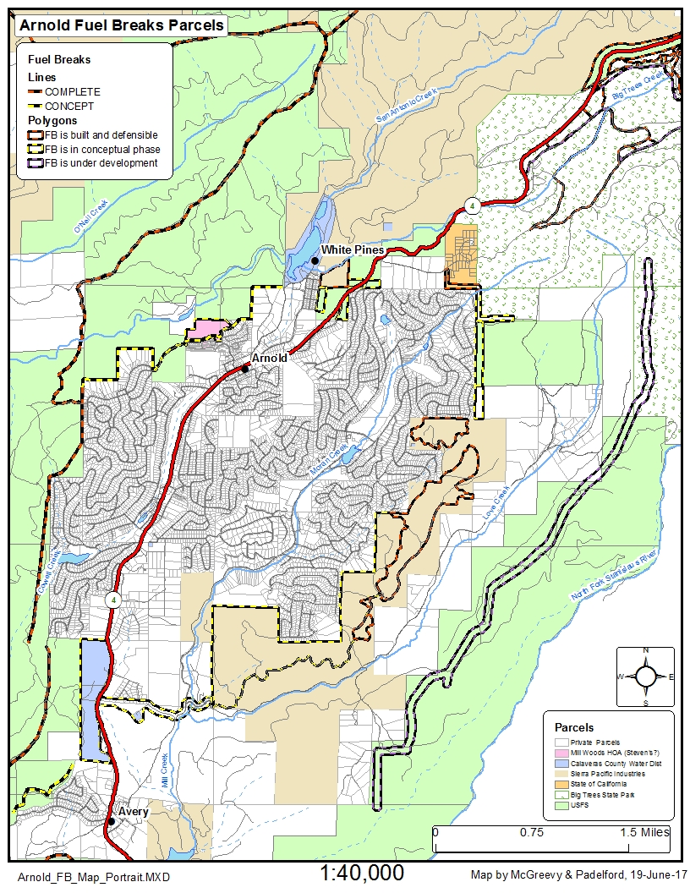
Figure 1. Map of greater Arnold showing fuel break system and locations of ACCG site visits.

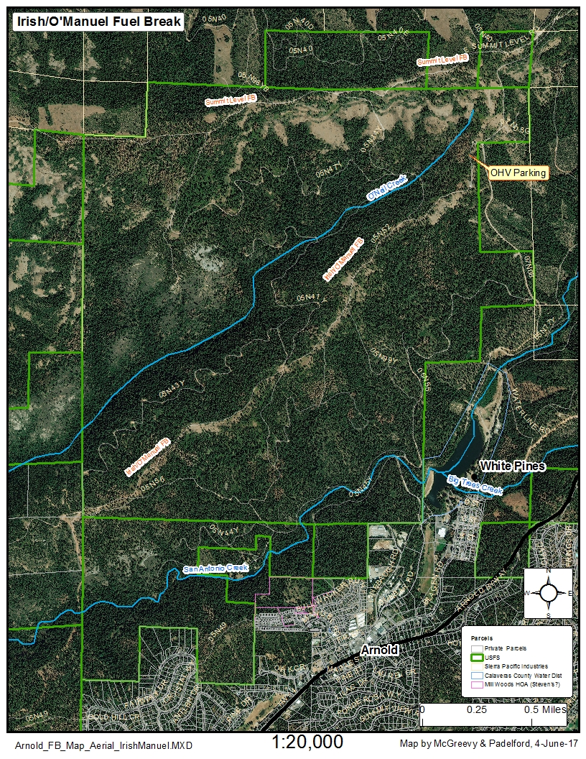
Figure 2. Aerial view of the Irish/O’Manuel Fuel Break showing its connection with the Summit Level Fuel Break. One of two OHV parking areas is also shown.

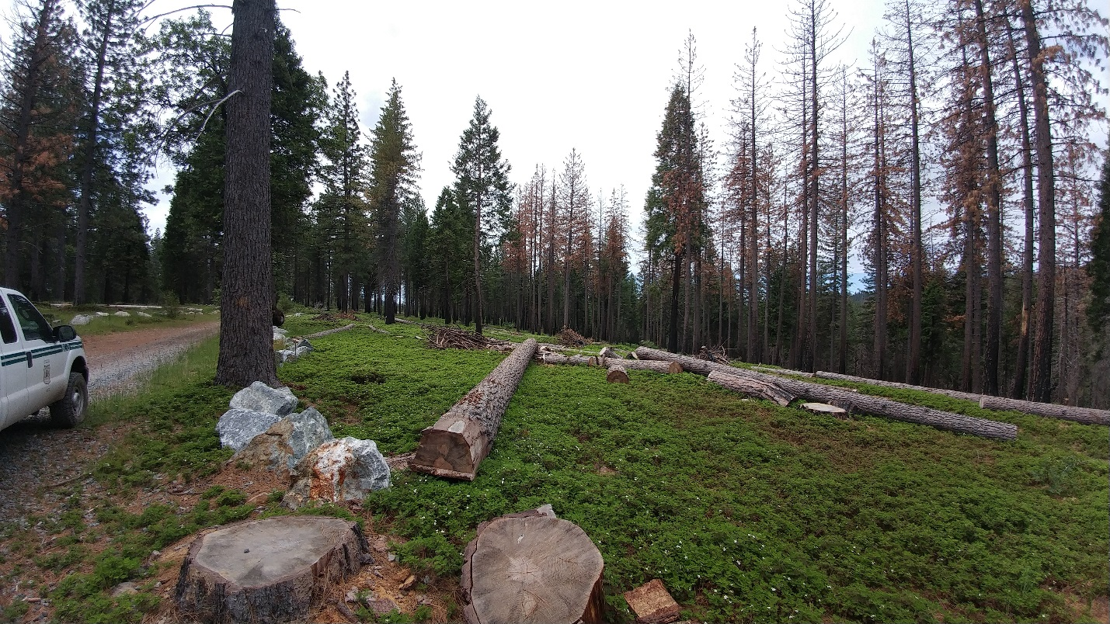
Figure 3. Image of Irish/O’Manuel fuel break at upper OHV Staging area. There was a prescriptive burn three years earlier and the ground is covered with low bear clover and the ladder fuel is scarce. The standing dead trees on the right died in 2016 and are scheduled for removal. While the burn piles can be burned in the wet season, prescriptive burns are not allowed until the logs are removed.

PART II. Tree Mortality Salvage
Tree Mortality Problem
In 2016, Dave Vosti discovered epidemic tree mortality on the WUI just west of the Lakemont subdivision. He wrote a Timber Harvest Plan to remove the dead trees from 198 ac and protect a dirt road used for hauling logs. The salvage operation started in November 2016 and will be completed in June 2017. About three million board feet of lumber were milled by SPI, the equivalent of 300 log loads or 200 homes.

Logs <10” in diameter are not purchased by the mill and they remain in piles on site with tree tops and branches. Dave hopes to transport this slash to the biomass facility in Merced operated by Phoenix Energy. Phoenix plans to ship the biochar generated at the facility back to the Arnold salvage site and treat ~40 ac. It will be broadcast over the ground to a depth of 1 inch. USFS soil scientists will compare pre-and post treatment soil parameters to determine the benefits of biochar in a coniferous forest.

For more information on biochar, click the following addresses:
- http://biochar-international.org/biochar/
- http://www.phoenixenergy.net/bulk_biochar

Conclusion
- Dave Vosti is commended for completing this salvage operation in seven months!
- The ACCG looks forward to the results of the biochar study.

PART III. USFS Steven’s Funds
The USFS allots funds each year to reduce fire hazard on non-federal land that abuts or is linked to forest service projects. While constructing figure 1, we discovered ~40 ac of land, depicted in pink, that are owned by the Mill Woods HOA that qualify for the next round of Steven’s funding in 2018 for fuels reduction.

