Amador-Calaveras Consensus Group
September 9, 2009
Break-out Group Discussion Notes
Group #1 Mission
- Reduce fuel load
- Create local jobs with livable wages
- Sustainable job employment, diversify economy
- Treating public, private lands
- Technically feasible and economically viable
- Reduce intensity of wildfires
- Identify processors, end users, material generators, and pull together
- Develop process to take from point A to point B
- End consumer for each element of waste materials
- Balance of reducing fire risk and erosion control
- Seek financial support and bring together research and development to avoid failure

Group #1 Vision
- Healthy, diverse and productive forest lands
- Create sustainability for local communities including tribes
- Appropriately managed forest lands, highly resistant to wildfire

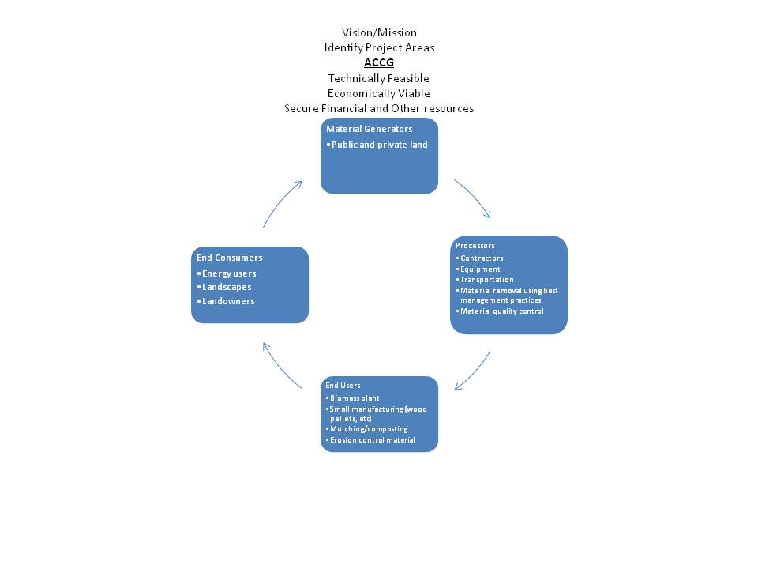
  - •Public and private land

  - •Contractors
  - •Equipment

  - •Transportation

•Material removal using best management practices
  - •Material quality control

End Users
Group # 1 Guiding Principles
- Utilize woody biomass material to the maximum extent possible
- Coordinate and utilize resources (equipment, personnel, and financial)
- Conduct project work in a way that minimizes impacts to the watershed
- Utilize local labor to the maximum extent possible
- Maintain working knowledge of local ecology
- Conduct project work to maintain significant archeological sites
- Treat all stakeholders, including competitors with dignity and respect

Group #1 Roles and Responsibilities
- Ethics, rules guidance as to how the group operates and how we treat each other, next step to specifically define individual and organizational roles and responsibility
- The list from the guide is similar and possibly redundant
- Serve as a representative of the group to the community
- Support projects, initiatives, funding proposals and the related activities that have been adopted
- Action =MOU – programmatic EA/EIR

Group # 2 Vision
- Fire safe community
- Use resources to build a sustainable economy with good paying jobs for locals
- Resources stewarded well
- Private landowners engaged in (private land treated/maintained)
- Recreation resources (trails, rivers, etc) that serve locals and bring in $$
- Scenic beauty, habitat etc are retained and sustained
Group #2 Mission
- Be a model for other groups
- Build fire safe community
- Demonstrate how diverse group can work together successfully for community wildfire protection
- Use projects to educate public (education/ marketing)
- Ecological and socioeconomic benefit of fuels reduction
- Ensure resources are used to create good paying jobs without compromising the integrity of the resources
- Work for sustainable economy community and environment
- Engage and involve private landowners
- Identify opportunities for new recreation facilities and protect existing resources

Group # 2 Member Roles and Responsibilities
- Participants educate each other about issues and interests
- Need to resolve – who can be a member?
- Core group and committees
- Need media policy
- Like the list

Group # 2 Guiding Principles
- Use local contractors and workers to the max possible extent
- Ensure all projects are ecologically sustainable
- Actively involve interested stakeholders in planning and process
- Be sensitive to cultural needs, practices and resources
- Share project information openly and often
- Ensure local contractors and workers have the training and resources they need to succeed
- Focus on fire-safe projects for communities
- Use woody biomass in a sustainable manner
- Develop value added industry that uses forest products sustainably
- Coordinate with other community projects and programs (trails & rivers etc.)

Group # 3 Mission
- The Amador –Calaveras Consensus Group initiates, encourages, supports, and implements balanced community-based efforts to improve the environmental, economic and social well-being of the Amador-Calaveras region, it’s communities and citizens.

Group #3 Vision
- We the people of the Amador-Calaveras Consensus Group believe the collaborative activities of all regional stakeholders will result in a changed relationship between local communities and our forested lands, so that our economy will be rebuilt on an ethic of land stewardship.

Group #3 Guiding Principles

Forestry Examples
- All projects be based on a stewardship ethic
- Focus project work on consensus driven activities
- Conduct project work ways that enhance maintenance or restore healthy watersheds
- Use best available science and technology in guiding project work
- Utilize woody biomass which would otherwise pose an air quality or fire threat or be wanted in more productive ways
- Encourage activities that support forest resiliency

Economic Examples
- Foster a locally based forest products industry on public and private lands
- Support expedited process for conducting activities under these principles

Social Examples
- Foster respect for the people and history of our region
- No fighting – work and play well with others

Environmental Examples
- Restore wildlife habitat
- Restore, enhance, maintain, healthy watersheds
- Improve overall air quality in the region

Group #3 Member Roles and Responsibilities
- Courtesy and consideration for others are the foundation for organizational success (i.e. no fighting)
- Alternative Version – “get along or get out”

Group #4 Misison
- Wildfire prevention
- Healthy forest / Healthy economy (sustainable vs. boom-bust)
- Recognized paradigm shift of resource
- Driven economies (extraction to biomass, etc.)
- Conflict driven relationships to collaboration
- Watershed protection
- The A-CCG is a community-based organization with the goal of converting forest conditions and community relationships into a sustainable local economy and healthy forest and watershed conditions

Group #4 Vision
- A-CCG is to have a healthy economic environment supported by the social and natural assets of the community
- Self sustaining/ holistic
- The vision of the A-CCG is holistic relationships between the land (public & private) people and economy in our local communities and to move away from reactive (firefighting) to proactive (prevention) land management

Group #4 Guiding Principles
Forestry examples
- Coordinate and leverage resources available through public and private partners
- Utilize woody biomass material to the maximum extent possible
- Include all stakeholders in planning process as a means of mitigating conflict
Economic Examples
- Utilize local contractors to the maximum extent possible
- Foster partnership that maximize the effectiveness and competitive status of local workforce
- Work toward self-sustaining electricity infrastructure
Social Examples
- Maximize the use of previously unemployed, local labors
- Share information openly and often about projects and promote awareness of issues of unhealthy forests
Environmental Examples
- Apply appropriate planning and design mechanisms to projects as required by statute
- Solicit input from all stakeholders early and often
- Use low impact techniques to accomplish project goals
- Restore ecosystem composition as a component of all possible projects
Group #4 Member Roles and Responsibilities
Member Roles
- Follow through on commitments
- Ask for help if you need it – don’t be afraid to project your limitations

Member Responsibilities
- Celebrate successes together
- Recognize and celebrate group based vs. ego based credit

Group #5 Vision and Mission
- Energy independence
- Amador and Calaveras Counties experience healthy and sustainable economies, ecosystems, communities
- Manage, protect, and restore public and private lands using a landscape approach within a framework of environmental responsibilities, community collaboration and economic sustainability
- Promote a level playing field for contractors
- Open and transparent process
- Focus on areas within zone of agreement
- Capturing maximum economic value of resource
- Minimize export of low value material

Group #5 Guiding Principles
- Conduct activities which protect, restore or enhance the watershed/soil
- Use local contractors to the maximum extent possible
- Provide living wage for the local workforce
- Treating everyone with dignity and respect
- Conduct activities which build local contractor capacity and cooperation
- Sustainable
- Regional
- Economy/maximize value of
- Fuel removed
- Maximize use of local resources
- Best value = local

Key Components
- Manage protect and Improve public and private forested lands with a landscape approach
- Multiple uses and sustained yield
- Within a framework of environmental responsibility and scientific technology
- Landscape approach
- Foster collaboration among varied community stakeholders

