About these notes: I did not come to the meeting prepared to be the scribe, but did take a few pages of notes, which I have transcribed here.
Attendees (no sign-in sheet was collected, so this is just a list of the people I knew): Joe Aragon, Terry Woodrow, Liz Gregg, Heidi Beswick, Pat McGreevy, Gordon Long, Reuben Childress, Rick Hopson, Scott Tangenberg, Alaina Osimowitz, Robert Smith, Marg Donnelly’s husband, Gwen Starrett, Jill Micheau, Debbie Phillips, Tim Tate + another from SPI, Mark ? (FS), Matt Hilden (FS), Jacob (FS from Groveland), Casey Jardine (FS), Bev and Martin (FS).

Rick Hopson, Amador RD:
- Making efforts to engage ACCG earlier on projects.
- Scottiago issues: spotted owl, tree mortality, biomass and what to do after plots are cleared. Will discuss with ACCG. Need to right-size the project. Need to develop the purpose and need for this project. Discussed pros and cons of different contract types (CE vs. EA), speed, complexity, etc.
  - Re tree mortality (Smith): despite last year’s rainfall and a slow-down of tree mortality, planning needs to address timing, fuel issues, and additional mortality; fir and sugar pines are now being affected.
  - Timing (Tate): faster is better. CE is faster than EA; use full EA for balance, apply roadside CE to larger bug patches. Break into small CE-sized projects to address quickly.
  - Try to get entomologist (Bev) to attend April field trip. Capture new mortality. How can we capture value beyond the 200-foot boundary? How deal with snags?
- Task: Rick and Robin to send out 2018-19 work plans.
- Task: Joe to notify Reuben Childress when tree removal will start and disposition of slash – pile, or lop and scatter?

Gwen Starrett, Onion Meadow Project:
- Letter of support for this project in development; will go out for comment, then be included with NFWF grant proposal. Tight deadline.
- Four working trips planned over the next season; some overnighters; contact Gwen if interested. Need volunteers.

Alissa Fogg, Point Blue (on telephone):
- Applying for NFWF funding to assess and prioritize meadows to target for restoration. Aligns with NFWF strategies. Reviewing 50 meadows using American River scorecard and LIDAR data for upper watersheds for channel impacts. Will prioritize meadows that can be addressed with low-impact techniques (i.e. don’t need heavy equipment).

Scott Tangenberg, FS:
- Need ACCG support on _____. Public scoping 2 weeks; Target mid-May; still need archeological surveys.
- Has 15 projects planned for FY 2018 (can he provide this?) plus 3 for FY 2019-20. Commercial thinning next year.

Alaina Osimowitz, FS:
- Alaina gave a presentation on the Arnold-Avery Healthy Forest Restoration Project (Farm Bill CE). Unfortunately I did not capture any notes on this (I was busy listening). Maps were provided and some slides were presented… see Alaina for details.
- Need ACCG support on _____. Public scoping 2 weeks; Target mid-May; still need archeological surveys.

Field Trip:
- Matt Hilden, Alaina Osimowitz, and Jacob XXX hosted a field trip with two stops:
  - Slope below Mill Woods along the Arnold Rim Trail, behind the Logging Museum. Team walked about ¼ mile along the trail. Discussed plans for thinning in this area.
  - Drove to Avery Sheep Ranch Road and Valley View Drive to survey existing fuel break, created during Butte Fire. Discussed plans for maintenance and how this links to other fuel break projects in the area.
  - 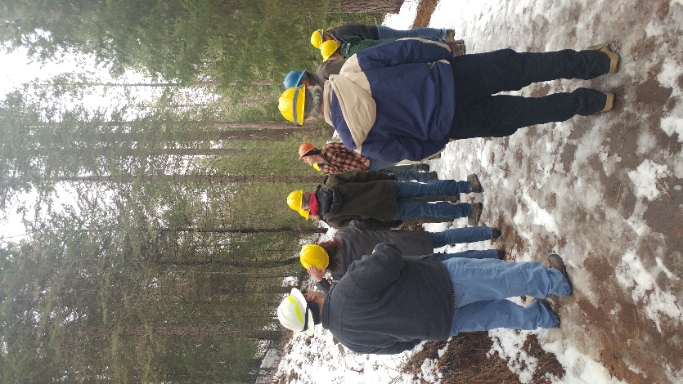
Jill’s notes on process:
- Need to have a sign-in sheet at all meetings with space to note time spent and mileage to and from meetings. FS uses this information to calculate volunteer in-kind for the annual report. Jill will send a blank form to use in the future.
- It would be great if each meeting had a facilitator to keep the conversation and timing on track. This is standard at ACCG meetings. Agenda should show approximate time for each topic.
- Would the General group be interested in a speaker on the pros and cons of various contracts (CE, EA, Farm Bill CE, etc.?) – Planning group or General meeting?
- Meeting topic: small vs. large NEPA???? Pros and cons…
- Get project description materials from Melissa Fogg prior to 3/21 General meeting; give time on agenda.

