Prepared by the Consensus Building Institute

Meeting Brief
The Planning Work Group (WG):
- Reflected on the key takeaways from the Scottiago field trip. Discussed need to elicit additional takeaways from field trip attendees.
- Provided input on the SLAWG pilot map and next steps for the mapping tool and landscape assessment.
- Agreed to recommend the full ACCG consider providing consensus support for the Power Fire Culvert project.
- Discussed public input on the MOTOR M2K project and provided additional suggestions for how the USFS can help the Planning WG provide meaningful input on the project.
- Briefly discussed the intent and purpose for a “zones of agreement” document that identifies non-controversial and controversial project activities. Recommended to call this document something different than “zones of agreement.”
- Delegated Planning WG members to review and provide edits on the Planning WG charge and responsibilities in the ACCG MOU.

Action Items
Actions | Point Person(s)
By July 31: Review and send edits (in track changes) to CBI on the Scottiago Field Trip key takeaways (from the June meeting summary). | ACCG Field Trip attendees
By July 31: Review and send edits to CBI on the Planning WG role and description in the ACCG MOA. | Planning WG
Draft SLAWG description on charge and functions to include in the updated MOA. | Megan Layhee
Determine if Todd Sloat’s 34 North presentation and Carol Ewell (Stanislaus NF) POD presentation are meant for SLAWG and/or Planning WG. Coordinate accordingly. | Megan Layhee
Include Carol Ewell in SLAWG calls going forward. | Megan Layhee
Send Megan and CBI information on POD application (e.g., Thompson paper and POD strategy overview). | Ben Solvesky
Send CBI Sierra NF paper on LiDAR tree heights relation/conversion to dbh. | Ben Solvesky
Develop project submission form and other background materials for the Power Fire Culvert project for the Aug General Meeting. | Rick Hopson and Rich Farrington
Send out MOTOR M2K materials for the Aug 12 meeting. | Michael Jow
Update the green/yellow/red light list of potentially controversial actions per 7/24 discussion. | Tania Carlone
Provide conference call line for future Planning WG meetings. | CBI

Summary

June Planning WG Summary Review
Tania Carlone presented the June 26 Planning Work Group (WG) meeting summary requesting clarifications and input, particularly on the Scottiago Field Trip. Several of the field trip participants indicated the presentations and discussions were substantially illuminating and presented new perspectives to management. The group wanted to capture these key takeaways and share with the full ACCG.

Discussion
Tania made a few edits in real time. Revisions and discussion topics included:
- Clarified that Callecat was suggested as a future field trip site (where GTR 220 was used for the first time with silviculture prescription). Upper Cole was also suggested (learn more about USFS proposed action (PA) decisions).
- Malcolm North, USFS Pacific Southwest Research Station ecologist and one of the field trip speakers, suggested creating tree stand clumps and gaps between stands, specifying that the ideal canopy cover in the clumps is highly variable based on the water availability of any given site. On drier sites, canopy cover could be 25-35% canopy cover in the clumps, where in wetter areas, the canopy cover would ideally be much greater. Malcolm had also emphasized considering water availability to determine the appropriate size of gaps.
- Malcolm and the other guest speaker John Keane (USFS Pacific Southwest Research Station) stated that suitable spotted owl habitat included big trees (for nesting) and low-lying herbaceous cover like shrubs (for owls’ foraging habitat where wood rats and other prey occupy). The group discussed whether “big” trees translated to large (i.e., large dbh) and/or tall. Ben shared a paper that research paper that converted LiDAR data to estimate dbh. Group members stated the need to distinguish and be aware of nesting vs. foraging habitat when managing for spotted owl suitable habitat.
- USFS staff reflected that implementing some of the suggestions from Malcolm and John Keane may prove challenging, as some of the current UFSF management policies are not well aligned (e.g., canopy cover management goals).
- A Planning WG member requested further discussion on climate change implications on prescriptions. Will the climate in the Amador-Calaveras districts become similar to the Southern Sierra? What can we learn from other treatment areas like the Tea Kettle experimental forest?
- The group identified other topics in addition to climate change (e.g., designation by prescription, monitoring, fire behavior, fire management options and constraints, and drinking water) and speakers (e.g., Eric Knapp, Brandon Collins, Scott Stevens, Malcolm North, and other fire experts) for future field trips / discussions.
- Rick Hopson, USFS, expressed appreciation for Ben Slovesky (Sierra Forest Legacy) leading coordination and discussions for the Scottiago field trip, stating it was beneficial to have different groups besides USFS take the lead.

Next Steps
CBI will send out the excerpted notes for the Scottiago field trip to the Planning WG, requesting that those who attended the field trip send back edits to CBI by July 31.

CBI will coordinate with the next speaker (Joe Sherlock) at the August 21 General Meeting to obtain presentation materials to share with Ben (who will be unable to attend).

Strategic Landscape Assessment Work Group (SLAWG) Update
Megan Layhee, CSERC and SLAWG-Planning WG liaison, shared an update on the SLAWG’s progress developing a mapping tool of existing and planning projects (that will help identify areas for future ACCG projects). She shared pilot maps that enable anyone to select attributes (layers) that present information that is useful for them:
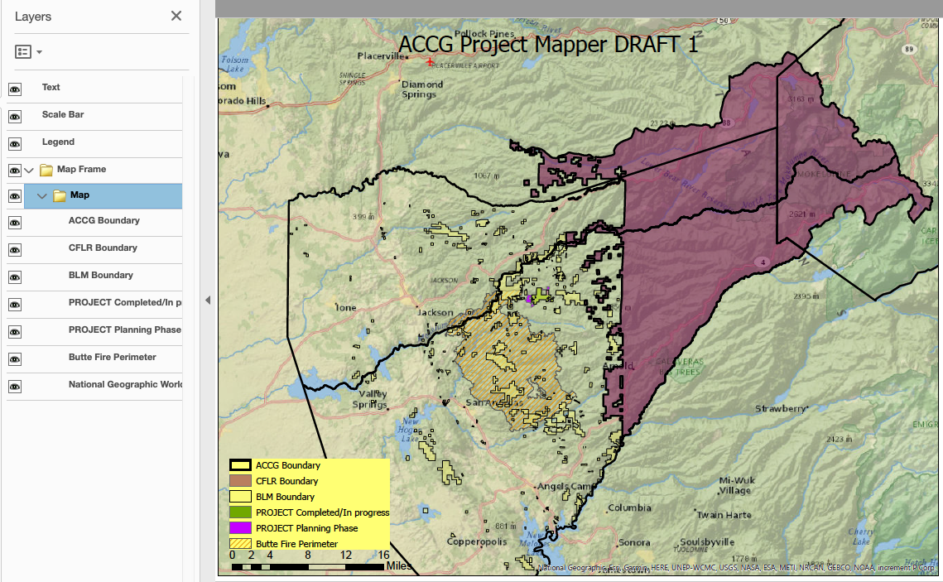
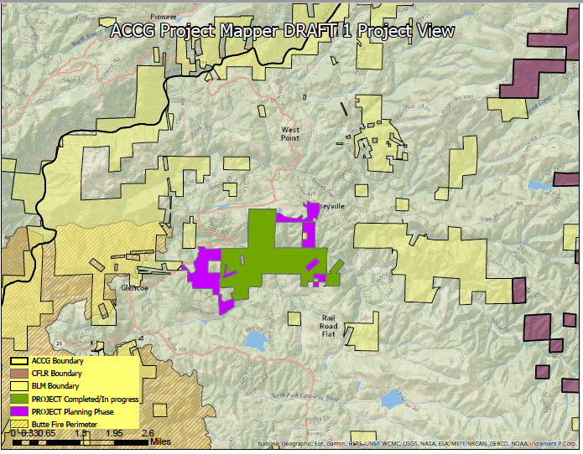
Megan presented a specific project example for the South Fork Mokelumne River Project (see map).

SLAWG aims to include maps for every project in the ACCG footprint in various planning phases. They also want to flag areas requiring maintenance (areas that have not been treated in a long time). Currently SLAWG has all of the USFS projects and is asking other ACCG members like BLM for their project information. Megan invited Planning WG’s suggestions on other information to include in the mapping tool and how best to present that information.

Megan also shared that SLAWG continues to discuss how to approach the landscape-scale assessment. An ongoing question includes what platform to use for tools like the project mapper. The current pilot maps use a free software, but the map layers are predetermined (unable to conduct queries like with ArcGIS). These maps were also generated using ACCG member organizations’ existing ESRI ArcGIS accounts. SLAWG plans to have Todd Sloat, Fall River RCD, give a presentation on their landscape assessment work with 34 North.

Discussion
- Planning WG members expressed interest in a presentation from Todd Sloat. Megan will follow up with Michael Pickard to determine if Todd’the SLAWG and/or Planning WG.
- Planning WG members encouraged SLAWG utilize existing work for the mapping tool and the landscape assessment. USFS has indicated the Potential Operational Delineations (PODs) analysis for Stanislaus NF will be completed in October. A Planning WG member suggested including Carol Ewell, SNF, in SLAWG meetings going forward to explore how to use the PODs concept for the ACCG landscape.
- Suggestions for other mapping tool attributes included: funding / grant phase status for projects and proposals, vegetation layers, fire footprints, different property ownership (e.g., public, private, state, and federal), CEQA/NEPA work and statuses (helpful for grant writers), areas that have not had historic fire in a long time, dates for treatments (to identify areas for maintenance), valuable infrastructure (water conveyance, power lines, etc.), HUC 6 watersheds.
- SLAWG will request additional project information from the full ACCG. The group recommended explaining the specific purpose and intent for the tool, the need for the tool, and specifying exactly what information the SLAWG seeks and in what format.

Next Steps
SLAWG will continue its progress gathering information for the mapping tool and landscape scale assessment.

SLAWG will notify the Planning WG when it would like to present an update and seek input from the full ACCG.

Power Fire Culvert Improvement and Erosion Control Project
Rick Hopson, USFS Amador District, and Rich Farrington, UMWRA, presented the Power Fire Project for the Planning Group to consider recommending to the full ACCG for consensus support (scoping letter, maps). The ACCG agreed to submit a letter of support last year for the project’s funding; this request is for the project’s implementation (support for the description of the PA and design criteria).
The project identifies 92 culvert and stream crossing sites for maintenance and reconstruction. It is a Categorical Exclusion from Category 18; therefore no alternative development, official comment period, or objection period. The project planners included input received to date on the design features (e.g., Foothill Conservancy requested including yellow-legged frogs. Project planners continue work with the Tribes and welcome comments (requesting comments by the end of the month).
Discussion
- Planning WG members did not have suggested revisions to the project letter.
- The proposed activities appear to be non-controversial.
- The Planning WG recommended briefly describing the context for the project so others understand that this project is not new to the ACCG.
Next Steps
Per consensus recommendation from the Planning WG, the Power Fire Culvert Project will go to the full ACCG to consider for consensus support.
Rick and Rich will complete the project submission form and other background materials for the Power Fire Culvert project for the Aug General Meeting.
Moving Towards Resiliency in the Mokelumne to Kings (MOTOR M2K)
Note: Per the General Meeting on July 17, the full ACCG recommended the Planning WG discuss and provide input on the MOTOR M2K project (following the standard process for project development and potential ACCG consensus support).
Michael Jow, USFS, summarized the feedback received at the first MOTOR M2K public engagement meeting on July 11 simulcasted in Sonora and Clovis. 37 people besides USFS staff participated. At the July 11 meeting, attendees expressed appreciation for USFS engaging a diverse group of stakeholders, the presentation content on vegetation and fire, and the small group discussions.
The purpose was to orient attendees to the project and obtain input on developing the PA. The concept for the project is to divide the project area into emphasis areas to define the specific objectives in that area that would identify prescriptions and what tools to use. USFS proposed public safety infrastructure as emphasis areas, which attendees supported; attendees suggested other areas such as roadless, wilderness, high-value timber, areas that have not experienced major tree mortality loss, and areas based on wildlife components (e.g., old growth habitats).
USFS plans to use this input to develop broad categories to identify emphasis areas. At the next public meeting (August 12), USFS would like input on sideboards for the emphasis areas (acceptable treatments in those areas) and management requirements to consider.
USFS held a field trip on July 22 to the Tuolumne-Stanislaus Experimental Forest. USFS hopes to hold another field trip in the Sierra NF in September before finalizing the PA.
Other Planning WG members who attended shared their insights on the meeting, including:
- Project schedule is very aggressive. Attendees expressed concern on sufficient time to provide meaningful input on the project given the short timeline. Is USFS genuinely seeking input and valuing the collaborative process?
- Different forests experience different issues and priorities (e.g., fisher and yellow-legged frogs).
- Has USFS considered other planning options rather than a 10-15 year work plan (e.g., shorter time span, place-based rather than condition-based planning, etc.)?
- What will be the collaborative groups’ roles in implementation (ACCG, Dinkey, and Yosemite Stanislaus Solutions [YSS])?
- Several attendees shared their appreciation that the USFS was taking action, particularly due to the urgency to avoid large wildfires. They also liked that the project focused on using prescribed fire as a major management component.
- Many attendees emphasized the necessity for monitoring and adaptive management.
- How will USFS coordinate the staff, funding, and resources for project implementation? The major limits for using prescribed fire and managing ignitions is getting the personnel out in the field to do the work (due to limited trained crews and limited burn windows).
- How will this planning effort align with existing planning efforts (e.g., Sierra NF revision)?
- Several attendees indicated they doubted whether the examples presented thus far (e.g., Lincoln NF) for condition-based planning documents have been truly successful. Attendees were concerned that litigation and other protests could stall progress.
Discussion
- USFS shared that the MOTOR M2K team is considering pushing back the scoping and finalizing the PA to late September, which will better coincide with the Sierra NF revision comment period (comment period closes at the end of September).
- Planning WG members expressed concerns that USFS will successfully implement prescribed fire treatments. Currently USFS is meeting its mechanical treatment goals (e.g., easily obtained the desired timber), but not prescribed fire.
- Planning WG members would like to see more details on the MOTOR M2K project in advance to prepare and provide meaningful input. They acknowledged USFS’ concerns that people may misinterpret these draft ideas as final; however, WG members stated they need to have a clear understanding of what USFS plans to do. The group suggested that USFS could clearly label these preliminary ideas as “Draft,” include placeholders for future information, and clearly indicate where USFS is seeking public input.
- The group also recommended Michael Jow or another MOTOR M2K USFS staff regularly attend the Planning WG meetings to provide updates, clarify ideas, and receive input during project development.
- The group briefly considered identifying a liaison between ACCG and the MOTOR M2K project. However, due to availability and budget constraints, the group decided CBI can continue serving this role.
- Planning WG members suggested using side bar conversations on an as-needed basis if people want to delve into the details to avoid MOTOR M2K discussions monopolizing the Planning WG meetings. Other high-priority discussions like the “zones of agreement” will also feed into the MOTOR M2K discussions.
- Planning WG members reemphasized that impact of the MOTOR M2K project schedule given members’ other existing priorities. A Planning WG member underscored that pre-scoping conversations with USFS are much more fruitful and productive than after PA is final; he encouraged USFS to further extend the pre-scoping period.

Next Steps
USFS will send out MOTOR M2K materials out 1 week before the August 12 meeting.

USFS will develop a draft outline for the PA based on the input received at August 12 and send to the Planning WG (via CBI) by August 23 in preparation for the August 28 Planning WG meeting.

ACCG “Zones of Agreement” and Project Development and Approval Process
Tania Carlone, CBI, reviewed the example list of project actions (originally developed by the Sierra Forest Legacy (SFL) and presented to in 2018), the Planning WG will continue its discussions to identify “zones of agreement” and protocols for how to proceed with each category. Ben Solvesky explained that this example list originated from a discussion among than association of environmental groups, USFS Regional Forester Barnie Gyant, and leadership staff to draft a list of activities (and under what conditions) the environmental groups generally supported. This example list is to serve as a starting point for the ACCG to develop its own list of controversial / non-controversial project actions.
The ACCG “zones of agreement” list is intended to help expedite project proposals for activities that stakeholders widely support (“green light topics”) and that are often under tight deadlines to seek funding. The project also helps project planners identify when they should engage the ACCG to discuss controversial activities (“yellow light” and “red light” topics) if they seek ACCG support.
Discussion
- The “zones of agreement” list should be a living document and specified for the ACCG.
- Include a disclaimer that the list is not exhaustive and serves as a starting place.
- Tania added that the project development and support process will not be finalized until the ACCG finalizes the “zones of agreement” list.
- The document should include a purpose statement.
- “Zones of agreement” appears to be a misnomer. This document identifies what is non-controversial and what warrants further discussion. This term could create confusion.
- Planning WG members reflected that the list of actions in itself is controversial and needs to be vetted with the whole ACCG. This topic should be at the top of the agenda next time.
- A Planning WG member reemphasized the driving purpose for creating the list of controversial/non-controversial actions was to help expedite activities that everyone supports and needs to be done. This should be included in the purpose statement.

Next Steps
Planning WG meeting attendees will send suggested edits on the green/yellow/red light list of actions to CBI. CBI will update the document for the next Planning WG discussion.

Planning Work Group Charge and Functions
Due to time constraints, the Planning WG members will review the Planning WG charge in the ACCG MOU and send suggested revisions to CBI by July 31. SLAWG will also write up a brief description of its charge and functions. The full ACCG will consider the updated language at a future meeting.

Future Meetings
The group observed the small number of attendees in the meeting. Planning WG attendance that represent stakeholders’ diverse interests is crucial, particularly to discuss large projects like MOTOR M2K. Attendance in person is preferred, but the group acknowledged that the travel distance poses a challenge for many WG members. The group recommended providing a call-in number on a regular basis going forward.

The next Planning Work Group meeting will be on August 28, 2019 at the Amador Ranger District Office?

Meeting Participants
Name | Affiliation | Miles | Time
Rich Farrington | UMRWA
Megan Layhee | CSERC
Rick Hopson | USFS
Ben Solvesky | SFL | Phone
Ray Cablayan | USFS
Michael Jow | USFS
Joe Aragon | USFS
Brian Wayland | SPI
Jill Micheau | CHIPS
Tania Carlone | CBI
Stephanie Horii | CBI

