Moving Toward Resiliency within the
Mokelumne to Kings Landscape (MOTOR M2K)
Proposal Development (version1.0)
Stanislaus & Sierra National Forests
Forest Service, Pacific Southwest Region
United States Department of Agriculture

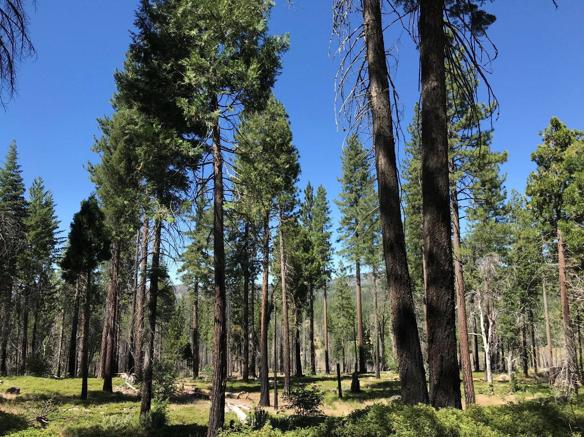Figure 1: Mixed conifer stand near Bear Mountain on the Stanislaus National Forest, Groveland Ranger District. Photo taken in 2019, 5 years after the 2013 Rim Fire. This stand was thinned in 2009 and burned approximately one year prior to the Rim Fire.

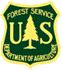
Forest
Service
Sierra & Stanislaus
National Forests
Pacific
Southwest Region
August 2019

Introduction
The Moving Toward Resiliency within the Mokelumne to Kings Landscape (MOTOR M2K) project is a landscape-scale, analysis that responds to unprecedented disturbances in the management history of the Stanislaus and Sierra National Forests. The intent of MOTOR M2K is to make the environmental analysis process more efficient and accelerate the pace and scale of treatments designed to improve the resiliency of our forests at a meaningful scale. The MOTOR M2K decision(s) will authorize vegetation management activities on the Stanislaus and Sierra National Forests, while providing management adaptability and flexibility in the face of uncertainty and rapidly changing conditions. Treatment activities are expected to be implemented over a period of 10-15 years. MOTOR M2K will rely strongly on Tribal and collaborative partnerships, and also use the best available science to describe conditions and identify locations that would benefit from prescribed fire and mechanical or hand treatments to reduce fuels and restore forest resiliency.
This document is a working draft intended to facilitate productive collaborative during the project development phase. This project proposal is expected to change based on continued interdisciplinary discussions as well as discussions with Tribes, collaborative groups and other interested stakeholders.

Where is MOTOR M2K?
The MOTOR M2K project area (Figure 2) is located on the western slope of the Sierra Nevada mountain range in California. The project area encompasses approximately 2.2 million acres of National Forest System (NFS) lands, stretching from the northern boundary of the Stanislaus National Forest (the North Fork Mokelumne River) down to the southern boundary of the Sierra National Forest (the Kings River). Portions of Alpine, Calaveras, Tuolumne, Mariposa, Madera, and Fresno Counties are within the project area.
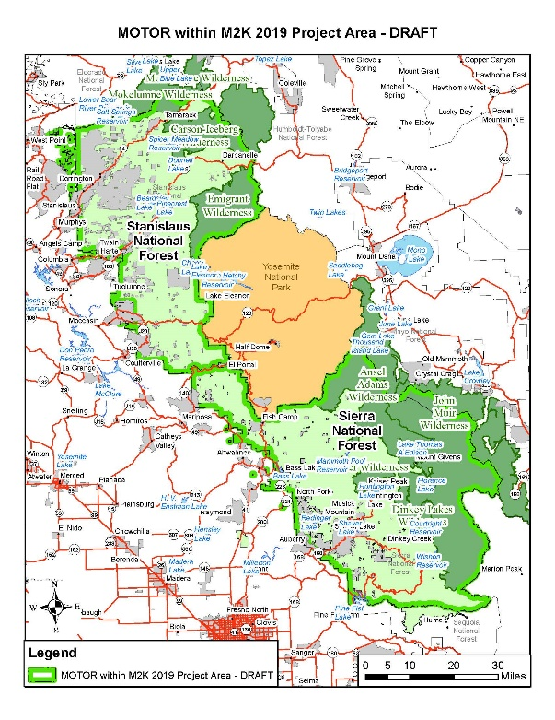
Figure 1 MOTOR M2K Draft Project Area map

Why MOTOR M2K? (Purpose & Need)
Throughout the western United States, risk of high severity wildfire and forest health issues are prevalent. From extensive insect and disease outbreaks to successive record fire years, the changes to the landscape and ecosystem function are beyond their natural range of variation (NRV). These disturbance factors are not only impacting the health of the forest, they are impacting our homes, communities, drinking water, recreation opportunities, and sensitive wildlife that rely on the Forest for survival. The challenge before us is to define a condition for the landscape that incorporates not only the historic landscape conditions, as in the NRV of the Sierra Nevada, but also lends itself to the changing climate while meeting our current and future needs. Table 1 summarized the MOTOR M2K working purpose and need

Table 1. MOTOR M2K Purpose and Need

Specific Purposes and Needs of the MOTOR M2K Project.
Purpose | Needs
Provide for Human Safety and Protection of Public Infrastructure. | - Manage hazardous fuel loadings and increase the extent of defensible space around resources and values at risk (i.e. local communities, private property, recreation sites, water supply, powerlines, roads, other public infrastructure, etc.);  - Abate hazardous trees.
Prepare the landscape to allow for the safe reintroduction of fire as a key ecological process where it does not pose an unacceptable risk to life, property, or ecosystem function. | - Reduce hazardous fuels to minimize the potential for large, high severity wildfires and the possibility of fires spreading onto adjacent, non-FS lands;  - Establish landscape scale prescribed fire and fuel treatment network;  - Create and maintain network of fuelbreaks.
Enhance forest resiliency to largescale, stand-replacing disturbances (i.e. high-severity wildfire and epidemic bark beetle outbreak). | - Use “natural range of variation” (NRV) a guide to restore composition, pattern, and structure of understory and overstory vegetation to make forests healthier and more resilient.  - Increase heterogeneity in vegetation structure and composition at multiple spatial scales (landscape, watershed, stand);  - Reduce stand densities and competition among trees for limited resources (water, nutrients, light);  - Actively accelerate recovery and regeneration of forest ecosystems following major disturbances.
Ensure current and future habitat for sensitive, threatened and endangered species. | - Manage vegetation where fire and/or tree mortality is identified as a threat to the habitat of sensitive, threatened or endangered species;  - Use NRV to inform land management that promotes resilient habitat.  - Increase habitat diversity and complexity at multiple scales.  - Develop large trees on the landscape, while decreasing intermediate- and small-sized trees, to promote more resilient trees and landscapes.  - Remove encroaching conifers from meadows and aspen stands.
Provide for Recovery of Forest Products. / Supply forest products to local industries | - Promote vegetation management to recover merchantable products;  - Provide commercial forest products to local industries at a level commensurate with Forest Plan direction and goals.

Desired Future Condition in the MOTOR M2K Project Area
The ultimate goal of the MOTOR M2K project is to move the landscape as a whole to a condition that is resilient to largescale, stand-replacing disturbances such as high-severity wildfire and epidemic insect outbreaks. Resilience has been broadly defined as “the capacity of a system to experience shocks while retaining essentially the same function, structure, feedbacks, and therefore identity” (Walker et al. 2006, as cited in Long et al. 2014). While “resiliency” may seem to be a fairly straightforward concept, it can be difficult to quantify. One method that is often used to determine whether an ecosystem is “resilient” or not is to determine the ecosystem’s departure from its historic, or natural, range of variation (NRV).
Restoring forest composition, structure, and processes based on NRV conditions has been linked to greater resilience to wildfire, climate change, and other stressors (Kalies and Kent 2016, Larson et al. 2013, Stephens et al. 2016a, as cited in USDA Forest Service 2019). The use of NRV is also prominent in the Conservation Strategy for the California Spotted Owl in the Sierra Nevada (USDA Forest Service 2019): “Promoting forest restoration toward the natural range of variation (NRV) is a central and guiding principle of this Strategy. NRV provides quantitative values for a range of conditions derived from studies in contemporary reference landscapes and from historic information sources.”
North et al. (2009) states that the NRV provides “inference about the cumulative process effects of fire, insects, pathogens, wind, and forest dynamics on stand structure and composition, producing forests resilient to most disturbances, including wildfire.” The use of NRV “is not necessarily an attempt to simply mimic or recreate the processes that occurred on a site long ago, or to return managed landscapes to a single and unchanging past condition. Rather, it is an attempt to improve understanding about the ecological context of an area and the landscape-scale effects of disturbance in an effort to make existing and future conditions more ecologically sustainable” (McGarigal et al. 2018). The Conservation Strategy for the California Spotted Owl in the Sierra Nevada concludes: “Given projections of future climatic conditions, NRV values should not be used as a targeted endpoint but rather as a starting point for movement towards a future range of variation. The future range of variation is an emerging concept and reference models can be applied as they become available (Haugo et al. 2015, as cited in USDA Forest Service 2019).” As such, Desired Conditions for the MOTOR M2K project area will be based on the natural range of variation of the different vegetation types (as described in the scientific literature) present on the landscape.

General Project-wide Desired Conditions
- The landscape contains a mosaic of vegetation types and structures that provide habitat and connectivity for a variety of species.
- Each vegetation type is represented by a mosaic of conditions, densities, and structures. This mosaic, which occurs at a variety of scales across landscapes and watersheds, reflects conditions that provide for ecosystem integrity and diversity.
  - (X Vegetation type) consists of vegetation composition and structure that reflect the natural range of variation for the site.
  - The structure, composition, and function of (Y Vegetation Type) are within the natural range of variation.
- Vegetation structure and composition provide ecosystem resilience to climate change and other stressors including altered fire regimes, drought, and flooding in riparian systems.
- Disturbances (fire, insects, disease, drought) produce mortality patterns consistent with the dynamics under which the forest evolved.
- Fire occurs as a key ecological process in fire-adapted ecosystems where it does not pose an unacceptable risk to life and property. Fire regimes, including the frequency, extent, and severity of fire, is ecologically appropriate and enhances ecosystem resilience and habitat heterogeneity, diversity, and quality.
- Native insect and disease populations are generally limited with occasional outbreaks. Vegetation structural diversity and

PROPOSAL DEVELOPMENT
In order to move the landscape towards the desired future condition, the Forest Service proposes to conduct vegetation management activities on NFS lands within the Stanislaus and Sierra National Forests. Since fire was the dominant disturbance agent that historically shaped Sierra Nevada forests, reintroduction of fire as an ecosystem process will be a key treatment utilized throughout this project. However, given that the reintroduction of fire is not currently practical or safe in some parts of the Sierra Nevada, other treatments will be necessary to implement at a pace and scale that will make a significant difference in how wildfire, insects and other ecosystem drivers behave on the landscape.
Many tools are being considered at this stage including prescribed burning, naturally ignited fires managed for resource benefit, mechanical thinning, hand thinning, machine piling, hand piling, pile burning, salvage, mastication, herbicides, and tree planting. The suite of available treatments would depend on the Emphasis Area (as described later in this document).

INCLUDE PICTURES OF EACH?
MAXIMUM ACREAGES OF EACH?

Potential Treatment Activities:

Prescribed burning:
- Any fire intentionally ignited by management actions under certain, predetermined conditions to meet specific resource objectives related to hazardous fuels or habitat improvement. A written, approved prescribed fire plan must exist, and NEPA requirements must be met, prior to ignition.
  - Broadcast burning: Prescribed burning applied to the majority or all of an area within well-defined boundaries for reduction of fuel, as a resource management treatment, or both
  - Jackpot burning: Prescribed burning of fuels in scattered concentrations that does not cover a majority of the unit
  - Underburn: Prescribed burns of low intensity covering a majority of the burn unit consuming surface fuels, but not the overstory canopy
Naturally ignited fires managed for resource benefit
- wildland fire caused by a natural ignition (i.e. lighting) that is managed with a strategy other than full suppression to achieve a certain resource benefit or desired condition. Managers may refrain from intervening with the progression as long as there is an approved fire management plan, which specifies intervention (that is, suppression) if other management goals (safety, or air quality for instance) are threatened.

Mechanical Treatments:
- Mechanical Thinning: refers to an intermediate treatment, or “partial cutting,” in which mechanized equipment (including feller bunchers, skidders, etc.) is used to remove trees and reduce stand density primarily to improve the growth of residual trees, enhance forest health, reduce forest fuels, improve wildlife habitat, or to increase stand heterogeneity. Tree removal may include commercial (sawlogs) and non-commercial (biomass) material.
  - Note that this does not include ‘Clearcutting.’ A clearcut is a harvest method in which essentially all trees in a stand (typically >3 acres) are removed in one harvesting operation to produce an even-aged stand. No clearcutting or any other “even-aged” methods (shelterwood, seed tree) are proposed in the MOTOR M2K project.
  - Include skyline/cable systems?
- Machine Piling: Any mechanical piling of fuels (dozer piling, for example, or an excavator with a grapple).

Hand Treatments
- Hand thinning: small trees (live or dead; generally <10 inches DBH), and brush may be felled and removed by hand.
- Hand Piling: Fuel treated by hand piling slash.
- Pile burning: burning of hand or machine piles or decks created as a result of a logging operation. As an alternative to burning, piles may also be chipped and removed, where feasible.
- Salvage: The removal of dead or dying merchantable trees for hazard tree abatement, fuel reduction or other objectives.
- Biomass Removal: Removal of live or dead (non-sawlog material) for hazard tree abatement, fuel reduction or other objectives.

- Mastication: Mastication treatments consist of a tractor, excavator or loader with a cutting head used to shred brush, large downed woody debris, and small trees (live and dead) to reduce live conifer density. Shredded material remains on site.
- Herbicides: Manual application of Environmental Protection Agency (EPA) approved herbicides to establish or maintain fuelbreaks and defensible space around key infrastructure or to control noxious weed populations?
  - Fungicides (Sporax?): to control spread of disease, root rot?
- Reforestation: treatment used to establish reproduction in a stand. Treatments may include site preparation, tree planting, and release?

Roads Treatments:
- Road Maintenance
- Road Reconstruction
  - Limited to roads needed for authorized vegetation management activities
  - Culvert upgrades
  - Includes relocation to reduce impacts to resources
- Temporary road construction
  - System roads would be used whenever possible to avoid the need for temporary road construction.
  - Project implementation would use the minimum amount of temporary road construction necessary to achieve resource objectives.
  - All temporary roads would be closed and rehabilitated within 3 years of project completion, unless agreed by ID team recommendation and Responsible Official decision that complete rehabilitation would cause more damage than a less complete technique.Level one roads may be used to access treatment areas. These roads would be closed and returned to level one status after treatments are complete.
- Road Construction
- Road Decommissioning
  - Limited to roads utilized for authorized vegetation management activities or for mitigation associated with authorized vegetation management activities?

Treatment Opportunity Areas (TOAs)
The proposed MOTOR M2K framework utilizes the concept of Treatment Opportunity Areas (TOAs) – areas where potential vegetation management activities could potentially take place. Currently, the Forest Service is considering three types of TOAs: 1) Prescribed Fire Only (_______ acres); 2) Prescribed Fire + Hand Treatments; and, 3) Mechanical Treatment + (_________ acres), for a total of _________ acres. These numbers represent the maximum number of acres that could be treated over the life of the MOTOR M2K project. Not all of the Proposed Action acres would be treated over the life of the project, as some acres will be eliminated due to on-the-ground resource conditions (e.g., steep slopes, wetlands, wildlife security areas) and operational feasibility. They have been identified by applying coarse filters, such as applicable laws, regulations, policies, and Forest Plan direction (to identify known legal constraints), as well as feedback from local stakeholders.

TOAs are broken down into specific Emphasis Areas – similar to management areas in our Forest Plans – which will drive objective, the prescriptions, and tools available for use within that TOA. These emphasis areas may be mapped or identified by description. Based on Interdisciplinary Team (ID Team) discussions as well as discussion generated at the July 11, 2019 public engagement session and July 22 field trip, the ID Team identified the following emphasis areas:

Emphasis Areas

Safety & Infrastructure
- Description: Includes the Wildland Urban Interface (WUI) Defense and Threat zones; buffers of defensible space around recreation sites, water supply infrastructure, powerlines, private property inholdings; 250-foot buffers (on either side) of key roads and fuelbreaks, and other community infrastructure.
- Primary Objectives: Provide for human safety and the protection of infrastructure; Enhance forest resiliency (Recognize that NRV may not strictly apply here (e.g. snags, down logs or proportions of shrubs)
- Desired Condition:
  - Limited fuels (snags, down logs, brush).
  - Stands are fairly open and dominated primarily by larger, fire tolerant trees.
  - Surface and ladder fuel conditions are such that crown fire ignition is highly unlikely.
  - The openness and discontinuity of crown fuels, both horizontally and vertically, result in very low probability of sustained crown fire.
- Potential Implementation Tools: Full Suite of Tool - prescribed burning, naturally ignited fires managed for resource benefit, mechanical thinning, hand thinning, hand piling, machine piling, pile burning, salvage, mastication, herbicides, and reforestation.
Notes: Different Zones treated to different intensities?
    - Defensible Space: .25 mi
    - Defense Zone: .25-1.5 miles(-ish) …defend, modify fire behavior
    - Resiliency: 1-3 miles (resilience guided by NRV)

Wilderness
- Description: Includes all officially designated wilderness areas and also proposed wilderness.
- Primary Objectives: Enhance forest resiliency; create conditions to allow natural ignitions to play their role as a key ecological process where fire does not pose an unacceptable risk to life, property, or wildlife habitat.
- Desired Condition:
  - Fire is restored as an ecosystem process and natural disturbance agent in wilderness where possible.
  - Fire return intervals and fire effects (fire severity) are within the NRV.
- Potential Implementation Tools: Prescribed burning; Natural ignitions managed for resource benefits
Notes: Consider acreage limit burning or line construction. Use natural boundaries where possible with no more than 25% of line being hand constructed; cutting down trees or snags along lines; helicopter ignition? Focus on buffer area…Whitebark pine? Likely listed soon, not sure if we need to do anything. UNDER WHAT CONDITIONS WOULD WE CONSIDER THESE ACTIONS? …Management ignitions in Wilderness

Special Emphasis Areas
- Description: Includes areas with special, administratively-designated status (not including wilderness), as identified in Forest Plans. This includes
  - Wild & Scenic Rivers;
  - Inventoried Roadless Areas (Includes areas with roads (“roaded roadless”); Overlaps with Near Natural + wilderness + recommended wilderness…report as IRA outside of other designations?)

  - Special Interest Areas (geological, botanical, historical);
  - Cultural or other gathering Areas?
  - Experimental Forests ?
  - Research Natural Areas + “Proposed RNA”
  - IRA’s:
- Primary Objectives: Within these areas, the primary objective is to protect or enhance the values or components for which they were set aside.
- Potential Implementation Tools: Prescribed burning; Natural ignitions managed for resource benefits; hand treatments to facilitate prescribed burning? mechanical equipment for fireline construction?
Notes: Need to determine under what scenarios we would enter these areas and what tools we might use; Note that where safety emphasis areas overlap (i.e. fuelbreaks, roads), safety would take priority.

Forest Resiliency Emphasis Area
- Description: All other areas outside of the Safety/Infrastructure, Wilderness, and other Special Emphasis Areas
- Primary Objectives: Refer to “Approach 2. Restoration of Resilient Forest Conditions Guided by NRV” from the Conservation Strategy for the California Spotted Owl in the Sierra Nevada.
- Desired condition: Refer to the Desired Conditions for Terrestrial Ecosystems in thethe Draft Land Management Plan for the Sierra National Forest.
- Potential Implementation Tools: prescribed burning, naturally ignited fires managed for resource benefit, mechanical thinning, hand thinning, hand piling, machine piling, pile burning, salvage, mastication, herbicides, and reforestation.
Notes:
- Sideboards/Design criteria:
  - Treatment of PACs and Territories consistent with CSO strategy?
  - Area limitation based Cumulative Watershed Effects thresholds of concerns?

Table 1: Summary of MOTOR M2K Treatment Opportunity Areas.
 | Total Area (Acres) | Prescribed Fire Only TOAs (Acres) | Prescribed Fire + Hand Treatment TOAs (Acres | Prescribed Fire + Mechanical TOAs (Acres) | Total TOA (Acres) | No Treatment (Acres)
Stanislaus NF
Sierra NF
MOTOR M2K

Potential Operational Delineations (PODs)/ Management Unit Groups (MUGs)?
The MOTOR M2K project area has been subdivided into Potential Operational Delineations (PODs), which are polygons whose boundary features are relevant to fire control operations (e.g., roads, ridgetops, and water bodies). The PODs are a way of dividing the project area into sub-units to provide detailed existing condition information and to facilitate effects analysis, decision making, and project implementation. The PODs will be used to increase site-specificity during project planning and to demonstrate Forest Plan consistency and NEPA compliance.

How Will MOTOR M2K Implementation Work?

Pre-implementation Surveys
Prior to implementation the following surveys will take place to inform treatment locations and other resource consideration.
- Archeological surveys consistent with MOTOR M2K Programmatic Agreement (to be developed through SHPO consultation as part of this project)
- Wildlife surveys consistent with Forest Plan direction
- Sensitive Plant (STF)/Botanical Species of Conservation Concern (SNF)
  - Where project activities have the potential to adversely affect populations
- Hydrological surveys consistent with Waterboard regulations, or as identified in the adaptive management trigger points (in development)

General Process (Once the MOTOR M2K analysis is complete and the Decisions are signed.)
- Identify annual treatment list
  - Activities to be implemented and priority project areas would be based on Forest Plan Direction, MOTOR M2K signed NEPA Decision, and Collaborative Planning
    - MOTOR M2K will be consistent with the Stanislaus and Sierra National Forest Land and Resource Management Plans.
    - We will develop a schedule to guide implementation over the life of the MOTOR M2K project.
  - an annual implementation checklist to ensure that individual projects, when added together, do not exceed treatment caps authorized by the decision
  - Finally, we will host annual meetings with our cooperating agencies and our stakeholders throughout the life of MOTOR M2K to make sure that everyone remains engaged, information about individual treatments is shared, and that we continue to have a positive influence on the future condition of our forests.
  - Utilize PODs (and MUGs?) prioritization process to identify where we go first on the landscape
  - Within a POD (or MUGs?) review Treatment Opportunity Areas (TOAs), identify specific treatment units: treatment consideration would be based on emphasis area, treatment feasibility, stand condition, additional management requirements
  - Annual stakeholder workshop to review/update POD prioritization based on completed projects, changed conditions and monitoring results.
  - Annual meeting: Identify priority PODs and discuss activities to be implemented
    - The public would have the opportunity to:
      - Have input on types and locations of activities, review maps for proposed activities;
      - Evaluate, discuss, and recommend the priority sequencing of activities, treatment prescriptions and integration of activities for funding;
      - Review updated maps of planned/in-process activities to provide feedback to Forest Service regarding prior-year management;
      - Submit applicable peer-reviewed research or individual studies to be considered that may influence implementation of activities/treatments.
- Design and Refine Treatments
  - Identification of site-Specific Treatment Units
  - Field analysis of specific sites
  - Surveys and prescriptions will be based on current conditions observed in the field, and will provide site information in a more appropriate timeframe than we have been able to achieve in the past. Boundaries for treatment units will be based on logical natural or management features identified on the ground rather than during office mapping.
  - Project checklists will be used to identify appropriate information needed during implementation, and District Rangers will have the responsibility to ensure that design features and resource surveys are in place before individual projects proceed.
  - We will also develop field checklists that must be completed before ground-disturbing activities can occur.
  - Objectives and design of site-specific treatments would be determined prior to any ground-disturbing activities using a series of field checklists developed as part of the analysis process. Condition-based NEPA results in a decision that is flexible, adaptive, and responsive to actual on-the-ground conditions.
  - a Supporting Document checklist where specialists sign off that necessary field surveys have been completed; a law, regulation, policy checklist to ensure that individual treatments are consistent with NEPA, the National Forest Management Act, Endangered Species Act; and so on.
  - These areas will be field verified and surveyed for sensitive resources, including cultural resources, rare plants, raptor nests, wetland and riparian concerns, access for proposed treatment methods, etc.
  - Conduct pre-implementation field surveys and complete pre-implementation checklist incorporating site specific design features
  - Adaptive management triggers [will be developed based on resource specialist (or public) concerns]
  - Specialist Surveys:
    - Preimplementation/Surveys: Can we use lidar to inform veg existing condition to implement (without on-the-ground-surveys); identify natural barriers (can we use data set for potential control lines for unplanned ignitions?) with objective of using least amount of handline.
    - CSO? Maybe surveys
    - Fisher surveys(?) Check SNF Rx Burn NEPA
    - Cumulative watershed effects analysis
    - Fuels assessment/Burn plan
    - Anything for SN Red fox?
    - Frog and toad? Just follow PA/PBO?
    - Potential heritage surveys, mitigation measures to protect heritage resources
  - Management Requirements/Mitigations
- Project Implementation
  - Individual projects would not be implemented until pre-treatment checklists have been completed and approved by a Responsible Official.
  - Project design criteria (PDC) would be applied to individual projects, as necessary, to protect area resources.
  - Treatment projects would be site specific polygons based on logical implementation boundaries, and will be included in contracts, agreements or other plans for fuels treatments, prescribed fire, silvicultural treatments or timber harvest/salvage.
  - MOTOR M2K Implementation Guide would include:
    - Checklists – Several checklists will be followed and will be included in the DEIS for public review and comment. Examples of potential checklists include:
      - A Pre-treatment checklist containing planning steps that will be followed for each MOTOR M2K Project which will detail specific annual public involvement with each project.
      - A Supporting Document checklist where specialists sign off that necessary field surveys have been completed
      - A law, regulation, and policy checklist to ensure that individual treatments are consistent with NEPA, the Nation-al Forest Management Act, Endangered Species Act
      - An annual implementation checklist to ensure that individual projects, when added together, do not exceed treatment caps authorized by the decision
      - A document compliance checklist to show requirements of the MOTOR M2K final environmental impact statement
    - Design Criteria – A list of project design criteria will be included in the DEIS for public comment. During project implementation, design criteria that are relevant to site-specific conditions will be identified and applied to each project. This will be part of the project record and available for public review and will be incorporated into the monitoring strategy.
    - Surveys - All required surveys will be completed for each individual treatment area prior to ground-disturbing activities.
    - The implementation plan will describe checkpoints for public input and proposed action refinement, special resource surveys, monitoring, and adaptive management.
- Monitoring
  - Monitoring - An annual monitoring plan will be part of the DEIS for public comment. This will include an opportunity to review implementation activities with interested stakeholders, partners, and collaborative groups to ensure treatments are implemented as planned and that project objectives are being attained.
  - Post implementation monitoring:
  - Adaptive Management
  - Potential Public engagement points
    - Check points for public review/involvement
    - Public Engagement: Collaborators recommend areas? Request assistance from collaborators for survey and monitoring?

Forest Plan Amendments
The Forest Service is considering a Stanislaus NF Forest Plan Amendment to adopt the CA Spotted owl strategy (USDA, 2019) [cut and paste Approach 2 from CSO strategy]
- Allow cutting of trees 30-40” dbh to create small gaps in historically pine dominated stands
- Map spotted owl territories as circular core around activity center.
- Mechanical treatments in PACs up to 1/3 of PAC

Information Contact
Information for this project is posted on the project website at https://go.usa.gov/xVcr5.

For additional information regarding this project, contact Michael Jow, Team Co-Leader of the MOTOR M2K Project, via email at michael.jow@usda.gov.

References
Fettig, C.J., C.J. Hayes, K.J. Jones, S.R. McKelvey, S.L. Mori, and S.L. Smith. 2012. Thinning Jeffrey pine stands to reduce susceptibility to bark beetle infestations in California, U.S.A. Agricultural and Forest Entomology 14: 111−117.

Hayes, C.J., C.J. Fettig, and L.D. Merrill. 2009. Evaluation of multiple funnel traps and stand characteristics for estimating western pine beetle-caused tree mortality. Journal of Economic Entomology 102: 2170−2182.

Jeronimo, Sean M.A,, Van R. Kane, Derek J. Churchill, James A. Lutz, Malcolm P. North, Gregory P. Asner, Jerry F. Franklin. 2019. Forest structure and pattern vary by climate and landform across active-fire landscapes in the montane Sierra Nevada. Forest Ecology and Management. Volume 437, Pages 70-86.

Kelsey, Rodd. 2019. Wildfires and Forest Resilience: the case for ecological forestry in the Sierra Nevada. Unpublished report of The Nature Conservancy. Sacramento, California. 12 pp.

Long, Jonathan W.; Quinn-Davidson, Lenya; Skinner, Carl N., eds. 2014. Science synthesis to support socioecological resilience in the Sierra Nevada and southern Cascade Range. Gen. Tech. Rep. PSW-GTR-247. Albany, CA: U.S. Department of Agriculture, Forest Service, Pacific Southwest Research Station. 723 p.

Mallek, C., H. Safford, J. Viers, and J. Miller. 2013. Modern departures in fire severity and area vary by forest type, Sierra Nevada and southern Cascades, California, USA. Ecosphere 4: 1-28.

McGarigal, K., M. Mallek, B. Estes, M. Tierney, T. Walsh, T. Thane, H. Safford, S.A. Cushman. 2018. Modeling historical range of variability and alternative management scenarios in the upper Yuba River watershed, Tahoe National Forest, California. Gen. Tech. Rep. RMRS-GTR-385. Fort Collins, CO: U.S. Department of Agriculture, Forest Service, Rocky Mountain Research Stations. 346 p.

Millar, C.I. and N.L. Stephenson. 2015. Temperate forest health in an era of emerging megadisturbance. Science 349(6250): 823–826.

Miller, J.D., H.D. Safford, M. Crimmins, and A.E. Thode. 2009. Quantitative evidence for increasing forest fire severity in the Sierra Nevada and southern Cascade Mountains, California and Nevada, USA. Ecosystems 12: 16-32.

North, Malcolm; Stine, Peter; O'Hara, Kevin; Zielinski, William; Stephens, Scott 2009. An ecosystem management strategy for Sierran mixed-conifer forests. Gen. Tech. Rep. PSW-GTR-220. Albany, CA: U.S. Department of Agriculture, Forest Service, Pacific Southwest Research Station. 49 p.

Safford, H.D., M. North, and M.D. Meyer. 2012A. Chapter 3: Climate change and the relevance of historical forest conditions. In M. North, editor. Managing Sierra Nevada forests. General Technical Report PSW-GTR-237. USDA Forest Service, Pacific Southwest Research Station. 23-46.

Safford, H.D.; Wiens, J.A.; Hayward, A.G.D. 2012B. The growing importance of the past in managing ecosystems of the future. In: Wiens, J.A.; Hayward, G.D.; Safford, H.D.; Giffen, C.M., eds. Historical environmental variation in conservation and natural resource management. Chichester, United Kingdom: John Wiley & Sons: 319–327. Chapter 24.

Safford, Hugh D.; Stevens, Jens T. 2017. Natural range of variation for yellow pine and mixed-conifer forests in the Sierra Nevada, southern Cascades, and Modoc and Inyo National Forests, California, USA. Gen. Tech. Rep. PSW-GTR-256. Albany, CA: U.S. Department of Agriculture, Forest Service, Pacific Southwest Research Station. 229 p.

Steel, Z.L., H.D. Safford, and J.H. Viers. 2015. The fire frequency-severity relationship and the legacy of fire suppression in California forests. Ecosphere 6: 8.

Stephens, S.L., B.M. Collins, E. Biber, and P.Z. Fulé. 2016. U.S. Federal fire and forest policy: emphasizing resilience in dry forests. Ecosphere 7: e01584.

Stephens, S.L., J.K. Agee, P.Z. Fulé, M.P. North, W.H. Romme, T.W. Swetnam, and M.G. Turner. 2013. Managing forests and fire in changing climates. Science 342: 41-42.

USFS Pacific Southwest Region Ecology Program. Natural Range of Variation of Sierra Nevada habitats.
<https://www.fs.usda.gov/detail/r5/plants-animals/?cid=stelprdb5434436>.

USDA Forest Service. 2019. Conservation Strategy for the California spotted owl (Strix occidentalis occidentalis) in the Sierra Nevada. Publication R5-TP-043.

Appendix A: Management Requirements
Aquatic Species

Cultural Resources

Fire and Fuels

Invasive Plants

Range

Recreation

Sensitive Plants

Soils

Terrestrial Wildlife

Vegetation

Watershed

APPENDIX B: Maps
- Project Area
- Different emphasis areas (or 1 for each emphasis area)
- Fuelbreaks
- Treatment Opportunity Areas
  - Rx burn
  - Rx Burn + Mechanical TOA
- POD’s
- Productive Forest / Non-Productive Forest / Non-Forest
- Fire History / Fire Departure

SELECTED MANAGEMENT AREAS and LAND ALLOCATIONS

MANAGEMENT AREA/  LAND ALLOCATION | GIS ACRES | NOTES
Private and other Non-NFS lands within MOTOR
NON-NFS Lands 294,201 M2K Project Boundary
Final and Provisional Boundaries clipped to
WILDERNESS, MOTOR M2K 775,830 MOTOR M2K Proclaimed Boundary
Inventoried Roadless Areas (2001), clipped to
Inventoried Roadless Area (2001) 284,969 MOTOR M2K Project Boundary
Includes Designated, Candidate and Proposed
Research Natural Areas 9,377 RNAs
Special Interest Areas 6,811
Experimental Forest 4,919
San Joaquin Experimental Range 4,506 NOT INCLUDED IN PROPOSED ACTION
WUI Defense Zone 116,361 Total Current WUI Defense Zone
STF Defense Zone 55,199
SNF Defense Zone 61,162
PROTECTED ACTIVITY CENTERS¹ 166,968 Total Acreage in PAC accounting for overlap.
California Spotted Owl PAC 142,691 469 CSO PACs Northern Goshawk PAC 34,018 162 NGO PACs
Great Gray Owl PAC 4,418 49 GGO PACs
Other acres within planning area not accounted
OTHER NFS LANDS¹ 819,063 for above. All slopes and land cover types
TOTAL
Proclaimed Forest Boundaries, Sierra NF,
MOTOR M2K Planning Area 2,505,505 Stanislaus NF

1Approximately 20,000-25,000 acres of PAC overlap with other management areas (i.e., Wilderness, IRAs, RNAs, etc.). Does not account for overlap with WUI Defense Zone.

