ACCG RFFCP Concept Proposal
October 2019
Submitted to: Sierra Nevada Conservancy
Submitted by: Upper Mokelumne River Watershed Authority
Collaborative Partners: Amador-Calaveras Consensus Group
Introduction
The following concept proposal is being submitted by the Upper Mokelumne River Watershed Authority (UMRWA) in collaboration with the Amador-Calaveras Consensus Group (ACCG). Both organizations identified the need for a mapping tool and database of fuels treatment projects within the Mokelumne and Cosumnes watersheds. The mapping tool would spacially display the locations and types of past, ongoing and planned fuels treatments projects throughout the watersheds as well as the status of NEPA and CEQA for those projects and other critical data points. The tool would be designed so that it can easily be updated and used by a wide array of partnering agencies indefinitely into the future and beyond the initial set-up phase that this grant would help fund.
The ACCG was formed in 2008 to bring together the diverse Sierra Nevada Community of loggers, environmentalists, business owners, and local residents with federal, state and local officials to find common ground on forest, economic, and community issues in Amador and Calaveras Counties. With the current Collaborative Forest Landscape Restoration (CFLR) funding expiring within the next few years, the ACCG is now focused on building its internal capacity to plan and identify new projects and to positions the organization to apply for increased funding from a wide variety of sources. Under this proposal, UMRWA would work collaboratively with ACCG and would serve as the fiscal agent to hire a staff person to design and compile the project mapper and oversee implementation this task.
Background/ Purpose and Need:
In 2018, the ACCG developed a 5-year Strategic Plan to move the collaborative forward and to prepare for “life post CFLR funding”. One of the main goals of the plan is to complete more work on the ground than the collaborative has previously been doing. The first objective of this goal is to create a landscape assessment for the ACCG region that prioritizes projects and maximizes project benefits by building off past treatment locations. While the collaborative has successfully accomplished a variety of projects throughout the landscape, we want to design a more strategic and comprehensive program that leverages all the various partners’ work to date.
In the summer of 2019, the Strategic Landscape Assessment Working Group (SLAWG) was formed as a branch of the ACCG Planning Work Group to start developing a mapping and project prioritization tool. The SLAWG group has been moderately successful in receiving project data from ACCG partners and plotting on a shared map. The idea is to compile one master map with all the projects ACCG has completed to date combined with projects that are currently in the planning and conceptual stages overlaid with critical data points such as the wildland urban interface, public infrastructure, critical habitat, and timber resources. With this critical data combined into one user-friendly mapping tool, the ACCG partners could easily identify areas within the landscape that are most in need of restoration and the partners could then design projects in the most strategic areas possible and in locations that build off past projects. Figure 1 shows the extent of one of the early drafts in this process.
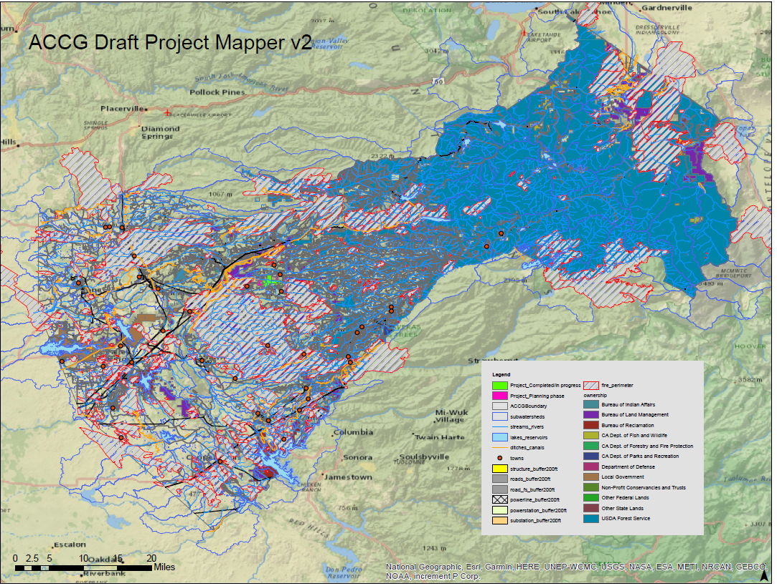
Figure 1: Early version of the ACCG project mapper/prioritization tool.
It was quickly discovered that this was a very laborious process: not only finding the correct data but clipping it correctly and adding the appropriate metadata to make the tool truly useful. The ACCG is made up primarily of volunteers with outside commitments and full-time employees who can dedicate limited time each month to special projects such as this mapper. In order to comply with the Regional Forest and Fire Capacity Program’s goals of creating a “pipeline of projects” the Upper Mokelumne River Watershed Authority (UMRWA) would like to apply for funding through the Sierra Nevada Conservancy’s bloc grant to hire a part-time staff person to assist the ACCG in completing this crucial project.
Methods:
The UMRWA staff team member would be responsible for various tasks including:
- Outreach to the ACCG partners to obtain data and information about past projects, locations, shapefiles, and local knowledge of the area.
- Development of a complex project mapper/prioritization tool using GIS software
- Organization of all spatial data into a functional system that’s easily accessible to the ACCG pertners and non-GIS experts.
- Coordination with the ACCG Planning Work Group on the development of the tool to optimize its effectiveness for the ACCG
- Teaching the ACCG members how to use the tool and update it indefinitely.
Length of time: My guess is 12 to 18 months? I think we should request as much time as SNC will give us.
Timeline: Estimated January 2020 to June 2021 (depending on when the grant agreement is executed)
Budget: Michael my WAG would be $50K but I really have no idea! How much funding do you think SNC has for this?

Long-Term Benefits:
One of the primary tasks this grant would help fund, is to to educate ACCG members about how to use the mapping tool its innerworkings so that the ACCG is not reliant on a single person to maintain this critical resource. By building this tool in-house using much of the ACCG’s own resources, it is anticipated that ACCG members will maintain and update the tool over time and it will be accessed by a wide variety of organizations for the longest time possible. . The collaborative believes that with a tool such as this, it will assist all the partner organizations in not only developing projects but will assist them in successfully applying for grant funding as they’ll have access to project data from within the whole watershed in a single location. This tool will inevitably increase the capacity of the UMRWA and the ACCG to strategically plan and develop projects that will assist the collaborative in meeting it’s mission of promoting fire safe communities, healthy forests and watersheds, and sustainable local economies.

