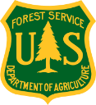
United States Department of Agriculture
Forest Service, Pacific Southwest Region
Stanislaus National Forest - Sierra National Forest

Briefing Paper: June 2019 (Revised)
Moving Toward Resiliency within the Mokelumne to Kings Landscape
(MOTOR M2K)

What is MOTOR M2K?
The Moving Toward Resiliency within the Mokelumne to Kings Landscape (MOTOR M2K) project is a large landscape-scale analysis that will:
- Authorize vegetation management actions across the Stanislaus National Forest and Sierra National Forest that will accelerate the pace and scale of treatments designed to improve the resiliency of our forests at a meaningful scale.
- Implement treatment activities over the next 10-15+ years
- Provide management adaptability and flexibility in the face of uncertainty and rapidly changing forest and rangeland conditions; and
- Rely strongly on collaborative relationships and partnerships.

Why Are We Doing This Project?

Throughout the western United States, forest health issues are prevalent. From extensive insect and disease outbreaks to successive record fire years, the changes to the landscape and ecosystem function are beyond their natural range of variation (NRV). These disturbance factors are not only impacting the health of the forest, they are impacting our homes, communities, drinking water, recreation opportunities, and sensitive wildlife that rely on the Forest for survival. The challenge before us is to define a condition for the landscape that incorporates not only the historic landscape conditions, as in the NRV of the Sierra Nevada, but also lends itself to the changing climate while meeting our current and future needs.

Large, High-Severity Wildfire
In just over 30 years the Sierra and Stanislaus National Forests have experienced extensive loss of mature forest to wildfire. In 2013, when the Rim Fire devastated the landscape it was the largest fire recorded in the Sierra Nevada’s, and the third largest in California at 257,314 acres. Just 6 years later, it now ranks 5th in California, surpassed by the 281,893-acre Thomas Fire in 2017 and this past year, the Mendocino Complex at 459,123 acres. Wildfires have been growing increasingly larger, more intense and more costly, and most scientists and managers see this trend continuing into the future. A century of fire exclusion has resulted in an ingrowth of shade-tolerant trees and an accumulation of surface and ladder fuels, increasing both the amount and patch size of high-severity fire in the Sierra Nevada low- and mid-elevation conifer forest types. In this past year (2018), we witnessed some of the most devastating and deadly fires in California history, including the Ferguson Fire, Mendocino Complex, Carr Fire, Woolsey Fire and Camp Fire, the latter in which at least 83 people died and over 18,000 structures were destroyed. Locally, the Ferguson and Donnell sires created significant impacts to local communities, watershed functioning, and air quality issues for a large portion of our region.

Tree Mortality (Related to Drought and Insects)
Forests of the Sierra Nevada range have also been experiencing one of the largest tree mortality events in recent history. Since 2010, more than 129 million trees have been killed—89 million in the past two years alone—in California’s drought-stricken forests. Between 2014 and 2017, tree mortality levels increased more than 100-fold in many areas of the southern Sierra. During this period, 55 percent of the California spotted owl (CSO) PACs on the southern Sierra national forests (Sierra, Sequoia, and Stanislaus) experienced tree mortality of more than 20 trees per acre with greater loss in larger-diameter trees.¹
While the southern Sierra Nevada has experienced some relief from drought over the past few years, tens of millions of dead trees remain on the landscape, and hundreds of thousands of acres remain at risk of insect outbreaks and associated widespread, ecosystem altering mortality due to current densities and species composition. These concentrations of dead trees not only pose significant threats to life, property and infrastructure, they also create heavy fuel loads as these trees start to come down. Some of the greatest concentrations of tree mortality have been concentrated in areas that are the most departed from the fire regimes under which they evolved posing serious threats to the sustainability of these ecosystems.

How Does MOTOR M2K Differ From Past Projects?

Pace and Scale
The Stanislaus and Sierra National Forests have been working toward protecting communities and creating healthy, resilient stands; however, a large part of our forests remain at risk. While we are implementing projects, the rate of forested land lost to wildfire, insects, and disease continues to increase, putting watersheds and wildlife habitat at risk, as well as critical infrastructures and facilities and businesses as we saw firsthand during the Ferguson and Donnell fires this past summer. In order to change this trajectory, we have to increase the pace and scale of these treatments.
Approximately 36% (911,503 acres) of the MOTOR within M2K project area can be classified as Yellow Pine/Mixed Conifer forests with fire regimes characterized as frequent, low to moderate severity fires. According to Stephens in others (2007) as summarized in PSW-GTR-256, an estimated 5-15% of the area of these forest types would have burned annually prior to European settlement. This would equate to an average of 91,000 acres burned annually across the planning area in these forest types alone, almost 5 times the current rate of treatment. Table 1 shows treatments that have occurred over the past 15 years on both the Sierra NF and Stanislaus NF verses treatments needed to better align with conditions under which these systems evolved.
Table 1. Vegetation Treatments across the Stanislaus and Sierra Nationals Forests over the past 15 years (2004 to 2018) compared to potential treatments for the next 15 years following the MOTOR within M2K decision.
 | Sierra NF (SNF) and Stanislaus NF (STF) Treatments¹ (2004-2018) | Acres Treated Past 15 years | Acres Treated Past 15 years² | Next 15 Years: Post MOTOR within M2K Decision³ | Next 15 Years: Post MOTOR within M2K Decision^{2, 3}
 |  | (Average Acres / Year) | (Total Acres Treated) | (Average Acres / Year) | (Total Acres Treated)
 | Prescribed Fire | 4,849 | 72,735 | 100,000+ | 1,500,000+
 | Sierra NF | 2,166 | 32,486
 | Stanislaus NF | 2,683 | 40,249
 | Fuels Treatments (SNF) | 9,879 | 148186
 | Sierra NF | 3,672 | 55,075
 | Stanislaus NF | 6,207 | 93,111
 | Timber Harvest | 2,871 | 39,858
 | Sierra NF | 1,269 | 19,028
 | Stanislaus NF | 1,602 | 20,830
 | Pre-commercial Thinning | 2,513 | 35,521
 | Sierra NF | 1,426 | 21,392
 | Stanislaus NF | 1,087 | 14,129
 | GRAND TOTAL | 20,112 | 296,300 | 100,000+ | 1,500,000+
¹ Primary and secondary fuels treatment acres from Forest Service's Forest Activity Tracking System (FACTS) database. Prescribed Fire treatments are recorded after completion of burning, other treatments may include acres that have been in an awarded contract, but activities may not be complete. Stanislaus NF Commercial and Pre-commercial thinning only includes the past 13 years (2006-2018).
² Total acres may include multiple entries across the analysis period.
³ Preliminary estimates based on desire to treat ~10% of the Yellow Pine/Mixed Conifer vegetation type plus an additional ~9,000 acres of other vegetation types annually across the planning area. Treatments could potentially include mechanical treatments, prescribed fire and managed wildfire fire.
To continue in this manor would take decades to address the need to treat our landscapes. We are in a race against the threats of wildfire, insects and disease. Now more than ever, attempting to conduct NEPA and project planning as we have in the past, makes us vulnerable to a high likelihood that conditions within a project area will change prior to the time of implementation (i.e. increased mortality, new wildlife nests or detections, wildfire, etc.). Now is the time to change our processes to allow project implementation to adapt to changing conditions and be implemented at a scale that will affect real change on the landscape.

Condition-based NEPA
Conceptually, MOTOR within M2K would utilize a combination of condition-based NEPA (if we find condition X on the landscape we apply treatment Y), management requirements, monitoring and adaptive management. The result of this planning effort will be a NEPA decision document for each Forest and Implementation Plan authorizing a variety of vegetation management treatments across both forests designed to improve resiliency in the face of wildfire, drought and insect outbreaks. The document will be specific enough to satisfy the requirements of NEPA but flexible enough to respond to changing landscape conditions as well as lack of initial site-specific data.
This NEPA analysis and decision will be different than anything we have done in the past, but we ask that you approach this opportunity with an open mind and come prepared to work together to make it successful. When you think about the level of detail, site-specificity, and time that has gone into traditional project planning, it’s clear that we cannot continue to operate in the traditional fashion. We need to explore and experiment with NEPA efficiencies to address our situation while meeting obligations to be consistent with laws, regulations, and policies. Our task is to define what we want our landscape to look like, and how we want it to act in the future, identify the steps necessary to accomplish that goal, and adapt the methods used throughout the life of this decision based upon monitoring and research.

Forest Plan Amendments?
We are open to considering a wide range of activities to meet our objectives, including necessary Forest Plan amendments. There has been a lot of research and new scientific information and tools since the 2004 Sierra Nevada Forest Plan Amendment Record of Decision as well as 15 years of implementation under that direction. The recently released Conservation Strategy for the California spotted owl in the Sierra Nevada (USDA 2019) highlights this growing body of literature supporting the need for change and potential paths forward. We intend to explore whatever options seem needed utilizing the best available science information (BASI) to achieve our goal.

How Will Best Available Science Information (BASI) Be Used?
To create resilient landscape conditions, managing the landscape toward the NRV will be a central and guiding principle of this project. This project will rely heavily on the best available science describing these conditions, as well as other literature addressing fuel treatments and forest health issues. In addition to Core and Extended IDT members and discussion partners, this project will utilize a Science Advisor from the Pacific Southwest Research Station. The role of the Science Advisor is to act as a neutral representative of the scientific community who will ensure that the purpose and need and proposed action represent and tier correctly to the best available science information (BASI), and that the BASI is utilized and interpreted correctly in the analysis.
The following references are some of the key pieces of literature informing project development and analysis:
Long, Jonathan W.; Quinn-Davidson, Lenya; Skinner, Carl N., eds. 2014. Science synthesis to support socioecological resilience in the Sierra Nevada and southern Cascade Range. Gen. Tech. Rep. PSW-GTR-247. Albany, CA: U.S. Department of Agriculture, Forest Service, Pacific Southwest Research Station. 723 p.
North, M.; Stine, P.; O’Hara, K.; Zielinski, W.; Stephens, S. 2009a. An ecosystem management strategy for Sierran mixed-conifer forests. 2nd printing, with addendum. Gen. Tech. Rep. PSW-GTR-220. Albany, CA: U.S. Department of Agriculture, Forest Service, Pacific Southwest Research Station. 49 p.
North, Malcolm, ed. 2012. Managing Sierra Nevada forests. Gen. Tech. Rep. PSW-GTR-237. Albany, CA: U.S. Department of Agriculture, Forest Service, Pacific Southwest Research Station. 184 p.
Safford HD, Stevens JT. 2017. Natural range of variation (NRV) for yellow pine and mixed conifer forests in the Sierra Nevada, southern Cascades, and Modoc and Inyo National Forests, California, USA. US Department of Agriculture, Forest Service, Pacific Southwest Research Station. General Technical Report no. PSW-GTR-256.
Spencer, W.D., S.C. Sawyer, H.L. Romsos, W.J. Zielinski, C.M. Thompson, and S.A. Britting. 2016.
Southern Sierra Nevada fisher conservation strategy. Version 1.0. Unpublished report produced by Conservation Biology Institute.
USDA Forest Service. 2019. Conservation Strategy for the California spotted owl (Strix occidentalis occidentalis) in the Sierra Nevada. Publication R5-TP-043.

What is the Framework for Determining the Proposed Action?
Our goal is to develop a vegetation management framework across the Stanislaus and Sierra National Forests – focusing primarily, but not exclusively on those frequent fire adapted ecosystems below 7,000 feet in elevation that historically burned roughly every 5-15 years prior to European settlement. This framework will specify the process for implementing these density reduction and fuel treatments over the next 10-15 years. This framework may also address additional vegetation types as the team deems necessary to implement a cohesive fire protection strategy across the forest, or to address additional forest health concerns that arise through the development of this project.
The focus of this project is intentionally narrow, as will be the focus of the treatments we will be developing. We understand achieving true ecosystem resiliency will need to address other issues such as invasive species, streams, meadows and riparian health, recreation and so on; however, the most pressing and time sensitive need is to address the ecosystem drivers that have the potential to drastically and rapidly impact the health of our ecosystem and the services it provides. The team realized that true resiliency involves addressing many other issues affecting the health of our forests. However, due to the urgency of addressing the risk of wildfire and wide spread drought and insect related tree mortality, the scope of actions considered will likely be narrowly focused on actions that reduce these threats.

What Types of Treatments May be Authorized by This Project?
Since fire was the dominant disturbance agent that shaped Sierra Nevada forests under NRV, reintroduction of fire (prescribed or managed fire) as an ecosystem process will be key treatment utilized through this project. However, given the reintroduction of fire is not presently practical or safe in some parts of the Sierra Nevada, other options will be necessary to implement treatments at a pace and scale that will make a significant difference in how wildfire, insects and other ecosystem drivers behave on our landscape. All tools are being considered at this stage including mechanical, and hand thinning, mastication, piling, prescribed burning, herbicides, etc.

Who Can Be Involved? How? When?
The ID team is interested in involving collaborative groups and other stake holders early in the process and often throughout the process and well before a fleshed out proposed action. The Forest Service will be hosting a series of meetings/workshops over the course of approximately 3 months that would be open to all collaborators and the general public and specifically dedicated to this project development. The hope is that specific collaborative groups would be able to send representatives (as many who would like to be involved) to participate in these meetings. The team is also open to any suggestions as how best to involve collaborative groups as well as the general public and other interested parties.
The first meeting will be held on Thursday, July 11, 2019 from 1:00 pm to 5:00 p.m. Since the MOTOR M2K spans two entire forests this meeting will be held in two locations simultaneously. The primary location will be at the Stanislaus National Forest Supervisor’s Office located at 19777 Greenley Road, Sonora, CA 95370. There will also be a satellite meeting linked via Video Teleconference held at the Sierra National Forest Headquarters, 1600 Tollhouse Road, Clovis, CA 93611.
Additional meetings are planned for mid to late August and September – specific dates and times TBD.

What is the Project Timeline?
Our goal is to issue a signed decision in late-November of 2020. Our preliminary timeline is summarized in the table below.
Dates/Timeframe | Key Stage
March 25, 2019 | First Interdisciplinary Team Meeting
May - August 2019 | Collaborators/ Public Engagement meetings and workshops
August 2019 | Finalize Proposed Action and initiate Scoping
October 2019 | Finalize Alternatives and Management Requirements
April 2020 | EA or Draft EIS for public review (Comment Period)
April/May 2020 | Public Meetings for EA or DEIS
July 2020 | Initiate Objection Period on Draft Decision
November 2020 | Issue Final Decision and Project Implementation
The timeline we’ve set is ambitious, but we wanted to present a goal that reflects the urgency that we feel is needed to address the threats to our landscape.
This project is being developed to respond to the increasing rate our forests and communities are being devastated by wildfire and insect outbreaks. While we have been tackling this problem and doing good work, we are not able to treat our forests at the pace and scale to alter this trajectory.

Are There Other Examples of Similar Projects within the Agency?
Other forests and regions have been tackling landscapes of similar scope and scale across the country. As we move forward we intend to build on the process and lessons learned from these projects and develop a framework and proposal that fits our specific landscape, issues and needs.
The following are links to other Forests/Regions large landscape project websites. The team is utilizing these examples from other forests and regions to inform our own framework and analysis to meet the needs of the Sierra and Stanislaus national forests.
Medicine Bow Landscape Vegetation Analysis Project: https://www.fs.usda.gov/project/?project=51255
Blue Mountain Forest Resiliency Project: https://www.fs.usda.gov/project/?project=48582
Four Forest Restoration Initiative (4Fri): https://www.fs.usda.gov/4fri
Prince of Whales Landscape Level Analysis: https://www.fs.usda.gov/project/?project=50337
Black Hills Resilient Landscapes Project: https://www.fs.usda.gov/project/?project=49052
Spruce Beetle Epidemic and Aspen Decline Management Response: https://www.fs.usda.gov/project/?project=42387

How Can I Find Out More About MOTOR within M2K
For additional Information you can contact Michael Jow, MOTOR within M2K Interdisciplinary Team Co-Leader via email at michael.jow@usda.gov.

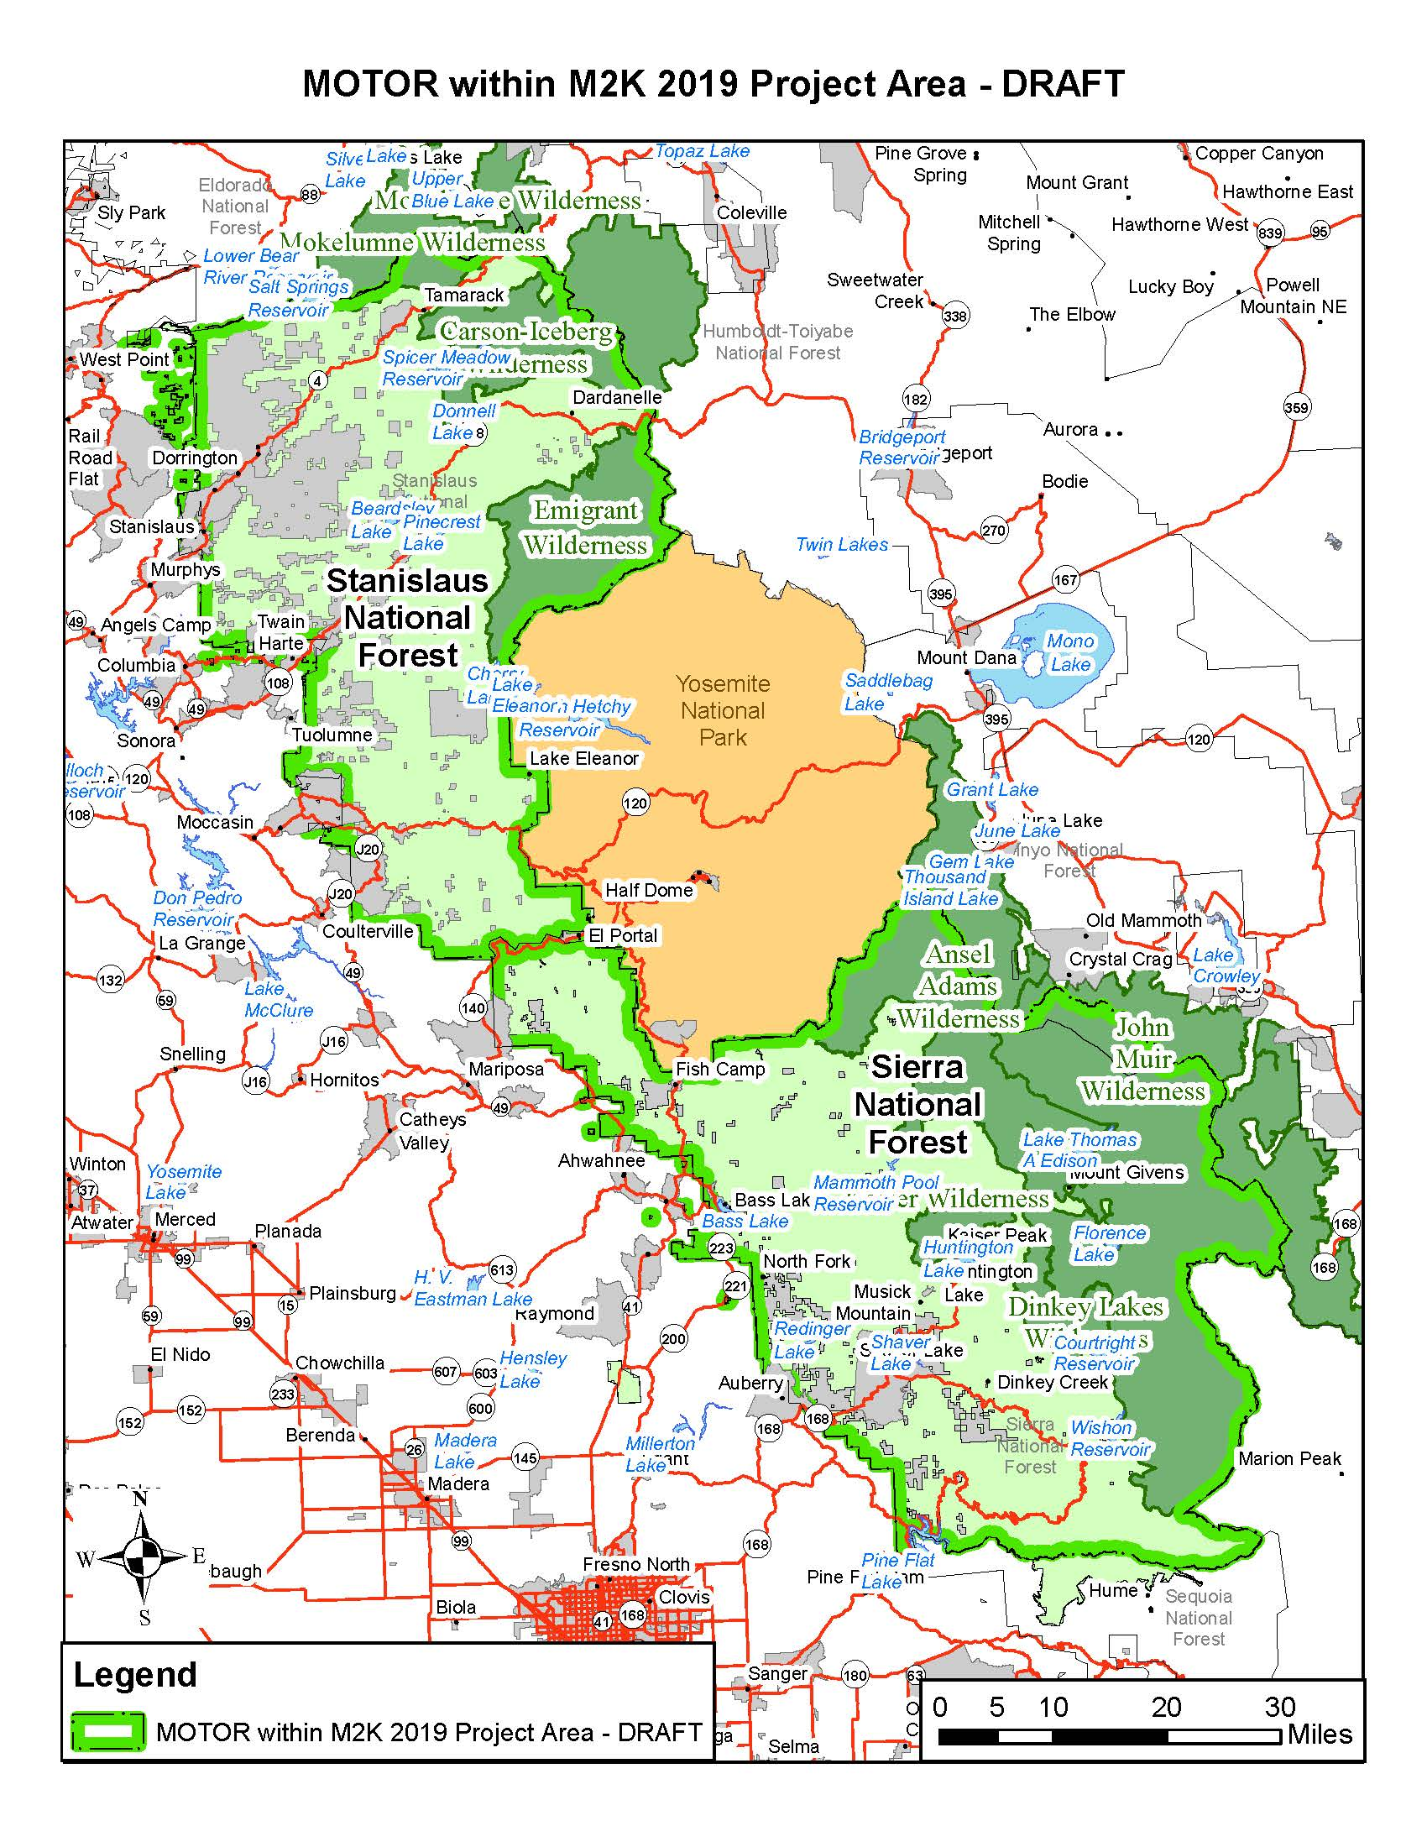

From USDA Forest Service. 2019. Conservation Strategy for the California spotted owl (Strix occidentalis occidentalis) in the Sierra Nevada. Publication R5-TP-043
Mallek, C., H. Safford, J. Viers, and J. Miller. 2013. Modern departures in fire severity and area vary by forest type, Sierra Nevada and southern Cascades, California, USA. Ecosphere 4: 1-28.
Miller, J.D., H.D. Safford, M. Crimmins, and A.E. Thode. 2009. Quantitative evidence for increasing forest fire severity in the Sierra Nevada and southern Cascade Mountains, California and Nevada, USA. Ecosystems 12: 16-32.
Steel, Z.L., H.D. Safford, and J.H. Viers. 2015. The fire frequency-severity relationship and the legacy of fire suppression in California forests. Ecosphere 6: 8.
Safford HD, Stevens JT. 2017. Natural range of variation (NRV) for yellow pine and mixed conifer forests in the Sierra Nevada, southern Cascades, and Modoc and Inyo National Forests, California, USA. US Department of Agriculture, Forest Service, Pacific Southwest Research Station. General Technical Report no. PSW-GTR-256.

