Prepared by the Consensus Building Institute

Meeting Brief
- The Planning Work Group (WG) rescheduled the October meeting for October 30th from 9-noon at the Amador Ranger District. The Planning WG meeting will include a field trip to learn more about the Power Fire Pre-Commercial project’s on-the-ground activities.
- The ad hoc group presented its final summary from the Scottiago field trip which occurred on June 26, 2019. Ben Solvesky will present it to the full ACCG at the October general meeting. The field trip summary describes what was discussed at the field trip but does not reflect consensus views of the ACCG.
- The WG refined the “yellow light” category of project activities, protocols and procedures for the ACCG Project Support Evaluation Tool and decided to add an “orange light” category to replace the draft “red light” category. This allows the group to contemplate if there are truly “red light” topics that under any scenario would not achieve ACCG consensus. The WG will continue discussing the “orange light” and “red light” categories of project activities in October and plans to bring the tool to the full ACCG for discussion at the November general meeting.
- The WG directed the SLAWG to develop a draft proposal to the Sierra Nevada Conservancy (SNC) for the continuing development of a mapping tool to help the ACCG realize an all-lands approach. The WG will review and refine the proposal at the October 30th meeting with an anticipated proposal submission to the SNC in November.
- The WG recommended the Upper Mokelumne River Watershed Habitat Restoration & Defense project for ACCG consensus support. The project will appear on the October 16th general meeting agenda to request a letter of support from the full ACCG.
- The WG agreed that it would be beneficial to have a common meeting venue to understand the three collaboratives’ (ACCG, YSS, and Dinkey) mutual interests and to get aligned on preferred options/alternatives for the MOTOR M2K project. Overall, the WG continues to express concern about condition-based NEPA. However, some noted that it may be possible to achieve consensus on condition-based analysis within the ACCG’s green light category of project activities (as specified in the Project Support Evaluation Tool currently under development). Attendees discussed the possibility of pursuing a programmatic EIS as an alternative whose analysis could focus on cumulative effects with smaller decisions that would fall under the programmatic document. Particularly if the courts block condition-based analyses, the programmatic EIS with speedy NEPA may be a practicable approach towards achieving landscape-scale treatments with less controversy. Under such an alternative, the WG further emphasized the importance of developing criteria for a streamlined EIS that all collaboratives could support.
- A field trip to the Pumpkin Hollow Restoration Project within the Hemlock project area took place after the Planning Work Group meeting.

Action Items
Actions | Point Person(s)
Finalize 8/28/19 Planning WG meeting summary and coordinate with Jill Micheau to post to ACCG website. | Tania Carlone
Finalize Scottiago field trip summary and coordinate with Jill Micheau to post to ACCG website. | Tania
Present Scottiago field trip summary to full ACCG at October general meeting. | Ben Solvesky
Provide draft language for the WG’s consideration regarding the types, scale, and timing considerations for the use of herbicides for inclusion in the Project Support Evaluation Tool. Send to Tania two weeks before October 30th WG meeting (by October 16th). | Craig Ostergaard
Draft proposal to the Sierra Nevada Conservancy to support the SLAWG mapping tool. Inquire if submission of the ACCG’s proposal would compromise ACCG’s competitiveness for funding. | Michael Pickard
Follow up with 34 North to try to schedule a presentation to a joint meeting of the Planning WG and SLAWG. | Joe Aragon  Michael Pickard
Place the Upper Mokelumne River Watershed Habitat Restoration & Defense project on the general meeting agenda in order to request consensus support for the Wildlife Conservation Board proposal. | Regine Miller  Stephanie Horii  Tania Carlone
Send Pumpkin Hollow Restoration Project field trip notes to Tania by Friday, October 4th. | Rich Farrington  Joe Aragon  Shane Dante

Summary

Agenda Review & Meeting Summary Approval
The Planning Work Group had no suggested changes to the August 28th Planning Work Group (WG) meeting summary. Tania Carlone, Consensus Building Institute (CBI), will finalize the document for posting to website.

The Planning WG rescheduled the October meeting to October 30th from 9-noon at the Amador Ranger District. The Planning WG meeting will include a field trip to learn more about the Power Fire Pre-Commercial Thinning project activities.

Scottiago Field Trip Summary Approval
The Scottiago field trip ad hoc group (Ben Solvesky, Craig Ostergaard, Rich Farrington, and Joe Aragon) integrated all comments received and prepared a final draft for the WG’s consideration. Tania will add a statement to the summary stating that the summary reflects what was discussed on the field trip but does not represent ACCG consensus. Ben Solvesky will present the key themes from the Scottiago field trip at the ACCG October general meeting. The purpose of this presentation is to identify topics that remain unresolved and that warrant further inquiry either through discussion, expert presentations, or field trips.

Project Support Evaluation Tool
Consistent with the Collaborative Engagement Strategy, the WG continued its discussion of the Project Support Evaluation Tool. The WG came to agreement on the “yellow light” category of project activities and associated protocols and procedures. The WG added an “orange light” category of project activities to replace “red light” in order to communicate the feasibility of reaching agreement on controversial activities and to consider if there is a true “red light” category of activities, where consensus would be nearly impossible. The WG plans to discuss the remaining categories of project activities on the tool at the October WG meeting and expects to present the project evaluation tool at the November general meeting to receive feedback from the full ACCG.

Next Steps
Based on the WG discussion, Tania will make changes to the document and send to the WG for review before the October WG meeting. Craig Ostergaard will send to Tania by October 16 draft language pertaining to considerations for the types, amount, and timing of applications for herbicides as they apply to the different categories on the Project Support Evaluation Tool.

Strategic Landscape Assessment Work Group (SLAWG)
Michael Pickard gave an overview of the Sierra Nevada Conservancy (SNC) funding opportunity that the ACCG could pursue to continue to develop the ACCG landscape mapping tool. He explained that the SNC funds come through the California Department of Conservation’s Regional Forests & Fire Capacity Program (RFFCP) whose overall goal is to increase regional capacity to prioritize, develop, and implement projects that improve forest health and fire resilience, facilitate greenhouse gas emissions reductions, and increase carbon sequestration in forests throughout California. The DOC has given the SNC $2 million towards achieving program goals. With the use of these funds, the SNC will grant sub-regions small awards (approximately $50,000). Any project awarded under this funding needs to be completed by early 2022 with the deliverables due in the spring of 2022. The WG discussed how to approach this funding opportunity.

Discussion
- WG members discussed the importance of the SNC promoting regional coordination by using universal technology(ies) that multiple parties can access and use.
- The WG confirmed that LIDAR information is not available in the short term on the Amador and Calaveras Ranger Districts (RD). There is some work being done to fly LIDAR on the Amador RD through the USGS 3D Elevation Program (3DEP) which is working towards an 8-year goal to provide a nationwide baseline of high-quality three-dimensional elevation information in the form of light detection and ranging (LIDAR) data.
- The group discussed the value of LIDAR information, specifying that it can be translated into usable information through analysis that can determine conditions such as:
  - fuel level
  - fuel arrangements
  - heights of trees
  - densities
- The WG clarified that LIDAR is a snapshot in time and conditions may dramatically change as a result of fire, etc.
- The WG contemplated the value of seeking funds to get LIDAR information but acknowledged that it would require much more funding than what is available through the SNC.
- Ultimately, the WG agreed that there are two viable options for a proposal
  - Seek funding to pay for a contractor (i.e., 34 North) to develop the tool
  - Continue to create a “home grown” tool with the assistance of a GIS specialist to work with the SLAWG.
- Some WG members asked if such a tool would be useful to the ACCG and if it would actually be utilized. The WG then discussed the purpose of the tool and the benefits it could bring to the ACCG, including:
  - Currently, the ACCG doesn’t know exactly what everyone else is doing within landscape and doesn’t have a way of tracking projects which makes coordination and prioritization across the landscape challenging.
  - A mapping tool would go a long way to help the ACCG realize an all-lands approach by increasing understanding about what is happening on industrial timber lands, public lands, the Cal-AM team’s project areas, CHIPS’ work, NRCS and fire safe council project activities and therefore being able to identify gaps and priority areas.
  - Mapping tool content is envisioned to include:
    - Completed projects
    - Projects that have been funded but not yet completed
    - Projects that are shovel-ready (environmental compliance completed)
    - Proposed projects with pending funding
    - Existing strategic fuel breaks
Next Steps
- Michael will take the lead in drafting a proposal that focuses on funding either a person or organization (such as 34 North) to assist with the mapping tool.
- The SLAWG will follow up with 34 North to try to set up a presentation to the Planning WG and SLAWG.
- Michael will follow up with the SNC to inquire if it’s possible for the ACCG to submit the proposal in November and if delaying it by a month would compromise the ACCG’s ability to receive funding.

Upper Mokelumne River Watershed Habitat Restoration & Defense Project
Calaveras Healthy Impact Product Solutions (CHIPS), the Upper Mokelumne River Watershed Authority (UMRWA), and the US Forest Service (USFS) Amador Ranger District (RD) are partners on the Upper Mokelumne River Watershed Habitat Restoration & Defense Project which they have submitted to the Wildlife Conservation Board for funding. Steve Wilensky explained that the intent of the proposal is to create a collaborative approach that aligns with ACCG’s areas of agreement. While the proposal has already been submitted, CHIPS and UMRWA have agreed that they don’t want to proceed with the project without ACCG consensus support. Therefore, the project partners attempted to develop a project that minimized controversial project activities. The project does not include the use of herbicides. The planting arrangements and densities proposed in the project reflect the project proponents’ understanding of approaches the ACCG has supported in the past, and the proposal includes a monitoring component to measure project success. UMWRA will take the lead on CEQA for the project.

Discussion
- Ben Solvesky, Sierra Forest Legacy, raised concerns similar to those identified during Power Fire Pre-Commercial Thinning (PCT) project discussions, stating that where trees are planted and at what densities have long-term fire strategy implications that could limit the reintroduction of prescribed fire for a prolonged period of time (up to ~20 years) which is something that should be avoided.
- The Forest Service staff indicated that the intent is to employ a strategy that gets trees bigger faster. They clarified that the plan is to conduct a PCT treatment within 5-10 years on 900 acres of the project.
- The Forest Service also sought to clarify if enough match was available without the use of match dollars from projects where herbicides are being used. CHIPs indicated that there is sufficient match without such projects.
Next Steps:
- The Planning WG recommended the project for ACCG consensus support. The project will appear on the October 16th general meeting agenda to request a letter of support from the full ACCG. Sierra Forest Legacy decided to stand aside to allow the project to move forward to the full ACCG.
Moving Towards Resiliency in the Mokelumne to Kings (MOTOR M2K)
Michael Jow, USFS, informed the WG that the Stanislaus National Forest (SNF) is slowing down the timeline for the MOTOR M2K project and that the SNF does not intend to go out for scoping until the end of November at the earliest. He announced that the next engagement meeting for the project is scheduled for October 28th.

Steve Wilensky reminded the WG that the full ACCG agreed to send a letter to the Region to convene a meeting of the three collaboratives across the MOTOR M2K project area and to use SCALE as the venue for the convening. The purpose of the meeting is to try to achieve a coordinated framework for how to move forward. It is not a decision-making forum but a forum for the collaboratives to achieve agreement in principle on the preferred option or options for how to proceed with the project and to reduce controversy.

John Buckley, CSERC, who is also on the YSS (Yosemite Stanislaus Solutions) Leadership Team, summarized YSS’ preferred alternative for MOTOR M2K which, in short, supports a 5-year condition-based pilot project as opposed to the 10-15 year period proposed by the Forest Service in its draft MOTOR M2K proposal. John cited a recent court decision in the Tongass National Forest in Alaska where a district court judge placed a preliminary injunction on a timber sale because the Forest Service relied upon a condition-based analysis in its Environmental Impact Statement (EIS), suggesting that the condition-based approach was not consistent with NEPA rules. John noted that another alternative YSS considered was a programmatic EIS which would support speedy NEPA to accomplish increased pace and scale for landscape level treatments.

Discussion
- The WG agreed that it would be beneficial to have a common venue to understand the collaboratives’ mutual interests and to get aligned on preferred options/alternatives.
- One WG member did not support the 5-year condition-based NEPA but clarified that it may be possible to achieve consensus on condition-based analysis within the ACCG’s green light category of project activities (currently in draft form as described on the Project Support Evaluation Tool).
- Attendees suggested that the Forest Service could bring unique conditions and expected scenarios to the WG identifying possible treatments and anticipated locations. This would facilitate working through the scenarios and getting more specific about activities which would make it possible to talk through desired conditions and their associated “rule-sets” and “sideboards” that the USFS is requesting from the ACCG.
- The WG discussed the possibility of pursuing a programmatic EIS as an alternative whose analysis could focus on cumulative effects with smaller decisions that would fall under the programmatic document. Particularly if the courts block condition-based analyses, the programmatic EIS with speedy NEPA may be a practicable approach towards achieving landscape-scale treatments with less controversy.
- The WG discussed the importance of developing criteria for a streamlined EIS that all collaboratives could support.

Future Meetings
The next Planning Work Group meeting will be on October 30, 2019 at the Amador Ranger District in Pioneer followed by a field trip to the Power Fire project area.

Meeting/Field Trip Participants
Name | Affiliation | Miles | Hours
Rich Farrington | UMRWA | 100 | 10
John Buckley | CSERC | 40 | 4
Michael Pickard | Sierra Nevada Conservancy | 140 | 8
Steve Wilensky | CHIPS | 90 | 8
Craig Ostergaard | SPI | 100 | 6
Michael Jow | USFS | 40 | 4
Shane Dante | Foothill Conservancy | 100 | 10
Marc Young | USFS | 100 | 6
Joe Aragon | USFS | 0 | 8
Rick Hopson | USFS | 100 | 6
Ben Solvesky | Sierra Forest Legacy | 80 | 6
Ray Cablayan | USFS | 0 | 4
Matt Hilden | USFS | 0 | 8
John Quidachay | Landmark Environmental | 130 | 7
Carinna Robertson | USFS | 0 | 4
Tania Carlone | CBI | 240 | 10

Field Trip Notes
Pumpkin Hollow Restoration Project (Hemlock Project Area)
Following the Planning Work Group (WG) meeting, several WG members and Forest Service staff participated in a field trip to the Pumpkin Hollow Restoration Project in the Hemlock Project Area. The field trip was led by John Quidachay, Forester, Landmark Environmental, consultant to the Upper Mokelumne River Watershed Authority (UMRWA) and Joe Aragon Cornerstone CFLRP Coordinator, assisted by Matt Hilden (Fuels specialist) and Carinna Robertson (Forester).

- Mastication (shredding) of brush and less than 10” diameter trees in plantations is proceeding (see photos). Fuel ladders and ground fuels are virtually eliminated. The prescription used in the plantations is DxD (stem spacing). The majority of the plantations are pine but fir has naturally seeded in and is left by prescription.
- Some of the mastication work in plantations went into adjacent stands which reduced the fuel ladder and ground fuels there.
- Additional mastication in existing stands will occur this field season.
- It will be possible to put fire on the ground in 2-3 years to allow time for snow to compact the low level of remaining fuels on the ground.
- The FS Staff has gotten comfortable with using Landmark Environmental for project administration due to continued building of relationships, expanding the role of the partner over time, and working with USFS points of contact in the field under the USFS Master Stewardship Agreement with UMRWA signed in 2016.
- A considerable number of trees continue to die this summer even though there was a wet winter. It takes a number of years to shake off the effects of the 2014-2016 drought.
- The contractor was hired and is being monitored by UMRWA Staff (Landmark Environmental) under the FS Master Stewardship Agreement. The contractor is local, a resident of Calaveras County.
- There are DxP prescriptions in the upcoming Cabbage Patch project which will probably be operated next summer.
- In DxP prescriptions, the FS will use a training procedure for the selected contractor around control plots.
- One of the stands planned for mastication was previously in a commercial timber sale which did not sell for lack of bidders. The previously proposed sale apparently did not include sufficient timber to offset costs to attract bidders.
- A plantation that was masticated last year already has brush covering the ground.
- Ensure LOP surveys are completed in timely manner with clear POC responsible for compliance and schedule.
- Need for NEPA to be less prescriptive and more flexible to allow for actual conditions on the ground.
- Current NEPA as written can hem field units into unrealistic requirements for treatments rather than what is most benefit to the landscape.
- Important to plan timber units with enough available timber in them so private contractors would bother to bid on doing the work.
- Implement the USFS 2019 Conservation Strategy for CSO.
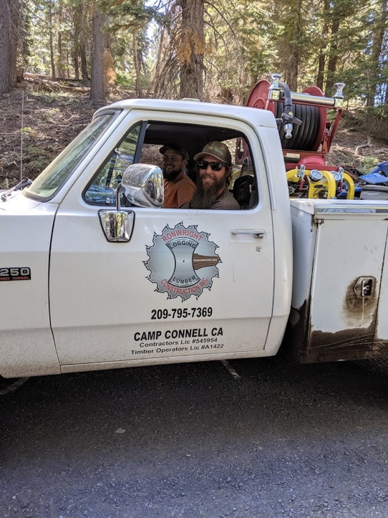
Local contractor Ron Wright of Camp Connell, CA doing the work

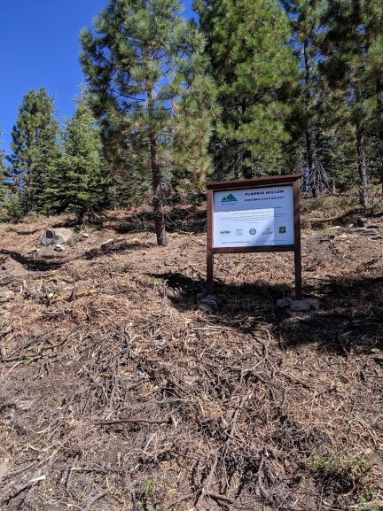
- UMRWA/FS/SNC/CCC/MULE DEER FND/ACCG/CFLRP/PROP 1 Partnership sign in a masticated Pumpkin Hollow plantation

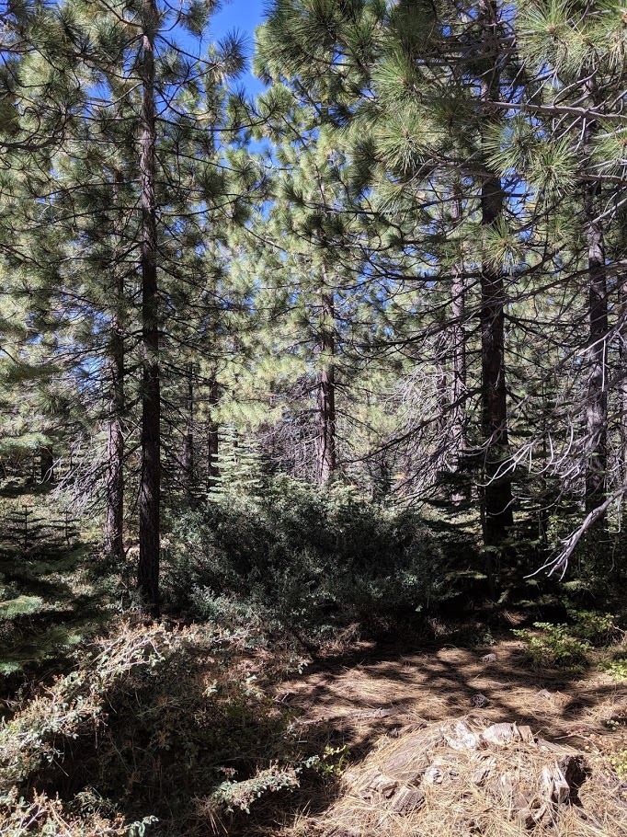

2) Before Mastication of Pumpkin Hollow plantation.
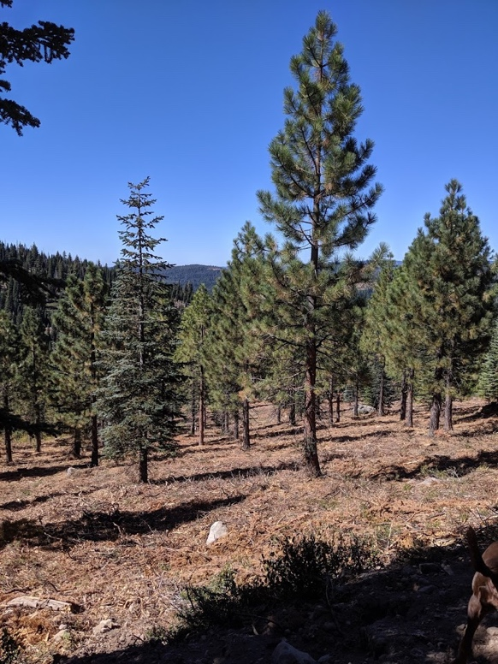
3) After Mastication of Pumpkin Hollow plantation.

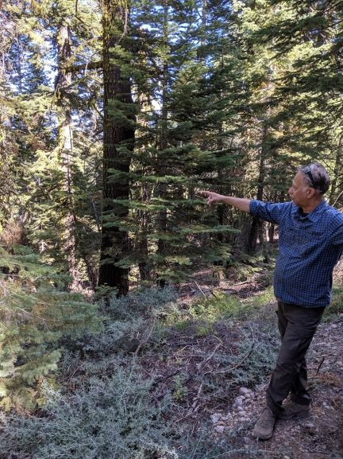
4) John Quidachay, UMRWA Forester, discussing mastication plan in a previously advertised but unsold timber sale unit.
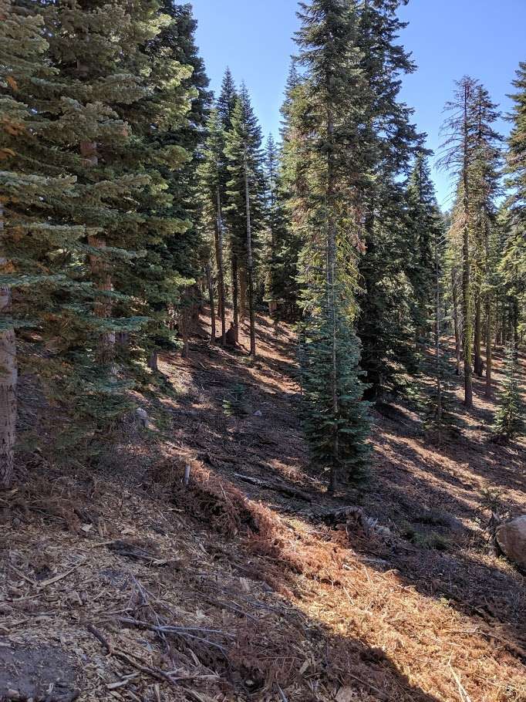
5) Mastication in a stand next to a plantation.
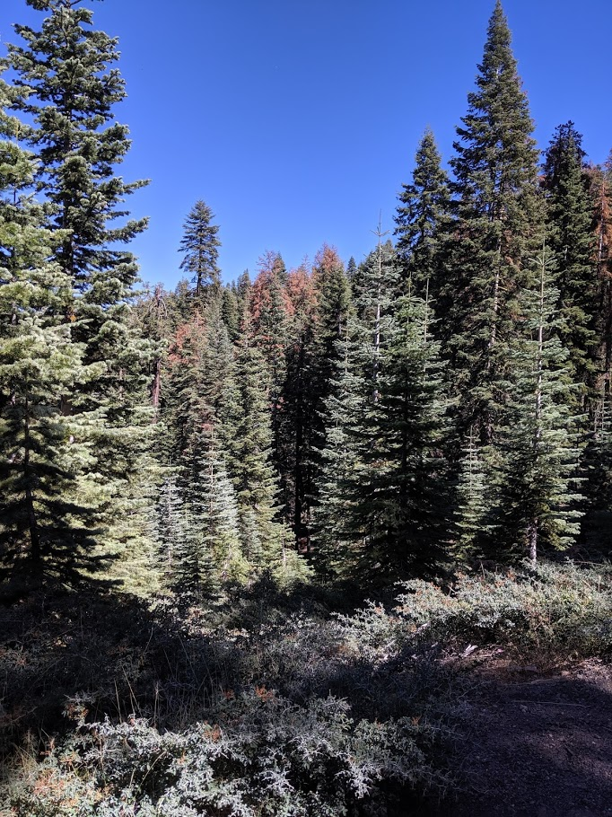6) Additional recent tree mortality in Pumpkin Hollow area.
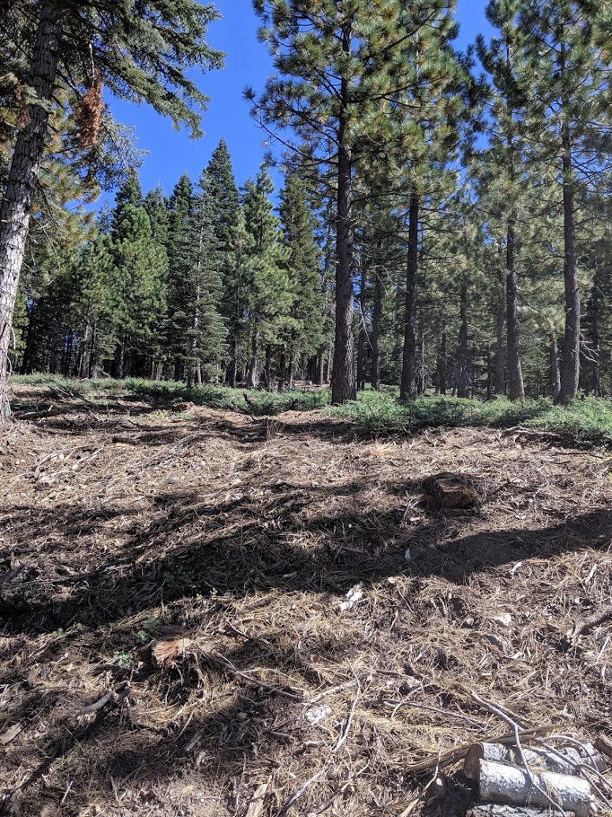
7) One-year old brush in 2018 masticated unit.

