**FPP Phase 1 -- Landscape Current Conditions Assessment, Prioritization Process & Identification of Treatment Locations**

3/18/2022

***Background***

A landscape-scale conditions assessment and prioritization process were conducted to (1) evaluate current ecological, social, and wildfire-related conditions across the Phase 1 proposed project area, and (2) to use this assessment to strategically identify priority areas for proposed mechanical fuels reduction treatments. (Note: This process was not used to prioritize the other fuels reduction treatments proposed in Phase 1 - hand thinning and prescribed burning. Rather, FS specialists identified large, contiguous hand thinning and prescribed burning treatment areas across the proposed project area to maximize planning coverage and maximize treatment location flexibility during implementation. Refer to the last section of this document for more details.) The conditions assessment and prioritization process utilized the GIS products developed by the ACCG’s Strategic Landscape Assessment Work Group (ACCG SLAWG, 2020), and also metrics utilized in other planning efforts (USDA Forest Service, 2021; Wilson et al. 2021).

The intent of this assessment and prioritization process was *not* to perform a comprehensive analysis of the landscape departure from the natural range of variability, or to model future desired conditions, but rather to simply assess current conditions to strategically inform locations for near-term ladder fuels reduction implementation on national forest lands – a more comprehensive landscape analysis is proposed for FPP Phase 2.

***Landscape Conditions Assessment***

For this assessment, four broad categories were used to characterize current conditions across the proposed project landscape (i.e., communities, ecological resilience, wildlife habitat, and fire dynamics). Each of these categories were further divided into sub-categories and various metrics, derived from the ACCG’s analysis (ACCG SLAWG 2020), and other planning efforts (USDA Forest Service, 2021; Wilson et al. 2021). See Table 1 for more details.

The FPP Phase 1 proposed project footprint (101,176 acres) is entirely within USFS lands in the Eldorado National Forest (ENF) Amador Ranger District. The project is *not* proposed on private lands, in designated wilderness areas, or research natural areas, though, 9% (9,311 acres) of the proposed project area falls within proposed wilderness areas and 35% (35,367 acres) is within inventoried roadless areas. The project area is to the north and south of the Highway 88 corridor within three HUC-8 watersheds (Upper Mokelumne - 44% of project area, Upper Consumnes - 28%, and the Upper South Fork American River watershed - 28%), and four counties (Amador Co. - 47% of project area, El Dorado Co. - 40%, Alpine Co. - 13%, and Calaveras Co. - < 1%). Approximately 13% of the proposed project area is within the 2021 Caldor Fire footprint. The project area is proposed outside of several recent planning projects - Scottiago Fuels Reduction Project, Scottiago Forest Health Project, Panther Fuels Reduction Project, and the Power Fire Pre-Commercial Thin (PCT) Project, with the exception of the areas in the PCT that overlap the Power Fire Fuels Study Phase 2 prescribed burn units.

Sixty percent of the proposed project area is within the WUI, including the WUI defense zone (20% of the project area) and threat zone (40%). The proposed project area encompasses one census populated area (Kirkwood) and is within five miles of six other census populated areas (i.e., Grizzly Flats, Buckhorn, Pioneer, Red Corral, West Point, and Markleeville).

The dominant forest types within the proposed project landscape is Sierran mixed conifer (26%), predominately in the lower elevations (< 7,000 ft), and Red fir (29%), predominantly in the higher elevations (> 6,000 ft). The dominant seral stage within the proposed project area is mid-seral closed (51% of the project area), followed by late-seral closed (12%; see Table 1). Based on 2019 LiDAR returns, 56% of the proposed project area has ≥ 50% canopy cover (ENF 2019 LiDAR).

Mature wildlife forest habitat makes up 12% of the proposed project area and immature wildlife forest habitat makes up 47% of the project area (see Table 1 for description of metrics). Additionally, the project area overlaps 76 California spotted owl and Northern goshawk PACs, which equates to approximately 16% of the project area. Fifty percent of the project area is within Sierra Nevada yellow-legged frog critical habitat, 5% within Yosemite toad critical habitat, and 1% within mapped suitable foothill yellow-legged frog habitat.

Fourteen percent of the proposed project area falls within high-risk areas to high-valued resources and assets (HVRAs, ACCG 2020 wildfire risk assessment), and according to a USFS R5 analysis, 11% of the project area has stand densities considered to be at high risk to mortality from drought, insects, disease, and wildfire (USDA 2021(b); see Table 1). According to fire modeling inputs used in the ACCG 2020 wildfire risk assessment, 6% of the total proposed project area falls within areas predicted to have high-intensity wildfire (≥ 8 ft flame lengths with ≥ 75% burn probability- see Table 1 for full description). See Table 1 for the full list of assessment metrics and acreage estimates.

***Identification of Priority Areas for Mechanical Fuels Reduction Treatments***

Several landscape condition metrics were used to identify highest priority areas for proposed mechanical fuels reduction treatments – high-risk WUI, high-risk HVRAs, high-intensity fire, high canopy cover and high stand densities (see Table 1 for full description of metrics). These metrics were assessed within landscape management units (LMUs), which characterizes a given landscape into simple topographical categories – ridges, slopes and canyon/drainage bottom (North et al. 2012). LMUs were further delineated by ENF’s potential operational delineations (PODs, see in Thompson et al. 2016), PACs, and finally, clipped to only include LMUs within the WUI – this is due to the fact that anticipated capacity to accomplish this magnitude of work warrants the need to limit the scope of proposed mechanical fuels reduction areas. Several landscape conditions were identified as areas *not* suitable for mechanical fuels reduction treatments – slopes > 40%, areas > 0.25 miles from a road centerline, and PACs outside of the WUI. (Note: Field reconnaissance of the proposed mechanical fuels reduction treatment areas will need to occur prior to unit layout in order to validate slopes, site accessibility, ladder fuel presence, and any other potential constraints (e.g., stream exclusionary zones, sensitive resources, barren areas) to mechanical operations not identified as part of this assessment. Hand thinning will be utilized wherever mechanical fuels reduction treatments are determined to not be suitable based on findings of field reconnaissance.)

The following University of Washington, Forest Resilience Lab LiDAR-derived products were not available at the time of this document preparation; however, these metrics will be utilized to inform the FPP project once available: percent canopy cover by stratum (1-2m, 2-4m, 4-8m), canopy base height, basal area, TAOs per hectare, and the resilience departure index.

14,527 acres of were identified from this assessment. These mechanical fuels reduction treatment areas were strictly within the WUI and predominately located in the lower elevations (< 7,000 ft, see Figure 1). Approximately 20% of this treatment area overlap prescribed burning treatment areas (see next section). Approximately 30% of the treatment area falls within areas with known Arch survey coverage adequacy (“confirmed”), with the remaining in areas with either unknown Arch survey coverage adequacy or no survey coverage (“conditional”). See Table 2 for a full summary of the proposed treatment activities and acreages.

***Identification of Locations for Hand Thinning, Prescribed Burning, & Aspen Restoration Treatments***

Locations and extent of aspen restoration and prescribed burning treatment activity areas were identified by FS specialists through their own spatial analyses, expertise and knowledge of on-the-ground treatment needs. See Figure 1.

Hand thinning was identified as a district-wide need by FS specialists. Subsequently, hand thinning, as a stand-alone treatment, was identified in all areas within the proposed project area not already identified as another treatment activity type – once locations of mechanical fuels reduction, prescribed burning and aspen restoration treatment areas were delineated, all remaining areas within the project boundary were then identified as hand thinning only treatment areas.

If warranted, the abovementioned prioritization process, coupled with FS specialist input and expertise, may be utilized to identify priority areas for hand thinning and prescribed fire.

**References**

* Amador-Calaveras Consensus Group (ACCG) Strategic Landscape Assessment Work Group (SLAWG) GIS Tools. (2020). Website link: <https://acconsensus.org/work-groups/slawg/>.
* North, M., Boynton, R. M., Stine, P. A., Shipley, K. F., Underwood, E. C., Roth, N. E., Viers, J. H. & Quinn, J. F. (2012). Geographic information system landscape analysis using GTR 220 concepts. In: North, Malcolm, ed. 2012. Managing Sierra Nevada forests. Gen. Tech. Rep. PSW-GTR-237. Albany, CA: US Department of Agriculture, Forest Service, Pacific Southwest Research Station. pp. 107-115, 237, 107-115. Link to The Landscape Management Unit (LMU) Tool, version 2, University of California, Davis, Information Center for the Environment: [https://www.ice.ucdavis.edu//project/landscape_management_unit_lmu_tool](https://www.ice.ucdavis.edu/project/landscape_management_unit_lmu_tool)
* Thompson, M. P., Bowden, P., Brough, A., Scott, J. H., Gilbertson-Day, J., Taylor, A., ... & Haas, J. R. (2016). Application of wildfire risk assessment results to wildfire response planning in the southern Sierra Nevada, California, USA. Forests, 7(3), 64.
* Wilson, Kristen N., and Patricia N. Manley, editors. (2021). Assessment of Current Landscape Conditions: Tahoe-Central Sierra Initiative. An unpublished report of the Tahoe Central Sierra Initiative. <https://sierranevada.ca.gov/wp-content/uploads/sites/326/2021/10/TCSI-AssessmentOfCurrentConditions.pdf>
* USDA Forest Service. (2021). Social and Ecological Resilience Across the Landscape: Draft Environmental Impact Statement. <https://www.fs.usda.gov/project/?project=56500>
* USDA Forest Service. 2021(b). Priority Areas for Treatment, USFS Region 5 Forest Health Protection 2021 Update. <https://www.arcgis.com/home/item.html?id=a95ec71cc0a5475e8e05bfe056bdbd3c>

**Table 1**: Forest Projects Plan (FPP) Phase 1 landscape current condition assessment and prioritization categories, sub-categories and metrics by acres and percent of project area. Metrics in red font are those used for the prioritization process. *LiDAR-derived metrics from the University of Washington, Forest Resilience Lab were not available at the time of this document preparation – these metrics will be used in future FPP phases.



**Table 2**: Summary of Forest Projects Plan (FPP) Phase 1 proposed treatment activities and estimated acreages.

|  |  |  |
| --- | --- | --- |
| **Count** | **Treatment activity** | **Estimated acres** |
| 1 | Mechanical fuels reduction* (confirmed) | 3,852 |
| 2 | Mechanical fuels reduction* (conditional) | 7,661 |
| 3 | Mechanical fuels reduction* (confirmed), prescribed burning | 606 |
| 4 | Mechanical fuels reduction* (conditional), prescribed burning | 2,408 |
| 5 | Hand thinning only | 35,913 |
| 6 | Prescribed burning (optional pre-hand thinning) | 48,421 |
| 7 | Aspen restoration | 1,082 |
| 8 | Aspen restoration, prescribed burning | 1,233 |
| **Total project acreage** | | **101,176** |

**\***Hand thinning will be utilized wherever mechanical fuels reduction treatments are determined to not be suitable based on field reconnaissance.

***Confirmed*** = adequate Arch survey coverage

***Conditional*** = Arch survey coverage adequacy unknown or there is no Arch survey coverage

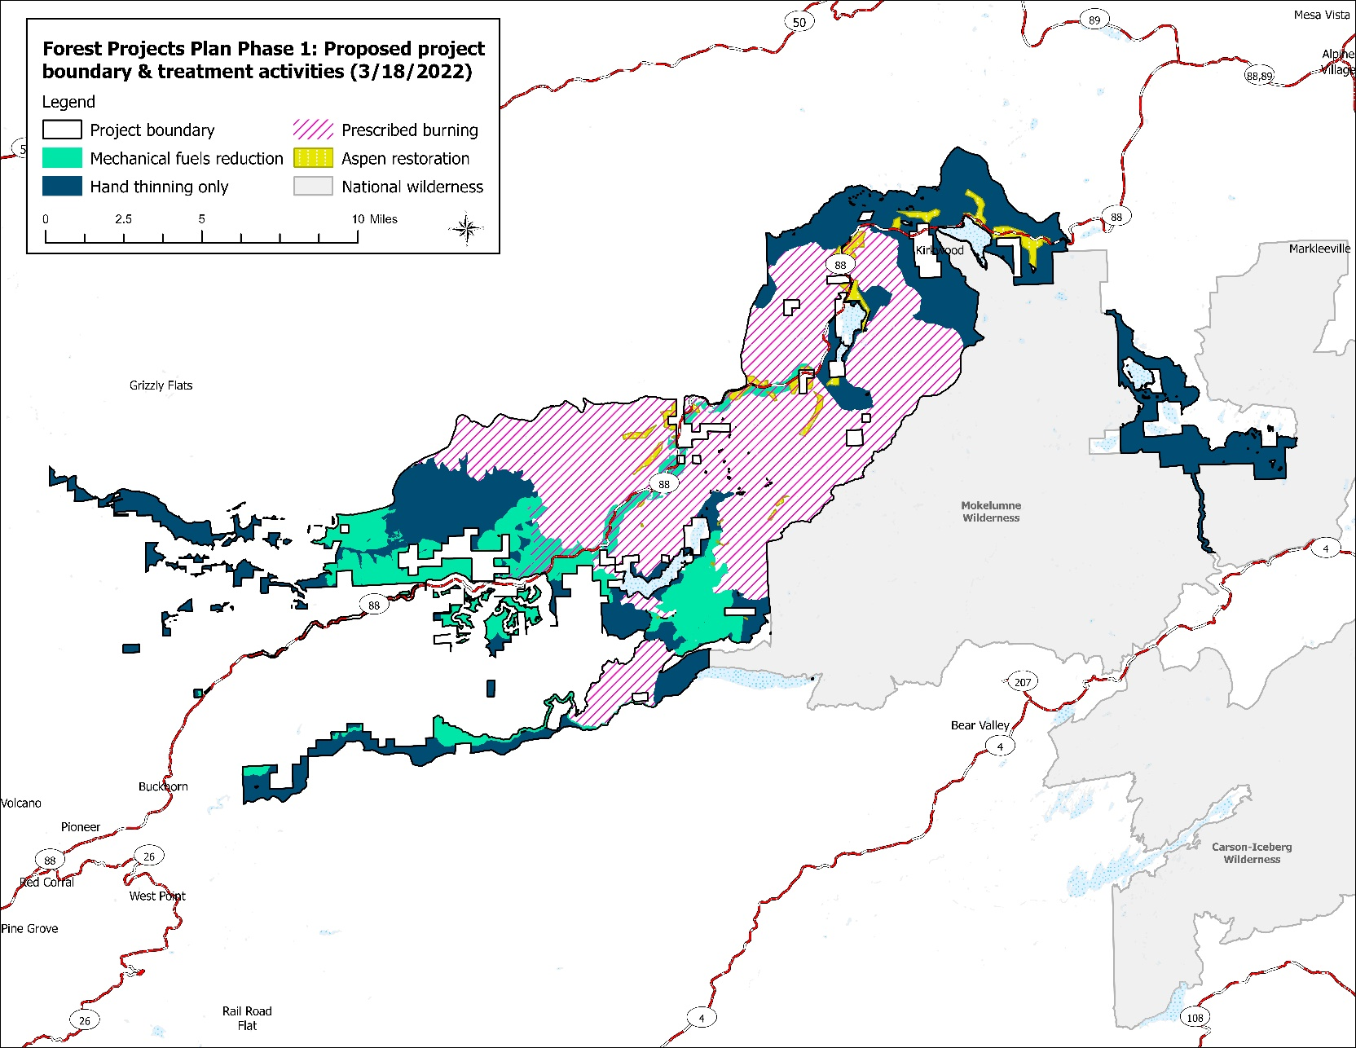

**Figure 1:** Map of Forest Projects Plan (FPP) Phase 1 proposed project boundary and treatment activity areas.