USDA Forest Service

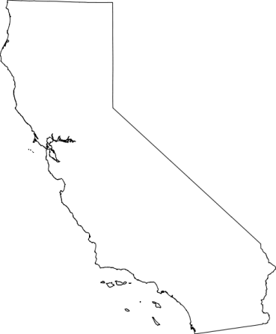
Pacific Southwest Region
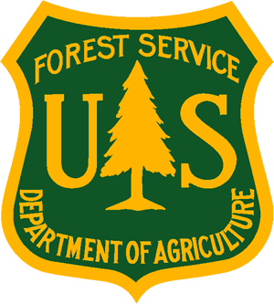
_______________________________
Outreach Notice
Stanislaus National Forest
___________________________________

Temporary Hiring Opportunities

The Stanislaus National Forest is seeking qualified applicants to fill temporary, full-time positions for the 2020 field season. Vacancy announcements will be posted to the USAJobs website (www.usajobs.gov) on March 3, 2020 and will close on March 9, 2020. Please see the list of job opportunities (below), and watch for a follow-up outreach document for specific vacancy announcement information.

We will be filling:
- Fire Suppression Forestry Technician positions (engine, handcrew, helitack)
- General Recreation Forestry Technician positions
- OHV Recreation Technician positions
- Trails positions
- Archaeological Technician positions
- General Laborer positions (road crew)

Target start date is May 11. Government-provided housing may be available in some locations. Applicants must be at least 18 years of age.

Pay Scale Info: All positions are paid an hourly rate and will vary by grade.

Duties: Duties vary depending on the position. A valid driver’s license may be required. Hours usually consists of a 40 hour work week, and some positions may require work on weekends. Work may be physically demanding and employees will work in a variety of weather conditions.

Points of Contact:
Helitack: Matt Muller 209-770-0517
Hotshots: Tim Markin 209-532-3935
Hand crew and engines Mi-Wok and Pinecrest: Shaun Craig – 209-432-3097
Hand crew and engines Groveland: Pat Laeng 209-962-7825 x519
Hand crew and engines Hathaway Pines: Scott Cones 209-813-6030

Archaeology: Kathy Strain 209-288-6302
Laborer (road crew): Greg Cox 209-288-6332
Recreation/OHV: Mi-Wok and Pinecrest – Chuck James 209-768-1210
Hathaway Pines – Casey Jardine 209-813-6011; Groveland – Trent Brown 209-962-7825

How to apply: Applicants must access the vacancy announcements through USAJobs – http://usajobs.gov/ . Applicants must establish a profile and build or upload a resume in the USAJobs site. For assistance in navigating USAJobs, reference the following site: https://help.usajobs.gov/index.php/Main_Page. Once you have established your profile and resume, that data will be used in all future applications without the need to re-enter. It is recommended that applicants complete the on-line resume and attach a document/resume with past supervisors’ contact information to expedite reference checks. Applicants are required to recertify their application every 60 days. Applicants will need to attach any required supporting documents (transcripts, DD-214 to claim Veterans Preference, IQCS master record, etc.) for each job applied to – they are not automatically added to your application from your profile. If your application documents are too large (more than 3MB) to upload into USAJobs, you can convert your documents into a Portable Document Format (PDF) file to reduce the file size. Please read the entire vacancy announcement carefully and follow all directions. Applicants respond to a series of questions to determine core eligibility and minimum qualifications. Your responses will be evaluated along with experience described in your resume. Any level of knowledge, skills, abilities and competencies claimed in the assessment questionnaire must be supported and documented in your resume and attachments.

Veterans are encouraged to apply on the USAJobs web site where Veterans Preference is applied to eligible applicants. Veterans MUST submit a DD-214 if claiming Veteran’s Preference.

Please Note: Incumbents for the fire suppression positions must be able to pass the Work Capacity Test.

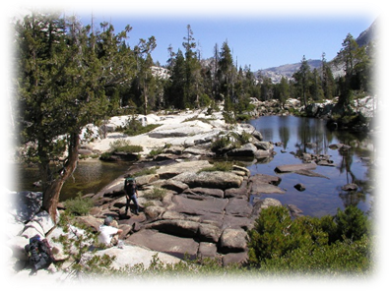
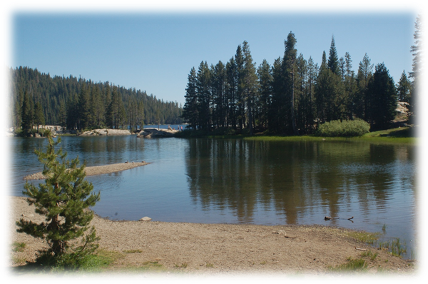

ABOUT THE FOREST:

The Stanislaus National Forest (http://www.fs.fed.us/r5/stanislaus/) totals approximately 1,090,000 acres within its boundaries. The Forest is bordered on the south by the Merced River and the Sierra National Forest. The Mokelumne River and the Eldorado National Forest comprise the northern border (map 1). Yosemite National Park and the Toiyabe National Forest make up the eastern boundaries. The Forest Supervisor's Office is located in Sonora, California, the county seat for Tuolumne County. The four Ranger Districts, Mi-Wok, Calaveras, Summit, and Groveland, are within 45 minutes of the Supervisor's Office.

The Stanislaus National Forest contains all of the Emigrant Wilderness and portions of the Carson-Iceberg and Mokelumne Wildernesses. The pristine and dramatic scenery offers a backdrop for outstanding hiking, backpacking, and horseback riding experiences. As home to a multitude of lakes and reservoirs, as well as 811 miles of rivers and streams and 18 fish species, the Stanislaus offers a wide variety of water recreation opportunities. The Tuolumne and the Stanislaus Rivers are popular destinations, as are Pinecrest and Cherry Lakes. Winter recreational opportunities are numerous and the area abounds with local history from the gold rush era.

WEBSITES WITH LOCAL COMMUNITY INFORMATION
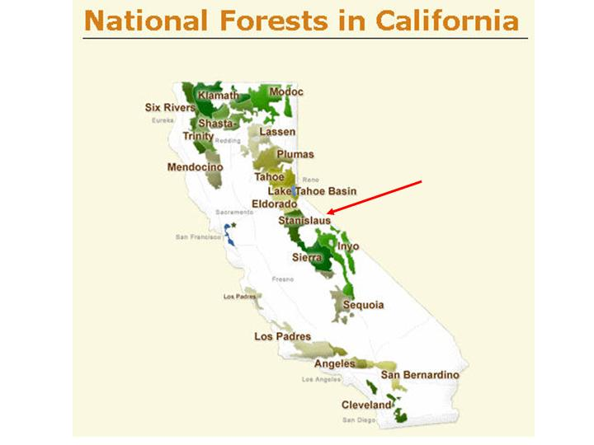
http://www.city-data.com/city/Sonora-California.html

http://tcrealtors.org/

https://www.mymotherlode.com/

The USDA Forest Service is an equal opportunity provider and employer.

