Prepared by: Helen Loffland

Jaunuary 8, 2021

Objective: Review existing ACCG/CLFR ecological effectivness monitoring questions and identify needs

During fall of 2020 the ACCG monitoring group identified a need to review existing monitoring priorities as developed through the CLFR process. To facilitate this process we are summarizing below the guiding goals and objectives of the Cornerstorne CLFR and reviewing the 41 monitoring questions that were identified in 2016/2017, with an emphasis on the ecological effectiveness monitoring questions. In addition we are providing context tthat describes how and when to re-asses those questions based on current situation and changing needs.

**A. BACKGROUND - CLFR GOALS & OBJECTIVES**

In Tables 1 and 2 below the goals and objectives originally identified for the Cornerstone CLFR are listed. Those in green are objectives that loosely fall within the ecological effectiveness monitoring program. These fall into the basic catagories of:

* Fire regime and departure
* Old forest stand structure and departure
* Sensitive species habitat
* Water quality and function
* Invasive species (aquatic and terrestrial)
* Roads

These goals and objectives were used to develop the monitoring questions identified in the next section and are useful for assessing what has or has not changed within the Cornerstone landscape since the original document was prepared and whether our questions still meet these needs of these objectives and goals. Similarly, they provide a framework for assessing our work to date and determining if new questions are needed or if additional attention needs to be applied to lower tier questions.

Table 1. CLFR Cornerstone Goals

| **Goal Number** | **Goal** |
| --- | --- |
| 1 | Reduce the risk of uncharacteristic wildfire, including through the use of fire for ecological restoration and maintenance and reestablishing natural fire regimes, where appropriate (Legislation: Sec. 4003 (c) (3) (A)). |
| 2 | Fully maintains, or contributes toward the restoration of, the structure and composition of old-growth conditions characteristic of the forest type, taking into account the contribution of the stand to landscape fire adaptation and watershed health and retaining the large trees contributing to old growth structure (Legislation: Sec. 4003 (c) (1)(D)). |
| 3 | Improve fish and wildlife habitat, including for endangered, threatened, and sensitive species (Legislation: Sec. 4003 (c) (3)(B)). |
| 4 | Maintain or improve water quality and watershed function (Legislation: Sec. 4003 (c) (3)(C)). |
| 5 | Prevent, remediate, or control invasions of exotic species (Legislation: Sec. 4003 (c) (3)(D)). |
| 6 | Maintain, decommission, and rehabilitate roads and trails (Legislation: Sec. 4003 (c) (3)(E)). |
| 7 | Facilitates the reduction of wildfire management costs, including through reestablishing natural fire regimes and reducing the risk of uncharacteristic wildfire (Legislation: Sec. 4001 (3)). |
| 8 | Use woody biomass and small-diameter trees produced from projects implementing the strategy (Legislation: Sec. 4003 (c) (3)(F)). |
| 9 | Benefit local economies by providing local employment or training opportunities through contracts, grants, or agreements for restoration planning, design, implementation, or monitoring (Legislation: Sec. 4003 (c) (7)). |
| 10 | A collaborative forest landscape restoration proposal shall be developed and implemented through a collaborative process that includes multiple interested persons representing diverse interests and is transparent and nonexclusive (Legislation: Sec. 4003(c) (2) (A)). |

Table 2. CLFR Cornerstone Objectives

| **CFLR Goal** | **Objective Number** | **Objective** |
| --- | --- | --- |
| 1 | 1.1 | Transition toward a more characteristic fire regime by restoring a landscape that is more consistent with a frequent fire regime. |
| 1 | 1.2 | Increase the pace and scale of prescribed or natural fire for multiple resource benefits. |
| 1 | 1.3 | Transition toward a resilient and diverse forest species composition and structure following large scale, stand replacing disturbance events. |
| 2 | 2.1 | Create resilient forest communities by developing a mosaic of forest density, size and age classes. |
| 3 | 3.1 | Maintain and enhance forest structure and understory plant communities, function and ecological processes to promote aquatic and terrestrial health, biological diversity, and habitat for a variety of native species, especially species at risk. |
| 3 | 3.2 | Maintain and enhance the frequency of large trees, increase structural diversity of vegetation, and improve the continuity and distribution of old forests across the landscape. |
| 4 | 4.1 | Maintain and enhance watershed functions of Special Aquatic Features. |
| 4 | 4.2 | Maintain or improve soil and landscape attributes characteristic of features that reduce the risk of sedimentation or other water quality stressors. |
| 5 | 5.1 | Prevent, remediate, or control invasions of invasive/noxious species. |
| 6 | 6.1 | Maintain, decommission, and rehabilitate roads to standard. |
| 6 | 6.2 | Construct, maintain, decommission, and rehabilitate trails to standard. |
| 7 | 7.1 | Reduce suppression costs by reducing the risk of uncharacteristic fire, threats to lives and property, and by encouraging the restoration of lands outside the CFLRP planning area to reduce the risk of wildfire spread. |
| 8 | 8.1 | Maintain or enhance infrastructure to utilize woody biomass such as: energy and heating, soil amendments, compost, landscaping chips, firewood, animal bedding, sawlogs, designer fencing, agricultural and architectural posts and poles, furniture wood, wood |
| 9 | 9.1 | Create, maintain, and enhance sustainable local economic activity based on restoration treatment work through project design and implementation that is consistent with the triple-bottom-line emphasis. |
| 9 | 9.2 | Create sustainable local, restoration stewardship-related economic activity and local jobs based on restoration treatment work and development of diverse woody biomass and small-diameter tree by-products and local markets, consistent with the triple-botto |
| 9 | 9.3 | Maintain and enhance local contractor completeness and success in obtaining contracts and employment. |
| 9 | 9.4 | Maintain and enhance forest employment of local residents to forge multi-generational relationships with the forest landscape. |
| 9 | 9.5 | Enhance youth forest resource education through activities, interaction, and volunteerism. |
| 9 | 9.6 | Maintain, enhance, and protect native cultural and historic sites and practices. |
| 10 | 10.1 | Collaboratively involve the diverse ACCG interests in project planning, implementation, monitoring and adaptive management. |
| 10 | 10.2 | Demonstrate the benefits of collaborative resource management in the region. |

Table 3. National Level CLFR monitoring guidance. Table reproduced from Cleland et al 2017.

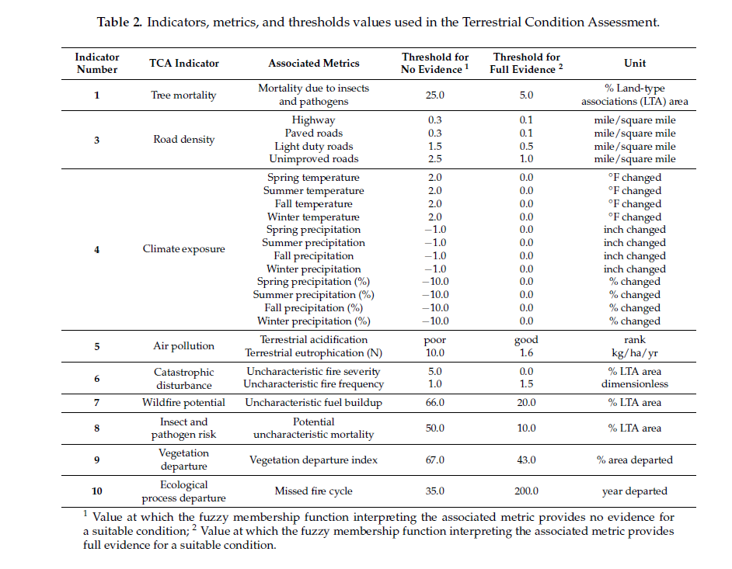

**B. Existing Monitoring Questions, Focus and Considerations**

After the goals and objectives were developed the monitoring workgroup narrowed the spectrum of monitoring questions to 41 (Table 4). The workgroup recognized the need to prioritize limited monitoring resources; therefore, the 30 ecological effectiveness monitoring questions were prioritized into priority tiers resulting in 15 questions in the top two priorities (Table 5, Table 6).

Tier 1: Core questions to address. Monitoring would be funded by Cornerstone dollars when feasible.

Tier 2: Core questions to address. Monitoring would be funded by other means (existing programs, grants, volunteers, etc…). Funding or responsible monitoring parties were identified for these questions.

#### Table 4. Number of monitoring questions by monitoring type.

|  |  |
| --- | --- |
| Monitoring Perspective | # of Monitoring Questions |
| Ecological Effectiveness | 30 |
| Implementation | 1 |
| Collaboration | 4 |
| Social/Economic | 6 |
| Total | 41 |

Tier 3: Secondary monitoring questions to address once funding is identified.

Tier 4: Secondary questions that would provide valuable information, but are likely not needed for adaptive management and would require expensive data collection methodologies or rely on a large scale disturbance prior to monitoring.

#### Table 5. Ecological effectiveness questions by priority tier.

|  |  |  |  |  |
| --- | --- | --- | --- | --- |
|  | Number of Questions | | | |
| *Discipline* | ***Tier 1*** | ***Tier 2*** | ***Tier 3*** | ***Tier 4*** |
| Aquatic Wildlife | 1 |  | 2 |  |
| Conifer Forested Communities | 2 | 1 | 1 |  |
| Cultural Resource | 1 | 1 | 2 | 1 |
| Fire and Fuels | 2 |  |  | 1 |
| Hardwoods | 1 |  |  |  |
| Noxious/Invasive Plants | 1 |  | 1 |  |
| Riparian and Special Aquatic Features | 1 |  |  | 1 |
| Sensitive Plants | 1 |  | 1 |  |
| Soils |  | 1 | 1 |  |
| Terrestrial Wildlife | 1 |  | 1 |  |
| Watershed | 1 |  | 3 |  |
| Total | 12 | 3 | 12 | 3 |

Table 6. Ecological effectiveness questions. Questions higlighted in gray do not currently have projects/monitoring ongoing or planned. All other questions have at least one project underway or planned.

| Tier | Objective | Community Type | Question | Indicators | Number |
| --- | --- | --- | --- | --- | --- |
| 1 | 3.1, 4.1 | Aquatic Wildlife | Did the quality/quantity of habitat for Threatened and Endangered and Forest Service Sensitive and other desired species change? | Water temperature, Canopy cover/closure, Fine sediment, Pool depths, Large woody debris, Stream bank disturbance, Connectivity between suitable habitats | 2 |
| 1 | 1.1, 1.3, 3.1 | Conifer Forest | How did treatments affect basal area and canopy cover in canyons and slopes with north-facing aspects compared to ridges and slopes with south-facing aspects? | Basal area, Stratified canopy cover | 5 |
| 1 | 2.1 | Conifer Forest | How did treatments affect the tree density and species composition in all size classes? | Basal area, Trees per acre/density by size class and species | 6 |
| 1 | 9.4 | Cultural | How did focus treatments improve cultural resource conditions? | Condition of cultural resources | 8 |
| 1 | 1.1, 1.2, 1.3 | Fire and Fuels | How did fuel treatments meet the project goals and objectives? | Acres Treated, Fuel loading, height to live crown, Mortality, Canopy bulk density | 13 |
| 1 | 1.1, 1.3, 7.1 | Fire and Fuels | Will fuel treatments result in future fire behavior consistent with the natural range of variability (size, frequency, pattern, severity)? | Modeled fire behavior, Observed actual fire behavior, Fire size | 14 |
| 1 | 1.1, 3.1 | Hardwoods | Did project activities improve growing conditions for hardwoods? | Density and range of hardwoods, Crown position/dominant trees | 16 |
| 1 | 5.1 | Invasive Species | Have target invasive plant populations been reduced? | Percent Cover, Abundance, Extent | 17 |
| 1 | 3.1, 4.1, 4.2 | Riparian | To what degree did the project move Special Aquatic Features or riparian corridors to desired conditions and maintain/improve hydrologic and ecosystem function? | Stream bank disturbance, Percent Cover, Extent, Flood plain connectivity, Water table, Ground cover | 19 |
| 1 | 3.1 | Sensitive Plants | Did restoration treatments or other disturbance result in a change in habitat suitability for sensitive plant species? | Amount of suitable habitat | 21 |
| 1 | 3.1, 3.2 | Terrestrial Wildlife | Did forest treatments impact habitat of mature Forest Sensitive species across projects? | Canopy cover/closure, Large woody debris, Habitat quality, Habitat heterogenity, Nesting/roosting/den sites, Species occupancy | 25 |
| 1 | 4.1, 6.1 | Watershed | To what extent are best management practices effective in protecting soil and water resources for Cornerstone management activities? | Regional and national BMP evaluations | 27 |
| 2 | 1.3, 2.1 | Conifer Forest | Did plantation treatments encourage a structure consistent with a more resilient forest stand (variable spacing designed to maintain the individual, clump and opening pattern, a desired future tree density consistent with historic forest conditions and mo | Condition of cultural resources | 4 |
| 2 | 9.4 | Cultural | Did restoration and conservation actions protect cultural resources from disturbance? | Ground cover, Soil erosion, Soil compaction | 9 |
| 2 | 2.1, 3.1, 4.2 | Soils | Are levels of detrimental soil disturbance and erosion increasing or decreasing with project treatments? | Abundance, Distribution/Extent | 23 |
| 3 | 3.1, 5.1 | Aquatic Wildlife | Did the status of undesired species change? | Abundance, Distribution/Extent | 1 |
| 3 | 3.1 | Aquatic Wildlife | Did the local abundance/distribution of TE and FS Sensitive and other desired species change? | Abundance, Distribution/Extent | 3 |
| 3 | 2.1, 3.1 | Conifer Forest | Were treatments successful in promoting diverse plant forms or species of plants? | Understory plant life forms | 7 |
| 3 | 9.4 | Cultural | How did project actions protect, promote, and make accessible species with ethnobotanical importance? | Abundance, Vigor, Sustainability, Accessibility | 10 |
| 3 | 9.4 | Cultural | Did vegetation treatments result in increased connectivity between cultural landscapes? | Landscape connectivity | 11 |
| 3 | 5.1 | Invasive Species | Are target invasive plants spreading throughout the Cornerstone area? | Number of | 18 |
| 3 | 3.1 | Sensitive Plants | Did restoration treatments or other disturbance result in a change in population size of sensitive plant species? | Abundance, Distribution/Extent | 22 |
| 3 | 2.1, 4.2 | Soils | Did the project treatments impact total carbon storage in soil? | Soil profile organic carbon, Surface organic carbon | 24 |
| 3 | 2.1, 3.1, 3.2 | Terrestrial Wildlife | How many snags per acre by size classes were removed/retained during treatments? | Number of snags by size class, Water quality | 26 |
| 3 | 4.2, 6.1 | Watershed | Are watershed Conditions improving in the cornerstone footprint, as evaluated through the Watershed Condition Ratings, particularly in priority watersheds? | Water quality, Aquatic habitat conditions, Channel geomorphic condition, Degree of watershed disturbance, Forest health | 28 |
| 3 | 4.1 | Watershed | Have treatments been successful in restoring: floodplain connectivity, channel/meadow/riparian habitat, improving water quality and quantity, and/or changed timing of base flows? | Condition of streams and meadows, Groundwater, Base flow | 29 |
| 3 | 3.1, 4.1, 4.2, 6.1, 6.2 | Watershed | Have impacts to water quality or aquatic habitat from roads and trails been reduced? | Hydrologically connected segments, Near stream road density, Road-stream crossing function - AOP, Miles of road/trail improvements, Miles aquatic habitat made accessible - AOP, Stream crossing density, Sediment samples | 30 |
| 4 | 9.4 | Cultural | Did wildfire result in impacts to culturally sensitive areas? | Percent of cultural sites impacted | 12 |
| 4 | 1.1, 4.2 | Fire and Fuels | Were treatments effective in reducing smoke emissions over the project/landscape area (modeled wildfire)? | PM10 and 2.5 | 15 |
| 4 | 3.1, 4.2 | Riparian | Are pesticide treatments affecting aquatic resources? | Pesticide concentrations | 20 |

## **C. Reviewing Existing Ecological Effectiveness Questions**

When the monitoring group initially developed the previous questions we acknowledged in the monitoring plan that additional prioritization of ecological effectiveness questions may be necessary to adapt to changing or new priorities. For example, controversial issues or value statements identified by ACCG could be used to prioritize limited resources.

Controversial issues identified at the time of development included:

* Herbicide applications,
* Red fir health and management,
* Plantation management and heterogeneity,
* Harvest of large trees,
* Spotted owl habitat management,
* Roads,
* Riparian treatments.

Potential additional criteria to prioritize monitoring effort includes:

* Monitoring questions or indicators for valued resource (sensitive species/habitat/cultural);
* Questions that fill information gaps;
* Areas without outside factors that may influence the monitoring results;
* Data collection method that may answer multiple monitoring questions;
* Monitoring costs, qualitative methods that could replace quantitative methods;

The objective of reviewing the monitoring questions at this time is to determine if there are new or changed conditions within the Cornerstone or ACCG planning area that warrant monitoring attention, and to determine if any of the original questions should be updated or their relative priority changed. Similarly we may wish to assess why some questions haven’t been addressed to date and if targeted projects should be proposed to the larger group to resolve this situation.

**Brainstorming questions/ideas for discussion**

In an effort to start this brainstorming effort, some ideas that have come up in recent meetings and conversations, or in Helen’s brain include:

* Use ICO protocol concept to assess existing SPOW and NOGO PACs on the Amador and Calaveras R.D. for use in identifying habitat restoration and fire risk abatement needs within PACS and for designing prescriptions for future planting/thinning projects throughout the planning area to achieve conditions selected by sensitive species locally.
* Determine if a more formal invasive plant monitoring protocol needs to be designed or implemented based on anecdotal observations by various surveyors within the power fire.
* Do current questions, projects, and monitoring adequately address bark beetle outbreaks and resultant changes to stand composition?
* Does the ACCG and CLFR areas have stands of Whitebark Pine? Does the potential listing of the species drive a need to monitor those stands for bark beetle and white pine blister rust?
* Challenges of monitoring wildlife response to herbicide treatment because of difficulty in tracking what herbicide contractor sprays in real time, and because of extreme variability in other hand and machine treatments that occur before and after herbicide. Can we answer herbicide questions without a controlled experiment? What can we confidently say with available data within FACTS database?
* Is there a need for targeted monitoring of willow and other woody riparian and herbaceous veg at meadow restoration projects.
* Determining and monitoring aspen stand health and identifying what healthy mature and young aspen stands should look like, and what appropriate browse and disturbance regimes should be (possibly by developing a larger hwy 88 corridor Aspen release project (fire & commercial conifer harvest?) spearheaded by monitoring group and Jesse/Chuck on Amador RD. This could be expanded to included parts of Calaveras district if desired).