FPP Update

Phase 1 Update:

- Map

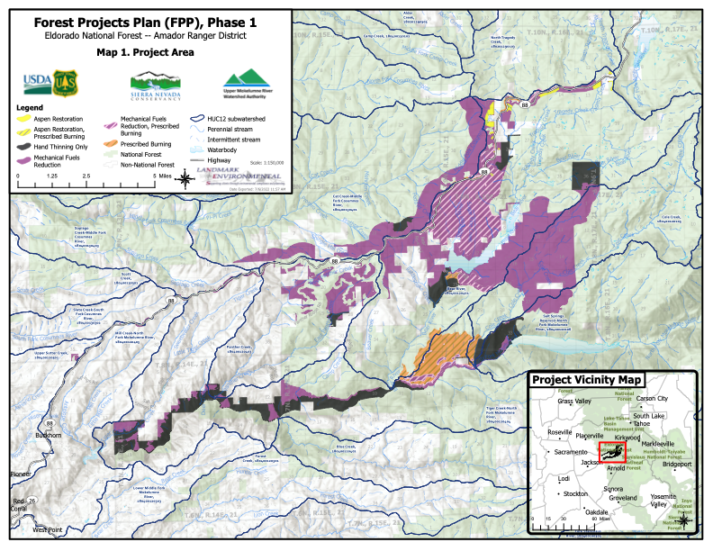

- Project remains at about 25,000 acres. Mostly ladder fuel work with primary method is mechanical mastication.

Treatment activity | GIS Acreage
Mechanical Fuels Reduction | 14,537
Mechanical Fuels Reduction, Prescribed Burning | 4,715
Prescribed Burning | 1,888
Aspen Restoration | 172
Aspen Restoration, Prescribed Burning | 22
Hand Thinning Only | 4,337
Total acreage | 25,671
--

- Obtained resources to fund archeological surveys for all areas that were identified as potentially needing surveys for possible mechanical fuels work. About 4,000 acres being surveyed. Work in progress now.

- Planning Phase is fully funded and should be complete this year.

- Detailed presentation at September ACCG meeting. Letter of support from ACCG expected prior to ENF decision.

- UMRWA recently awarded Cal Fire grant which will fund implementation of about 12% of Phase 1. Pre-application to SNC for next 10-12% to be submitted at end of month.

Phase 2 Update:

- Meeting held this past month with ENF Supervisor to confirm approach and plan for getting PM and Env. Planning assistance.

- Discussion held this past month with others engaged in similar efforts.

- Reviewed preliminary physical scope in Calaveras and Amador Ranger Districts. Potentially 220,000 acres.

- RFP issued beginning of the Month. Proposals due by August 1. Selection by mid-August. Key deliverables of initial scope of work:
  - Prepare Draft Work plan (description, goals, objectives, major tasks to achieve NEPA/CEQA compliance, preliminary schedule, and budget)
  - Outreach and Communication Plan
  - Fundraising Strategy
  - Meeting Organization and Facilitation (kick off TAC and Stakeholder group)

- UMRWA is looking to ACCG as a partner is Phase 2 and it should be seen as an ACCG sponsored effort. This will be critical to obtaining funding.

