# Background

During the 2021-2022 Fiscal Year, CalFire awarded over $98 million in Forest Health. During the previous fiscal year, over $72 million in Forest Health Grants were awarded. During 2022, The Sierra Nevada Conservancy awarded $23 million in wildfire recovery and forest resilience projects. The need for the treatments that these grants fund is clear—from site preparation to reforestation, and fuel breaks and fuels reduction projects, each acre of ground is being restored and moved back toward a healthy and resilient ecosystem.

Fuels reduction costs can vary wildly, based on project type, timeline, complexity, and region.. This Market Analysis will serve to help overcome inneficiencies in the pricing of fuels reduction treatments. We will collect publicly accessible bids for fuels reduction projects, including mastication, hand piling, and hazard tree removal. Per/acre prices will be stratified by region, treatment type, and time.

This project will be qualitative, but will include quantitative components. Quantitative analysis will be limited not by the lack of data, but by the heterogeneity of it. Two fuels reduction treatments may have wildly different scopes of work, even if they are both mastication treatments that occur in the same region in the same year, resulting in disparate implementation costs. Analysis of variance and other quantitative approaches are limited by the qualitative components that affect and drive project costs. As such, quantitative analysis will occur, but will be used to support qualitative analysis, including regional summaries and thematically organized bid prices.

# Specific Tasks

**Overview:** This project will have three phases: the data collection phase; the information synthesis phase; and the knowledge dissemination phase. Each of these phases builds upon the last, and will result in a robust Market Analysis of forest health treatments. This project is scalable in size, and is able to occur for a single region (i.e the Sierra Nevada) or for the state. This project is proposed to occur in all 24 counties in the Sierra Nevada Region, with each county creating its own local industry.

**Data Collection:** Data collection will occur via email and phone call. Every Resource Conservation District (RCD), Firesafe Council, County Administration Office, Watershed Authority, and implementation partner in each region will be contacted in an attempt to collect census data of fuels reduction treatment costs. Unlike timber bids, which are sealed bids, the majority of forest health treatments are open bids, resulting in publicly accessible information. As bids and awards for treatments are collected, information will be extracted and stored in a database. This database will include the date, the project name, treatment type, contractor, bid prices, and award prices for every solicitation that can be gathered.

Data collection will be limited by a pre-determined number of parameters—namely, the region or regions for which this Market Analysis will occur, the type or types of treatments this Market Analysis will focus on, and the timeline that this Market Analysis shall occur over. Additionally, access to information may also limit the efficacy of the data collection phase. Proprietary information and sealed bid procedures could affect the extent to which data can be collected, as could responses from organizations.

**Information Synthesis:** After data is collected, information synthesis can occur. Information synthesis will take each raw data point (price/acre) for a project and associated metadata and extract thematic trends. Trends will be identified on a local (county) and regional scale, to allow for specific and general conclusions to be drawn. Trends may include competitive differentiation by project, region, and/or managing organization. For example, if Region A has two organizations advertising solicitations, and one of them solicits bids from a larger number of operators than the other, they may have a competitive advantage in their bid advertisement. Region B, being spatially separated, may find that they receive fewer or more bids than Region A due to proximity to urban hubs and associated labor pools, as well as geographic factors (a region that is dominated by steep slopes would commonly result in higher treatment costs).

Quantitative outcomes will include bid and award prices for treatment costs over time, as well as statistical summaries (minimum, median, maximum bid prices, number of bids, standard deviation).

Trends and quantitative factors will ultimately be used to create a Market Analysis, summarizing these variables and beginning to explain them through the Porter’s Five Forces framework for analyzing the competitive environment of an Industry. Each County will be considered its own market, supporting an independent industry. Porter’s Five Forces looks at 1), the competition in an industry; 2) the Potential of new entrants into the industry; 3) the power of suppliers; 4) the power of customers; and 5) the threat of substitute products. This Market Analysis will have quantitative similarities to the reports produced by Timber Mart South, an organization that provides market data and analysis to the softwood timber markets in the southeastern United States, but will be dominantly defined by its qualitative summaries, organized by locality and region.

Information synthesis will be limited by the data collected in the first phase of this project. Market Analyses are definitionally retrospective and limited by the data that can be collected.

**Knowledge Dissemination:** The Market Analysis will be included in the grant deliverables to CalFire. Additionally, the Analysis will be provided to every organization that is contacted during the data collection phase of this project. By providing this Analysis to industry participants, competition and transparent bidding may be increased, allowing organizations to effectively budget for implementation costs, solicit more bids for projects, and increase the cost effectiveness of forest health treatments.

# Example Market Analysis

The Following Market Analysis was conducted in Tuolumne County as a proof-of-concept for the CalFire Business and Workforce Development grant application. This example exclusively focuses on fuels reduction and fuel break projects and does not address hazard tree removal, reforestation, or herbicide treatments.

## Data Collection

The County of Tuolumne, the Tuolumne County Resource Conservation District, and the Tuolumne FireSafe Council were contacted about forest health projects and treatments. As of this example analysis, the County of Tuolumne provided 84 bids for 14 separate fuels reduction and fuel break projects since 2019; the Tuolumne County RCD had no information, and the Tuolumne FireSafe Council is seeing how many files from the last 20 years they can reasonably provide.

## Information Synthesis

A brief excerpt of quantitative analysis of Tuolumne County’s Fuels Reduction Bids and awards over time reveals the following trends:

* At a 95% level of confidence, Tuolumne County has, on average, between 4 and 7 bidders on fuels reduction projects. There has been an upward trend (y=0.0034x+3.7124) in number of bidders since Tuolumne County began issuing projects in 2019 (r2=0.265). Tuolumne County has had as few as one bidder (the first project issued by the County) and as many as 10 bidders.
* At a 95% level of confidence, Tuolumne County has, on average, paid between $1,479 and $1,996 per acre for fuels reduction projects. There has been no statistically significant trend in treatment costs over time (y=0.2021x+1,586.8) since Tuolumne County began issuing projects in 2019 (r2=0.019). Tuolumne County has awarded fuels reduction contracts for as low as $819 per acre and as high as $2,380 per acre.

The bid prices over time, as well as award prices and quantity of bidders, can be seen in Chart 1. While the information in Chart 1 tells a powerful and compelling story about the Fuels Reduction Market in Tuolumne County, it is by no means able to capture the full complexity and intricacies that affect the bid prices. Trendline analysis based simply on bid prices over time is reductive and ignores many dependent and independent variables that affect bid prices. Minimum wage increases (foreign and domestic) have driven up the costs of hand work. Fuel prices spiked during the COVID-19 Pandemic. And beyond all of these factors, each scope of work for fuels reduction treatment is different. From the slope requirements that machinery can operate on to fuels reduction requirements and limited operating periods, a myriad of factors influence the bid prices on individual treatments. As such, all statistical and quantitative analysis is limited in use. As such, a qualitative and explanatory Market Analysis is appropriate, and a Porter’s Five Forces is well suited to provide analysis of the fuels reduction industry in Tuolumne County overall.

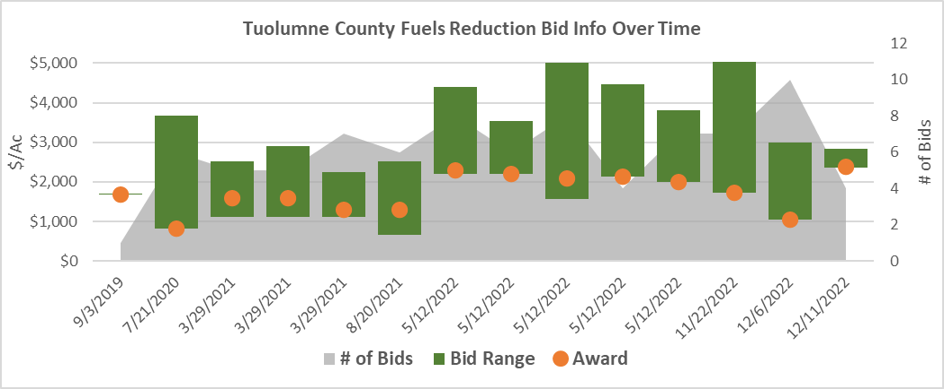

Figure 1: Bid Info Over Time

### Qualitative Analysis of the Fuels Reduction Industry in Tuolumne County using a Porter’s Five Forces model:

**Competition in the Industry:** Tuolumne County has a robust and established fuels reduction industry. With bidders local to Tuolumne County, as well as from neighboring counties in the state and three separate bidders from outside states, competition is high. Tuolumne County employs a “best value” approach to its contract awarding process, assessing both price and approach to determine value. This high level of competition allows Tuolumne County to seek out bids with a high-quality approach *and* a low price. Tuolumne County should continue to support competition in the fuels reduction industry to in order to maximize efficiency in fuels reduction projects.

**Potential of new entrants into the industry:** Given the high level of competition in the fuels reduction industry in Tuolumne County, as well as large projects (often 1,000+ acres in size), as well as the financial barriers to entry for new fuels reduction companies (with each piece of equipment costing in the hundreds of thousands of dollars), the opportunity for *new* entrants to establish themselves in the industry is low. *Existing* companies, either locally or from neighboring counties and states that have overcome the financial barriers to establishment and are able to bid on large projects should consider the opportunity to break into the fuels reduction industry in Tuolumne County.

**Power of suppliers:** Tuolumne County is currently the largest supplier of fuels reduction projects in the County. The Stanislaus National Forest, as well as the Tuolumne County RCD, the Tuolumne Firesafe Council, and private actors all work to reduce fuel loading on public and private lands. Given the shared goal of these organizations to reduce fire risk, support local economies, and increase forest health, the power of suppliers to create projects, solicit state and federal grant funding, and implement these projects is high.

**Power of customers:** Given the competitive industry within Tuolumne County, customers (fuels reduction companies) have a low amount of power. Whether bidding on a project advertised by Tuolumne County or another supplier, there are a high number of bidders competing for a single contract. Customers are required to compete to provide a high-quality approach at a low price, with little opportunity to negotiate. Fuels reduction projects are constrained by NEPA and/or CEQA, which provides strict parameters and goalposts to define the range of options that a contractor can consider in their approach.

**Threat of substitute products:** There are no substitute products in the fuels reduction industry. While new equipment can provide contractors with a competitive advantage, the overall industry is resilient to the threat of substitute products. As fuels reduction is the ultimate goal, and the suppliers have little preference for how fuels reduction occurs (as long as it occurs within NEPA/CEQA and contract specifications), fuels reduction will continue to remain an established industry. Outside threats (fire) do not reduce the need for fuels reduction, as hazard trees and post-fire vegetation still require fuels reduction.

# Project Impact

This project will positively impact the fuels reduction industries in each of the 24 counties in the Sierra Nevad, as well as funders, land managers, and partners. The Market Analysis of the Fuels Reduction Industry will increase the competitiveness of each county, lowering treatment costs and providing a roadmap to increase the efficiency of fuels reductions across the region. By increasing competition, and therefore reducing fuels reduction costs, grant funding from CalFire, the SNC, and others will be able to restore more acres and reduce fire risks across the landscape.

# Project Readiness

This project is ready to be taken on. No environmental compliance is required. This Market Analysis will rely on publicly available information, and data collection is able to begin as soon as funding is secured.

# Budget

This project will require no transportation costs, or equipment/operating costs. This project is scalable, and is able to focus on select counties or all counties in the state. The outlined budget for this project can be scaled up or down depending on award amounts. The cost/county for each phase of the project is as follows:

* Data Collection: $2,500
* Information Synthesis: $3,100
* Knowledge Dissemination: $950
* **Total Cost: $6,550**

This cost is a per-county cost. The proposed cost is to occur on all 24 counties in the project area, totaling **$157,320**.

# Collaboration, Community Engagement, and Local Support

This project will rely on the collaboration and local support of organizations and entities in each county in the region. While not all organizations have been reached out to, fuels reduction bid and award amounts are commonly open-bid projects, facilitating engagement and support. Additionally, the knowledge dissemination phase of this project will focus on providing a completed Market Analysis to each organization in the counties that provided data to this project, free of charge, supporting local business and development across the Sierra Nevada Region.

# Job Creation

This project will create an 0.8 FTE position. It is anticipated that this project will take 1.5 years to complete, creating an 0.53 FTE position/year. This project may be completed sooner, increasing the FTE positions/year, but not overall.

# Future Research

This Market Analysis of fuels reduction implementation costs focuses on projects that have external funding sources (i.e grant funding). This Market Analysis does not look at projects that have an extractive component—that is, biomass or sawlog removal. This Market Analysis is a standalone document, but will pave the way for future analysis, including Market Analysis of biomass removal projects, as well as a Transportation Analysis to support low-grade biomass utilization. It is expected that a subsequent CCI Business Research grant from the applicant will address topics not addressed in this Analysis.