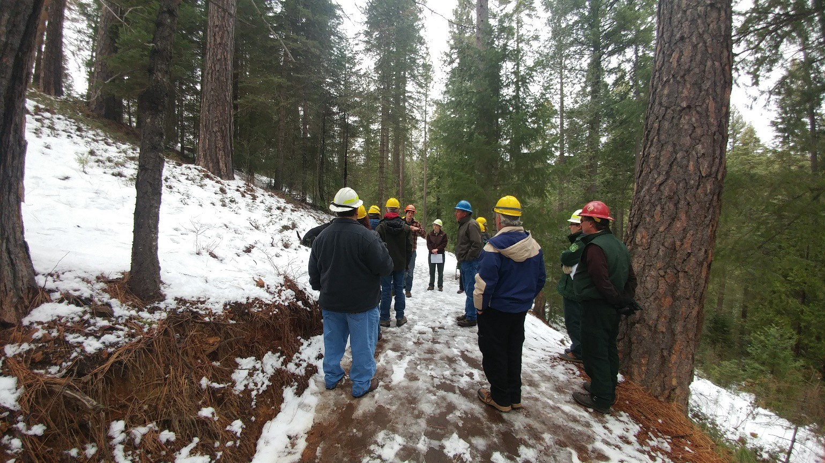

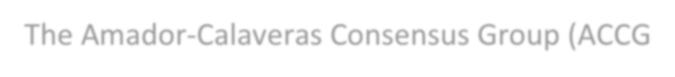Executive Summary…

The Amador-Calaveras Consensus Group (ACCG) was formed in 2008 to bring together the diverse Sierra Nevada community of loggers, environmentalists, business owners, and local residents with federal, state and local officials to find common ground on forest, economic, and community issues in Amador and Calaveras Counties, where the collapse of the timber industry decades before had led to chronic unemployment and poverty along with unhealthy forests and struggling local economies.

In 2009, Congress established the Collaborative Forest Landscape Restoration Program (CFLRP). The stated purpose of the CFLRP is to encourage the collaborative, science-based ecosystem restoration of priority forest landscapes. The program called for complete commitment to forest restoration and pursuit of an all-lands approach based on collaborative solutions for landscape-scale operations.

The CFLRA established funding authority for up to $40,000,000 annually for fiscal years 2009 through 2019 for up to 10 projects per year nationally.
In 2012 the ACCG applied for funding under the Collaborative Forest Landscape Restoration Act (CFLRA) and was selected as one of the ten projects approved for the national program. With the benefits and mandates of the CFLRA program and funding, the ACCG continued collaborating with many agencies and groups, but became focused on working mostly with the US Forest Service, with ACCG serving as a sort of network hub for the community of Sierra Nevada healthy forest and clean water interests in Amador and Calaveras Counties.
The anticipated 2022 sunset of CFLR funding was the catalyst for developing this 5-year strategic plan to examine the group’s current state and to position ACCG for the future, once CFLRA funds are no longer available.
A dedicated working group, representing the interests of the full ACCG, attended monthly meetings to review existing governance documents, consider current and future needs of the group, and to plot a deliberate path forward that provides a productive and sustainable future for ACCG. This document is the result of that work. It was developed in 2017-18, was presented to ACCG members for comment in June of 2018, and was adopted July 18, 2018.
The plan is intended to be reviewed quarterly to track progress toward goals, and to change course where required. An annual “celebration of progress” will also be held.

A Brief History…
The Amador-Calaveras Consensus Group was first convened in December 2008 by then-Calaveras County Supervisor Steve Wilensky, Sierra Nevada Conservancy Executive Officer Jim Branham and Sierra Business Council President Steve Frisch. The initial meeting brought together loggers, environmentalists, business owners, and local residents with federal, state and local officials, who decided to form the Calaveras Consensus Group. The group originally worked to find common ground on forest, economic, and community issues in northeastern Calaveras County, where the collapse of the timber industry decades before had led to chronic unemployment and poverty along with unhealthy forests and struggling local economies. In 2009, the group was broadened to include Amador County.
Activities of the group over the first few years were focused on developing Forest Principles and Policies to guide operations, and development of a Memorandum of Understanding, which serves as the primary governance document for the organization.
Key events and activities over the past decade include:

Year | Activity
2008 | First meeting convened by Calaveras County Supervisor Steve Wilensky, Jim Branham (Sierra Nevada Conservancy), and Steve Frisch (Sierra Business Council). Participants included  loggers, environmentalists, community members and agency staff.
2009 | Group broadened to include Amador County.
2010 | - Developed and adopted Forest Principles and Policies to Guide Operations.  - Developed and adopted a Memorandum of Understanding for membership and governance.  - Received U.S. Forest Service Regional Forester’s Award for “All-Lands Ecological Restoration”.
2011 | Developed the Cornerstone Project Application for funding under the Collaborative Forest Landscape Restoration Act.
2012 | - Cornerstone selected as one of ten projects approved for the CFLR Program nationally; implementation began.  - Received Sierra Business Council “Sierra Vision” award.
2013 | - Participated in founding of Sierra to California All-Lands Enhancement project (SCALE).  - Participated in the Mokelumne Environmental Benefits Program project and the Mokelumne Avoided Cost Analysis.  - Developed Cornerstone Monitoring Strategy.  - CFLR funds used to collect baseline conditions for Callecat, Power Fire, Mattley Meadow, West Calaveras Plantation Thinning, Ramsey Fire Salvage, Foster Firs, and Hemlock Landscape restoration projects.  - Calaveras Healthy Impact Product Solutions (CHIPS) Master Participation Agreement signed. CHIPS provides the Forest Service with trained workers to implement restoration activities.
2014 | - Ten field trips (approximately 1,259 hours) to project sites ranging from fuels  reduction to post-fire salvage, to meadow restoration.
2015 | - Butte Fire in Amador and Calaveras counties burns 70,868 acres.

- Developed definitions of “local” for potential project contractors.
- Developed monitoring strategy with tiered monitoring questions, appropriate indicators and data collection strategies.
2016 | - 129 million trees on 8.9 million acres die due to drought and bark beetles in the state of California.  - Upper Mokelumne Watershed Authority (UMRWA) signed Master Stewardship Agreement with the U.S. Forest Service.
2017 | ACCG and USFS conducted an all-day Monitoring and Science Symposium to provide knowledge of ongoing work and present findings from monitoring and research occurring  within the ACCG footprint.
2018 | - ACCG partners with Sierra Institute to conduct socioeconomic monitoring.  - 2017 marked the 13th anniversary of CHIPS, and several key milestones for the company, including project revenues of nearly $1,000,000; 43 full-time employees, 60% of which are of Miwok, Washoe, and Paiute heritage.

Accomplishments noted in ACCG 2012-2017 annual reports include cumulative totals of 21,264 footprint acres treated, 9,377 acres of hazardous fuels treated inside the WUI, and 600 full or part-time jobs created in local communities.

What is the ACCG?
ACCG is an informal, community-based group of diverse stakeholders that works to create fire-safe communities, healthy forests and watersheds, and sustainable local economies. Its members include state and federal agencies, business owners, nonprofit organizations, elected officials and private individuals. The group focuses on a triple-bottom-line approach to environmental, economic and community issues. It makes decisions by consensus and works primarily in the upper Mokelumne River and Calaveras River watersheds east of Highway 49.
Our mission…
Collaborate to promote fire safe communities, healthy forests and watersheds, and sustainable local economies.
Triple Bottom Line…
The highest priority desired outcomes of the ACCG include:
- Reduced risk of uncharacteristic fire and threats to lives and property;
- More-natural fire regime;
- Restored cultural sites, streams, meadows and watersheds;
- More-resilient vegetation;
- Restored forest structure, processes and function;
- Protected municipal water supply;
- Sustainable local jobs and improved social conditions resulting from creation of a re-tooled forest economy.
Desired outcomes occur in the collaborative partners’ stewardship efforts to create a healthy balance between the environment, community, and economy – a triple bottom line.

Strengths, Weaknesses, Opportunities, Threats…
An important part of the planning process was developing a SWOT analysis. This was used as the basis for determining our current state, deciding where we want to be in 5 years, and developing goals to get us there.

Strengths | Weaknesses
- Collaborative processes  - Consensus decisions  - Structure, principles, MOA  - Track record of success  - Community engagement and involvement  - Deep understanding of local issues  - Breadth and depth of knowledge among members  - Diversity of participants and interests  - Support, appreciation, and engagement of agencies  - Fostering new partnerships | - Conflicting views, positions, levels of knowledge  - Slow decision processes and collaborative decisions  - Too focused on Cornerstone, CFLR funds, and Forest Service projects/lands  - Not well known across local communities  - MOA is out of date; not enough signatories  - Low participation from communities, organizations, businesses, tribes, etc.  - Lack of interaction with community  - Declining participation
Opportunities | Threats
- Pursue funding opportunities beyond CFLR; write more grants  - Increase participation with new MOA and outreach efforts  - Identify and learn about partnership and contracting options  - Increase scope to all-lands watershed scale projects  - Improve processes for collaboration, consensus, project support  - Identify and support implementation of projects  - Socioeconomic monitoring to identify impact and capacity | - Loss of CFLR funding and support from Forest Service  - Competition between counties; lack of cooperation  - Value conflicts  - Issues stemming from cannabis industry and legislation  - Budget constraints  - Fires, floods, pest infestations  - Competing organizations  - Diminishing number of volunteers willing to work on projects  - Loss of key participants and institutional knowledge  - Loss of funding andstaff support and participation from Forest Service

Strategic Plan…
The following chart embodies the 5-year strategic plan. Three key goals were identified, based on current conditions and a desired future state vision for each.
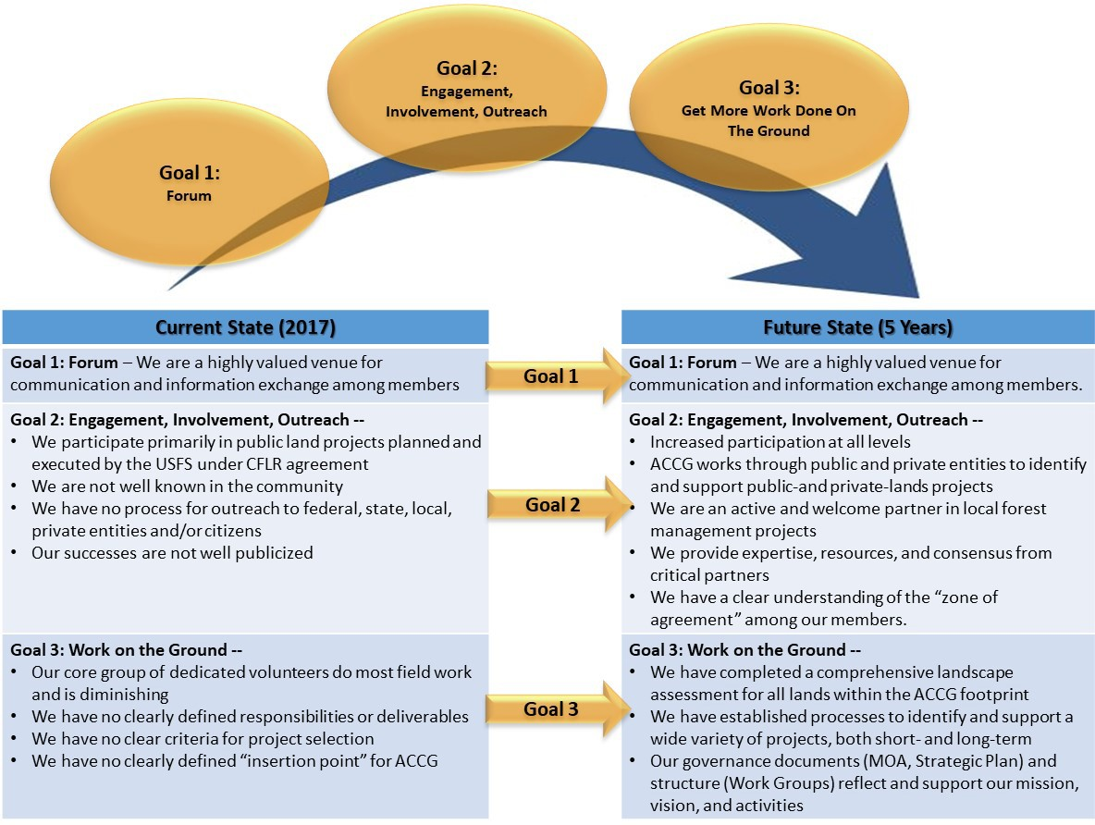

Each goal has milestones associated with it, as well as a reporting format to be used to inform the membership of goal status and progress.
ACCG will seek to establish working groups to address each goal.

Performance Indicators…
In this section of the plan, each of the three goals is described in expanded detail, with SMART (Simple, Measurable, Achievable, Relevant, Time-bound) attributes defined.

Each goal is also described in a one-page chart which will be used to report progress quarterly to the Administration Work Group and annually to the membership at the January general meeting.
Each goal has defined objectives, dated milestones, and notable issues and potential barriers to success.
Progress will be reported via a stoplight “red, yellow, green, check” designation, with each category defined as follows:
Red: The goal is on hold or has made no progress. Explain why this is so and suggest solutions.
Yellow: The goal is stalled or moving slowly. Explain the reason for the slow progress and ask for the resources needed to move it forward (i.e., funds, manpower, consensus, better weather, etc.)
Green: The goal is ongoing and on track, making progress, and there are no apparent barriers that would derail its progression and eventual success.
Check: The goal has been met/completed.

GOAL 1

ACCG will serve as an active and rich communication forum for its members

Goal 1: Forum -- Objectives

ACCG will serve as an active and rich communication forum for its members by:
- Increasing attendance at the monthly general meetings through outreach efforts and by offering compelling content, including a roster of speakers and panel discussions that are relevant and broadly interesting to the ACCG membership and the wider community. Establish a venue for networking before/after each meeting.
  - Measureable: keep monthly count of attendees via sign-in sheets; compare to past year(s).
  - Achievable: Administrator can plan and manage meetings, speakers, annual report, surveys, etc.
  - Relevance: General meetings were identified as a key benefit to members. Networking lunches expand opportunities for member interaction.
  - Time Bound: Start immediately with 2018 general meetings. First report to full group in January 2019.
- Making the ACCG website more relevant and more frequently accessed by making it easier to navigate and by providing a broad spectrum of relevant content.
  - Measurable: Track hits/month.
  - Achievable: Need additional funding for web work (Administrator does not have this skill set); may need to pursue new funding sources.
  - Relevance: Useful and relevant web site is an inexpensive and practical way to engage the community and members.
  - Time Bound: ongoing; review quarterly – may need outside web consultant.
- Conducting surveys of ACCG members and community to assess our impact.
  - Measurable: Conduct first survey in November 2018;
  - Achievable: Administrator can work with Admin WG to develop survey; use web-based and paper-based surveys.
  - Relevance: A good way to track progress, successes, adjust strategic direction, take pulse of membership.
  - Time Bound: First survey November 2018; Follow-up June 2019; determine if annual or semi- annual needed after first 2 surveys.

Producing an annual report of ACCG projects and successes.
  - Measurable: First annual report due in December 2018.
  - Achievable: Administrator can do this in conjunction with the CFLR annual report produced by the Forest Service; should include accomplishments beyond the “direct” data in the CFLR annual report (i.e., acres treated); put emphasis on local benefits.
  - Relevance: Requires that ACCG be deliberate in tracking projects, successes, goals. Useful when writing grant applications.
  - Time Bound: First annual report December 2018.

Forging tighter connections among Work Groups
  - Measurable: Basic set of information on every ACCG project (common format) available on website and updated at general meetings.
  - Achievable: Develop a simple and effective way to report on activities (i.e., develop a simple 1- page project tracking form); post to web and provide updates at general meetings; develop process for deciding what projects ACCG will support.

  - Relevance: Integrates all aspects of ACCG work (admin, planning, monitoring, operations)
  - Time Bound: Plan developed and presented to working groups, Forest Service, and other partners by November 1, 2018.

Goal 1 Quad Chart:
Statement of Goal: ACCG will serve as an active and rich communication forum for its members

Objectives |  | Milestones (with dates)
1 | Increase attendance at meetings through outreach, improved content, relevant speakers,  providing a venue for networking | 1 | - Track meeting attendance (start January 2018)  - Compelling speakers lined up for all meetings (ongoing)  - Post-meeting networking venue (begin Jan 2018)
2 | - Improve website content and user interface  - Train Admin WG members for backup  - Install Google Analytics, Twitter and Facebook feeds. | 2 | - Outside expert to install Google Analytics (by Nov 2018)  - Create web update guide for Admin WG so they can post to site if Administrator is unavailable (done)  - Get outside consultant to improve interface (by Nov 2018)
3 | Conduct annual survey of members and community; perhaps consolidate with socioeconomic monitoring project | 3 | - Create survey questions (by Jan 2019)  - Develop list of who to take survey (Jan 2019)  - Determine how survey will be delivered (by Jan 2019)  - First survey delivered (Jul 2019)
4 | Produce Annual Report | 4 | - Pull data and narrative from FS CFLR report (Sept 2018)  - Supplement with non-FS information, narrative, successes, etc. (Nov 2018)  - Complete report and deliver to members (Jan 1, 2019)
5 | Tighter connections to Planning and Monitoring Work Groups | 5 | - Include more data on web (i.e., agendas, minutes) (Apr 2018)  - Develop simple form to track progress of projects; post info to web (Nov 2018)  - Develop process for selecting ACCG projects (Nov 2018)
Issues and Barriers |  | Updated as of October 17, 2018
1 | None | 1 |  | On track. Keeping numbers of attendees and will compare with 2017. Working to line up speakers for 2019; post-meeting lunches regularly scheduled. This is an ongoing effort. Owner is  Administrator (Micheau).
2 | Need outside help for Google Analytics, Twitter and Facebook feeds | 2 |  | Need to write RFP for web work by outside professional. Evatt has contacts.  Web tutorial created and emailed to Admin WG February 2018.
3 | Need Admin WG to assist with  developing survey. | 3 |  | Put on Admin and Monitoring WG agendas for November 2018;
4 | None | 4 |  | Keeping folders with pictures, stories, field trip info, etc. so that report can be easily created late in year. Evatt will help with format and template.
5 | Time and lack of cross-fertilization among members. Need more  volunteers to attend meetings of multiple working groups. | 5 |  | Trying to promote more attendance at meetings; recent Planning WG meeting in Calaveras very well attended; Need to “advertise” field trips, volunteer opportunities, etc.

GOAL 2

Increase participation at all levels; ACCG works through public and private entities to identify and support public- and private-lands projects. ACCG is an active and welcome partner in local forest management projects. We provide expertise, resources, and consensus from critical partners.

Goal 2: Engagement, Involvement, Outreach -- Objectives
Increase participation at all levels; ACCG works through public and private entities to identify and support public- and private-lands projects. ACCG is an active and welcome partner in local forest management projects. We provide expertise, resources, and consensus from critical partners.
- Increase participation at all levels through improved media and outreach efforts
  - Measurable: Publish 4 news articles/year; 1 non-project related field trip or volunteer opportunity/year; announce general meetings in local papers and calendars each month; develop and deploy a standard ACCG PowerPoint presentation to be delivered to local groups (4/year); ask all members to help by identifying and engaging groups who may be interested in our work; conduct a contest to develop an ACCG logo.
  - Achievable: Admin and Media Team can develop and implement a plan for this; develop lists of groups to reach out to; develop presentation; conduct logo contest.
  - Relevance: Attrition is weakening the organization. We need broader participation, new ideas and energy, and greater public awareness of ACCG.
  - Time Bound: Develop a schedule and plan for articles and meeting announcements by July 1, 2018; develop PowerPoint presentation by July 1, 2018; Develop lists of potential targets by July 1, 2018. Schedule at least one non-FS field trip, volunteer opportunity, or seminar each calendar year.
- ACCG works through public and private entities to identify and support public- and private-lands projects.
  - Measurable: Develop and maintain a list of current projects on both public and private lands; develop a simple and effective way to collect and present this information (1-page form, perhaps web-based).
  - Achievable: The CFLR projects are tracked by the USFS already; for non-FS and private lands projects, ACCG should be able to identify projects at the general and planning meetings and collect data from reporting representatives of groups.
  - Relevance: Expanding beyond CFLR has been identified as a critical goal to make ACCG function beyond the end of the CFLR program.
  - Time Bound: List of current projects developed (by 9/1/18); process introduced at planning and general meetings (by 10/18), information posted to web by November 1, 2018.
- ACCG is an active and welcome partner in local forest management projects.
  - Measurable: Attendance at ACCG general and planning meetings is a success indicator, as is the number of MOA signatories. Track the different groups represented at each meeting to see if participation expands. Get more MOA signatories; set a milestone of 6 new signatories per calendar year.
  - Achievable: Administrator can pull group affiliations from meeting sign-in sheets. Open up MOA for signature at every general meeting.
  - Relevance: Expansion beyond USFS projects is central to Goal 2.
  - Time Bound: Results are dependent on many outreach activities; include annual figures in Annual Report, January 1st of each year.
- ACCG provides expertise, resources, and consensus from critical partners.

  - Measurable: Number of ACCG members who attend general and planning meetings; number of Letters of Support and/or Comment letters generated each calendar year; number of volunteers engaged in ACCG projects; number of presentations to ACCG by subject matter experts; number of field trips. Some can be tracked via sign-in sheets; others are more qualitative and may be captured in the member surveys that are part of Goal 1.
  - Achievable: The existing ACCG framework of general and planning meetings, work group activities, presentations and field trips provides the basis to improve and enhance this resource.
  - Relevance: Bringing together a group that represents a broad spectrum of knowledge, skills, perspectives, and resources is a key element to ACCG’s success.
  - Time Bound: Baseline measurements to be developed for the 2018 ACCG Annual Report (completed by 1/1/19); numbers should increase in concert with outreach activities.
- Develop ACCG members’ “Zone of Agreement” to increase understanding of the many perspectives represented by the group and to use as a basis for project selection. Hire professional facilitator to implement this action.
  - Measurable: A chart, graphic, and/or short document qualifying ACCG’s standing on a range of potentially contentious issues. (complete 6 months from start date)
  - Achievable: Hire professional facilitator; Admin WG work with facilitator to develop a plan of action, logistics, who to involve, etc.; present at general meeting; execute.
  - Relevance: It is felt that the group would be more productive and less contentious if we have a clear understanding of what we agree and disagree on – what we can and can’t live with.
  - Time Bound: Complete with six months from hire date of facilitator.

Goal 2 Quad Chart:
Statement of Goal: Increase participation at all levels; ACCG works through public and private entities to identify and support public- and private-lands projects. ACCG is an active and welcome partner in local forest management projects. We provide expertise, resources, and consensus from critical partners.

Objectives |  |  | Milestones (with dates)
1 | Increase participation at all levels | 1 | - Develop a communication plan (1/1/19)  - Develop list of potential targets for outreach (completed 9/1/18)  - Plan and execute at least one educational activity, symposium, or volunteer opportunity each year (by 12/1/18)
2 | Work through public and private entities to identify and support public-and private-lands projects | 2 | - Develop list of current public and private projects (9/1/18)  - Develop and introduce process for collecting and maintaining project information; present at general meeting (by Jan 2019)  - Post project information and a web-based collection form to web by 1/1/19)
3 | Become an active and welcome partner in local forest management projects | 3 | - Gather data, pictures, and stories to include in annual reports (first report 1/1/19)  - Hold more workshops and/or field trips aimed at educating the public. Engage more with local universities and community colleges (UC Merced/Davis and Columbia College)
4 | Provide expertise, resources, and consensus from critical partners | 4 | - Baseline measurements to be developed for the 2018 ACCG Annual Report (completed by 1/1/19)  - Develop a process and repository to collect this information (by 2/1/19)
5 | Develop “Zone of Agreement” | 5 | - Hire facilitator (done; will engage November 2018)  - Develop plan, schedule meeting(s) – by 6/1/19  - Complete and present results by 8/1/19
Issues and Barriers |  |  | Updated as of October 17, 2018
1 | Need to recruit a dedicated group to focus on outreach and media |  | 1 |  | - Establish a Media-Communications team, including USFS PIOs – Aragon may help; also ask for BLM participation  - List of targets was developed in a strategic planning meeting – need to organize and prioritize (by 12/1/18)
2 | Need lists of planned projects from USFS and others; refer to annual reports for current projects |  | 2 |  | - USFS to provide POW lists to Planning WG (get from S. Tangenberg and/or L. Crabtree?)  - No format established for collecting information
3 | Need to ask all ACCG groups and members to let us know of their  activities and projects |  | 3 |  | - Not started; need someone to own this.
4 | Plan and format for annual report must be developed; information collected |  | 4 |  | - Administrator to develop format for the annual report and collect information to populate it for first edition, 1/1/19; this  has not been started.
5 | Need to select facilitator and get FS contract in place; develop an outline of our needs; get proposal from facilitators |  | 5 |  | - USFS has agreed to pay for professional facilitation; Contract placed in time for 11/14/18 meeting.  - Topics and projects for facilitator will be developed in November – January timeframe.

GOAL 3

Get More Work Done On the Ground

Goal 3: Get More Work Done On the Ground -- Objectives
Active engagement in ACCG projects
- Conduct a landscape assessment for all lands within the ACCG footprint
  - Measurable: Form a working group to lead this effort with representatives from USFS, BLM, RCDs, etc. – many of these groups are already assessing projects of similar range; determine if a funding source is required (grants?); develop scope of work – develop an outline for a product that shows priority projects/treatments areas within the ACCG footprint; determine who will do the work.
  - Achievable: A long term goal, but with collaboration and a funding source (grant) it can be done.
  - Relevance: A landscape assessment would provide a roadmap for future projects, identify needs, and aid in project planning.
  - Time Bound: Will take 2-3 years from inception of project.
- Develop processes to identify and support a wide variety of projects; rapid-turnaround process for support of grant applications and a more rigorous process for long-term project engagement
  - Measurable: Develop processes; provide templates and guidance for both types of projects to make working with ACCG easy and productive; be clear about what ACCG needs to support projects. This falls within the purview of the Planning WG.
  - Achievable: Planning WG has some of this done already; develop more fully and test with new projects
  - Relevance: Collaboration on projects requires clear understanding of the concepts and methods proposed for each project. Developing a simple and replicable method of communication between projects and ACCG will promote collaboration and support
  - Time Bound: Develop processes, present to full group, post on web by 1/1/19
- Redefine Work Groups to achieve future objectives
  - Measurable: Admin WG to develop new structure and present to full group; include permanent WGs (Admin, Planning, others); ad hoc groups for special projects will form as needed (i.e., socioeconomic monitoring)
  - Achievable: Based on strategic planning discussions, rearrange current WGs and their responsibilities. Present potions to full group. Recruit members to populate WGs.
  - Relevance: The WGs defined in the original MOA have not all functioned as intended; a new structure that supports this strategic plan is needed.
  - Time Bound: The Admin WG will develop a new set of parameters for WGs and present to full group by 11/1/18

Goal 3 Quad Chart:
Statement of Goal: Get More Work Done On the Ground

Objectives |  | Milestones (with dates)
1 | Conduct a landscape assessment for all lands within the ACCG footprint | 1 | - Propose to full group; get consensus on its value (9/1/18)  - Ask members how to best achieve this; is grant money needed? (9/1/18)  - Identify sources of funding and apply for grants if needed (CY 2019)  - Implement assessment; complete within 3 years (by 2021)
2 | Develop processes to identify and support a wide variety of projects; rapid-turnaround process for support of grant applications and a more rigorous process for long- term project engagement | 2 | - Develop, test, and adopt a project planning process and supporting documents to provide consistency across projects (by 1/1/19) – (facilitator and Planning WG)  - Determine needs for short-term vs. long-term projects (8/1/18) (Planning WG)  - Adopt processes for all new projects (1/1/19)
3 | Redefine Work Groups to achieve future objectives | 3 | - Current WGs to review and assess relevance and requirements, resulting in a revised set of “permanent” WGs, including their responsibilities and goals (1/1/19)  - Update MOA to reflect structural changes (3/1/19)
Issues and Barriers |  | Updated as of October 17, 2018
1 | Very large project which may require grant funds; need to establish and populate a WG to identify scope the project, define requirements, write proposals,  etc. | 1 |  | Not started; start no later than 9/1/18
2 | Need time to review current processes, assess their strengths and weaknesses, refine and  improve them. | 2 |  | Not started; timing dependent on professional facilitator engagement.
3 | None; Admin WG has this on agenda for October 2018 | 3 |  | Discussions started in the strategic planning WG will be continued in the Admin WG

