Attendees: Zac Croyle, Chuck Loffland, Linda Diesem, Megan Layhee, Becky Estes, Michelle Wolfgang, Sue Britting

Introductions/Ice Breaker/Agenda Review
Next meeting – July 12 2023; will likely not meet in August and September, using aspen and meadow monitoring workshops as touch points for August and September; will revisit this at July meeting

Overview of Regional Resource Kits and GTAC Data Sources

How can we use the RRK for monitoring for ACCG?

Sierra Nevada RRK: https://wildfiretaskforce.org/sierra-nevada-regional-resource-kit/

Becky provided an overview of data site and tools
Arranged by pillars of resilience and broken down into metrics for each pillar with data sources for each pillar and metric (see the metadata)
This data can provide good baseline data but in order to be used as monitoring data if they resource kits are updated on an annual basis or at least with enough frequency to capture pre and post treatment.

Follow up: Need to find out how to provide feedback on RRK – who to send this to and in what form?

Can get data from ACCEL website: https://data.fs.usda.gov/geodata/rastergateway/accel/
Fire dynamics and fire resilience metrics might be most interesting to ACCG for monitoring, but other pillars might be relevant.

Follow up: Need to clarify if download data is same as in viewer and if metric dictionary posted on website is the current one need to have meta-data and data layer update page

How to use this data for project prioritization and project planning?
Phase II: Teams are starting to talk more about models and data to use. Land Tender has been presented to ACCG. Hoping to have Planscape presented at the Phase II TAG on July 19.
Modeling framework – What is the best? Becky – Big differences among them.
LandTender – if have funding, Land Tender will be available throughout planning of project. Planscape may not be developed enough to deliver pre- and post-treatment conditions.
Chuck – feels like may be jumping model selection before looking at landscape and setting priorities
Becky - how are we prioritizing areas to treat? RRK is probably good for this assessment. Also mentions that there is LIDAR data for all of ACCG (both STF and ENF but would need to be merged)
Sue – There may be some support from PSW research station to run Planscape for ACCG
Michelle – What about approaching GTAC to provide support for running Planscape; also need a cost comparison to identify products and costs
Cost, group providing pros and cons
Sue – Important to understand how important it is for LIDAR to be used to enhance available data as was done for North Yuba and SERAL
Chuck in chat: To further complicate the issue, we're working with a partner UMWRA who's contracted the NEPA/project development to STANTEC and funding is primarily grant funding through UMWRA. I think UMWRA believes they have the funding for the Landtender bill...
Michelle in chat: That's true; and now not sure if they would prefer at this point to compare costs. At least with GTAC we would also have the same level of contact that we would have with LandTender
Chuck in chat: My guess is that UMWRA/STANTEC might prefer to contract Landtender as it might take some of the weight off their roles.

Can RRK be used for monitoring?
Took a deep look at a couple of fire metrics; fire behavior modeling may not be best way to examine landscape change, since the fire modeling relies on the underlying assignment of fuel models that may not be changed following treatments or perhaps it could be to coarse scale
Looked at trees per acre – TPA, SDI, large trees
Becky not sure if can use RRK for monitoring since would only have post treatment conditions, one point in time - at least for ACCG – might be some opportunity to obtain retrospective look using F3
Becky thought about using climate classes x LMU as a “reference condition” and to compare degree to which treated area has moved toward
Could use RRK to summarize descriptive statistics for treated versus untreated; can use this to validate treatments on the ground
Chuck – could use eveg/xveg as pre-treatment condition
Follow up: Becky – will develop questions and then summarize what we want to do re: generating monitoring data from RRKs; will then submit project to MARS (Mapping and Remote Sensing) to assist in

GTAC (Geospatial Technology and Applications Center) Data Support for CFLR
Addressing ecological effectiveness monitoring for CFLR: https://apps.fs.usda.gov/lcms-viewer/dashboard.html
Generating data sets for monitoring data to address social and ecological questions
Also updating terrestrial condition assessment

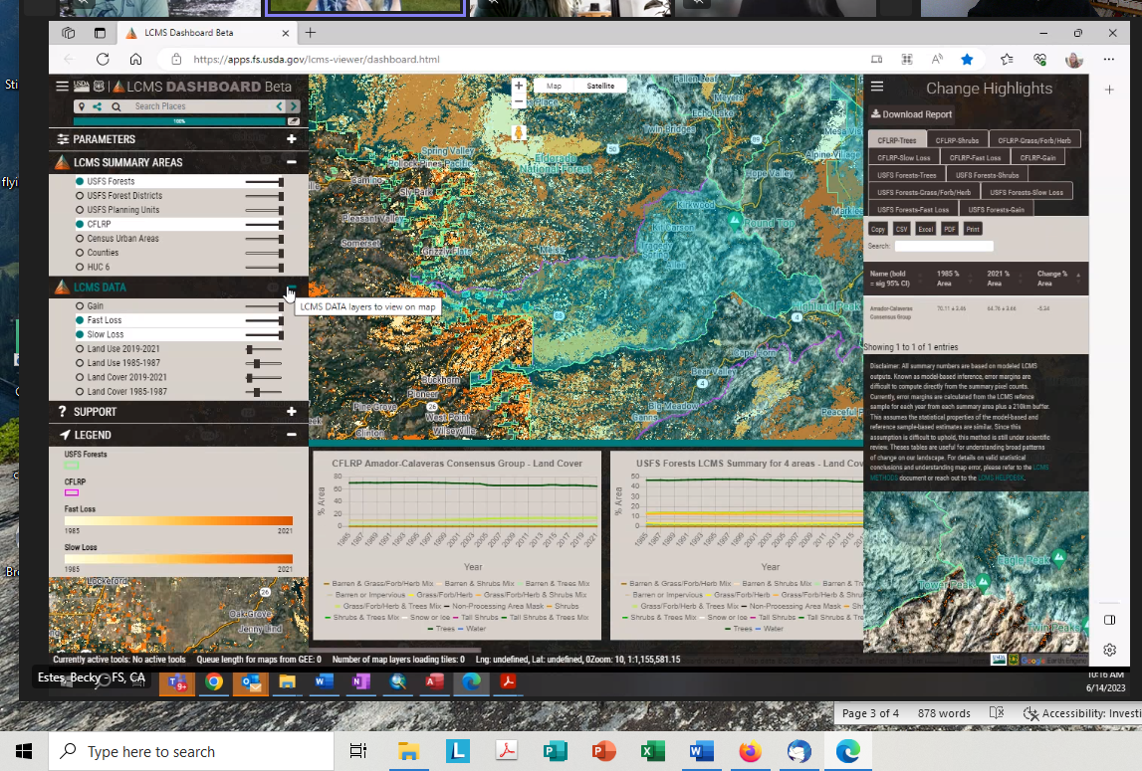
Monitoring Workshops (Aspen & Meadow)
- Resampling Martin Meadows in Caples
- Thompson Meadow – last monitored in 2017; installed transects, now treated and want to repeat transects
Meadows are still snowed in; likely dates would be in late August or September
Thompson – probably not a very wet meadow since
Protocols – neither use herbaceous species (not full floristics), so wetness of meadows may not be a concern; road system damage has not been bad so far, so access may not be affected; there was a blowout in the Thompson Meadow area (Zach mentioned)
Becky will share data points for sampling of Thompson with Zach to help decide about limitations to access
Becky mentions that there was an ACECS group (or something like that) on last Thompson Meadow sampling that might be interesting to invite back.
May be a tight time frame at late summer to fall for the workshop due to potential El Nino and possible fall ppt
Follow up: Becky will offer tentative dates for workshops in Late September and will recirculate some information on the workshops

ACCG Monitoring Website Finalization
Megan made changes that we discussed last time; CA fire Science Consortium link still needs to be updated, but CFSC knows about that and is working on it
Project table is well on the way and Megan is creating a cheat sheet to help other know how to modify the table in the future

Support for ACCG ARCGIS online
Two possibilities:
- Could allow induvial access for those with accounts (easier)
- Allowing public access (more complicated)
Becky has some ideas about pursuing either, but needs feedback on which to pursue
Megan – want general public to view layers; more informed like WGs might want more of data sharing hub
Follow up: Megan will bring this to Admin WG for a future decision
Becky is checking on if it would be good to have an ARCGIS online for all the collaboratives

Aspen Presentation at Full Group ACCG Meeting
For meadow ppt at nest ACCG - Regine will give an overview on meadows and Becky will give ecological perspective; and will pose questions to larger group on if anyone knows of additional aspen locations; ppt will be 10-15 minutes
Follow up: Becky will follow up with Helen to confirm the details, assuming that Helen will not be able to join the meeting for the aspen/meadow ppt

Round Robin, Closeout

Watershed Outcomes Bank – Grant to Cosumnes River Watershed to develop this process
RX fire in Arnold Avery project – Megan asks if she needs to change to her monitoring protocol for her assessment area. Megan will follow up with Becky on this.

To do list

Becky

- Need to find out how to provide feedback on RRK – who to send this to and in what form?
- Need to clarify if download data is same as in viewer and if metric dictionary posted on website is the current one need to have meta-data and data layer update page
- Develop questions and then summarize what we want to do re: generating monitoring data from RRKs; will then submit project to MARS (Mapping and Remote Sensing) to assist in (in progress – will review at our July meeting before submission)
- Will offer tentative dates for workshops (target is late September) and will recirculate some information on the workshops (done)
- Will follow up with Helen to confirm the details, assuming that Helen will not be able to join the meeting for the aspen/meadow ppt (done)

Megan

- Will bring ideas about mapping website discussed above about to the Admin WG
- Will follow up with Becky on monitoring in her Arnold-Avery plots
- Share cheat sheet for website updates
Sue
- Recruit CNPS folks for monitoring when more specific information is available

Ongoing Task List

All
- Share relevant papers or talks that might be important to share with the group

Becky
- Summarize Long Fire data – is this something that Saba could tackle
- Summarize Caldor field tour summaries with Derek
- Summarize Foster Firs Data (Becky W. will complete this task) (at end of field season)
- Continue to merge all monitoring spatial data into one place
- Determine whether the Forest Service can house the spatial database on our ArcGIS Online (in process)
Helen
- Will look into potential effects of changes in phenology and how this might affect the NDVI - no hurry on this task - 2025 revisit this analysis

Future Agenda Topics
- Another interesting project Virtual fencing - UC Extension - in Caldor Fire - interest to ACCG - relatively new technology for grazing allotments - topic for future meeting
- Thompson Meadow Monitoring Field Event (September)
- Review map of Karen Pope’s meadow model for Caldor area and discuss at a monitoring meeting how to use this to assess meadows and aspen
- Landscape scale monitoring – RSL/MARS/RRK is willing to help us evaluate a landscape to evaluate treatment effectiveness by pulling information together; Chuck suggests submitting Phase II as a project for evaluation
- Landscape Scale Assessment – circle back to reporting and how we can tackle assessing at a broader scale – maybe LiDAR will help us with this? (linked to part 2 of SLAWG been postponed) a. Think about how we can use the LiDAR as a monitoring tool and start looking at outputs b. Presentation on LiDAR products once it is available for the ENF (maybe have Van and UW folks to talk about the LiDAR outputs for the ACCG)
- Need to address monitoring in plantations both the variable density PCG and the variable density planting – will we continue this
- Monitoring Strategy - review the strategy and see if there is something else we might need to pursue (ongoing) a. Track key issues and make sure we are monitoring them
b. Is there any new information gained that can be applied to management?
9. CA Forest Observatory – could be a good topic for our group (this might be a great SLAWG topic as well)
11. Summarizing data now that we have data – what projects need a report out? a. discuss how information is being presented/translated and if we can improve that
12. 2023 symposium to cover monitoring projects on the Stanislaus
13. Meadow monitoring protocol comparison, Kyle– field visit of monitoring workgroup for late summer
14. Short presentation to appropriate audience re: need for monitoring funds post-project (up to 10 years post).

The chat:
[9:05 AM] Loffland, Chuck - FS, CA
GTAC=? Government Transendental Angry Communists?
[9:06 AM] Loffland, Chuck - FS, CA

Geospatial Technology and Applications Center (GTAC)
Geospatial Technology and Applications Center (GTAC) | US Forest Service
Mission: Mapping Our Future Together
[9:12 AM] Estes, Becky - FS, CA
https://wildfiretaskforce.org/sierra-nevada-regional-resource-kit/
Sierra Nevada Regional Resource Kit - California Wildfire & Forest Resilience
Sets of tools and data developed by a Task Force interagency science team.
[9:29 AM] Loffland, Chuck - FS, CA
I think we haven't really broken down the difference between using these various tools/data sources for analasys vs. prioritizing treatments. I think the phase 2 discussions are jumping the gun to prioritizing before we have a good plan for analyzing what were were working with on the landscape.
[9:30 AM] Wolfgang, Michelle - FS, CA
I think there is still confusion on what Planscape can/cannot be used for - I believe the intention was to streamline the NEPA project planning, but not necessarily dictate where/why treatments would occur. Because if that were true, why would we engage tribes?
[9:31 AM] Wolfgang, Michelle - FS, CA
Loffland, Chuck - FS, CA
I think we haven't really broken down the difference between using these various tools/data sources for analasys vs. prioritizing treatments. I think the phase 2 discussions are jumping the gun to prioritizing before we have a good plan for analyzing what were were working with on the landscape.
100% agree
[9:33 AM] Wolfgang, Michelle - FS, CA
No model framework is perfect haha
[9:34 AM] Wolfgang, Michelle - FS, CA
Cost compare: how much would it cost to hire a data manager to utilize Planscape vs buying the whole LandTender model package
[9:45 AM] Loffland, Chuck - FS, CA
To further complicate the issue, we're working with a partner UMWRA who's contracted the NEPA/project develpment to STANTEC and funding is primarily grant funding through UMWRA. I think UMWRA believes they have the funding for the Landtender bill...
[9:48 AM] Wolfgang, Michelle - FS, CA
Loffland, Chuck - FS, CA
To further complicate the issue, we're working with a partner UMWRA who's contracted the NEPA/project develpment to STANTEC and funding is primarily grant funding through UMWRA. I think UMWRA believes they have the funding for the Landtender bill...
That's true; and now not sure if they would prefer at this point to compare costs. At least with GTAC we would also have the same level of contact that we would have with LandTender
[9:49 AM] Loffland, Chuck - FS, CA
My guess is that UMWRA/STANTEC might prefer to contract Landtender as it might take some of the weight of their roles.
1f4af_hundredpointssymbol 1
[9:53 AM] Wolfgang, Michelle - FS, CA
fuel accumulation ?
[9:57 AM] Wolfgang, Michelle - FS, CA
could also be vegetation based? pine-dominated v fir-dominated v etc?
[10:13 AM] Loffland, Chuck - FS, CA
MARS is the new/old RSL correct...
[10:15 AM] Wolfgang, Michelle - FS, CA
YAY i worked on this!
[10:15 AM] Estes, Becky - FS, CA
LCMS Dashboard Beta (usda.gov)
[10:17 AM] Wolfgang, Michelle - FS, CA
they are also working on an update to TCC (total canopy cover)
[10:18 AM] Loffland, Chuck - FS, CA
now if we can just get a socio/economic monitoring tool...
- we are getting one for the Cosumnes River Watershed
- not monitoring per se but an "outcomes bank by Wolfgang, Michelle - FS, CAWolfgang, Michelle - FS, CA10:18 AM
not monitoring per se but an "outcomes bank"
1 Like reaction.1
- but if we want to throw some ideas around f... by Wolfgang, Michelle - FS, CAWolfgang, Michelle - FS, CA10:20 AM
but if we want to throw some ideas around for that, we have the opportunity. it's being created through HELP..Healthy Eldorado Landscape Partnership
- access issues at Thomposon's? by Loffland, Chuck - FS, CALoffland, Chuck - FS, CA10:20 AM
access issues at Thomposon's?
- sure, with rain dates by Wolfgang, Michelle - FS, CAWolfgang, Michelle - FS, CA10:27 AM
sure, with rain dates
- brb by Wolfgang, Michelle - FS, CAWolfgang, Michelle - FS, CA10:31 AM
brb

