October 18, 2023, ACCG General Meeting Presentation:
Nina Gordon-Kirsch

Presentation: “Where Does Your Water Come From?”

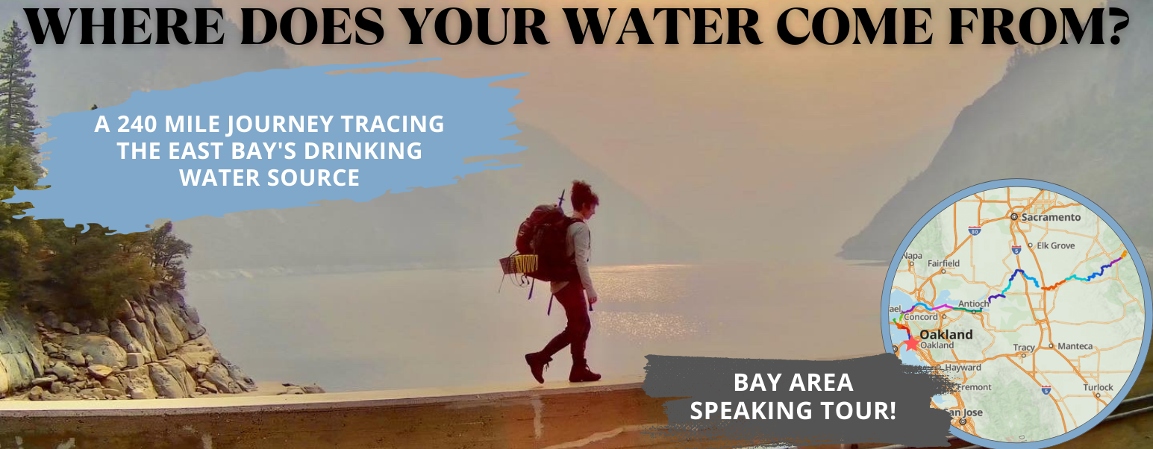

Short description:
In July 2022, Nina Gordon-Kirsch walked more than 240 miles, tracing the Mokelumne River from her house in Oakland to where our East Bay drinking water comes from. Now, she and her team are raising money to make the journey into an educational curriculum to bring into East Bay schools and teach students where our water comes from.

Donate now to support making the film!
www.home2headwaters.com

About Nina Gordon-Kirsch:
Nina grew up in Berkeley and graduated from Berkeley High school. She earned her B.Sc. in Environmental Science then was awarded a Fulbright Scholarship and earned her Master’s degree studying wastewater recycling. Over the past ten years, Nina has become deeply immersed in CA water systems including having worked for the Regional Water Quality Control Board, Greywater Action, and Walking Water. She also taught high school for seven years teaching an experiential education class about CA water systems.

