**Brief summary**

This document is a brief summary of the ACCG-hosted field tour held on September 10th, 2024 on the Eldorado National Forest, Amador Ranger District.

Field tour participants visited existing forest health and resilience projects and also locations along the edge of the Caldor Fire burn scar to view and discuss treatment prescriptions, effectiveness and lessons learned in the context of the planning effort that is underway for the UMRWA-USFS Mokelumne Amador Calaveras Forest Health & Resilience Project, Phase 2 (aka MAC Phase 2, formerly FPP Phase 2).

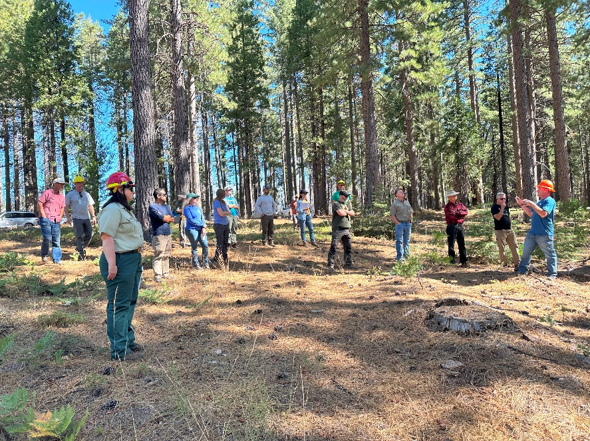

There were five stops on the tour. The first three locations were within the Scottiago Project area to view forest health treatments, fuelbreaks, fuels reduction units, and CA spotted owl (CSO) Protected Activity Centers (PACs) both within and outside the Caldor Fire burn scar. The PACs viewed within the burn scar had varying fire severity (low-high). The last two stops on the field tour were locations along the Highway 88 corridor to view examples of fuelbreaks and fuels treatment units and an opportunity to discuss prescriptions, maintenance tools, and lessons learned.

Picture above is of field trip participants at Stop 1. Photo courtesy of Megan Layhee. Special thanks to the Eldorado NF staff for assisting with coordination and leading discussions on the field tour.

**Stop 1: Scottiago forest health treatment unit, PAC in Caldor Fire footprint (low-med severity)**

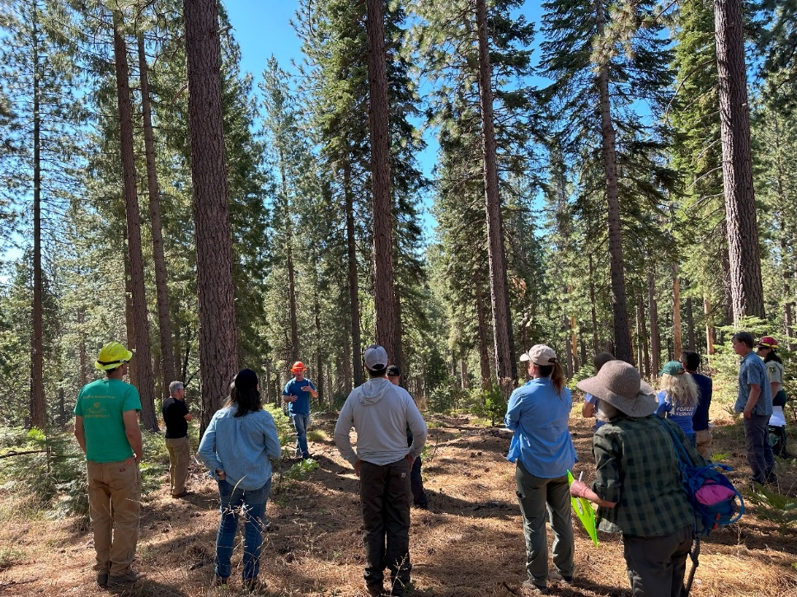This stop was located along a ridgetop with a CSO PAC to north within the Caldor Fire burn scar, and to the south a forest health treatment unit, part of the Scottiago Forest Health & Fuels Reduction Project.

The group spent time first viewing the PAC, which burned at low-moderate severity during the Caldor Fire. Question was asked of whether the PAC had been treated prior to the Caldor Fire, and it was noted that it had not. It was also discussed the concern of not opening the canopy in PACs in the context of increasing resiliency and protection from future potential wildlife. It was noted the under the current forest plan surface and ladder fuels can still be treated with CSO PACs just not removing larger trees nor reducing canopy cover. Another question was asked about whether an abundance of intermediate trees and a lack of large trees impacts owl habitat quality (e.g., canopy cover). For fuels treatments like fuelbreaks near PACs, they have tried to retain a mix of both large and intermediate and this seems to still provide the canopy cover the owls need.

The group then crossed the road and spent time viewing a Scottiago forest health treatment unit (picture on right, photo courtesy of Megan Layhee). The objective of this unit was to reduce stand density index (< 200 SDI, 100-140 basal area) using a variable density thinning approach. Average canopy cover was maintained at 50% or greater across the unit. Some positive lessons learned from this project was: 1) the utility of land management units (LMUs) to further delineate treatment units into topographically-relevant subunits to help with the variable density thinning prescription based on slope and aspect (e.g., ridges, slopes and valley bottoms), 2) that D x P was a useful strategy though there was a learning curve for operators, and finally, 3) that it was an economic timber sale. Question about the metric mentioned by Dr. Eric Knapp at the ACCG general meeting presentation the month prior about the utility of the canopy bulk density metric as a useful predictor of fire severity risk. MAC team will look into that (action item).

**Stop 2: PAC in Caldor Fire footprint (high severity), fuelbreak**

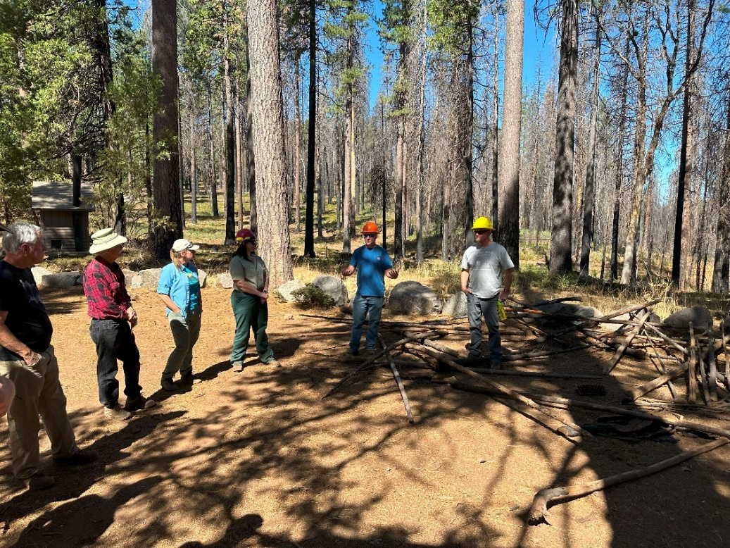The location of Stop 2 was along a roadside fuelbreak just adjacent former CSO PAC to the Caldor Fire burn scar. PAC was retired due to the high intensity burn it experienced during the Caldor Fire.

Forest Service staff provided an overview of what transpired in this location during the Caldor Fire. Due to low resource availability (a lot of active fires across the state, region at the time) and the intensity of the fire, many of the fuels treatments within the heart of the Caldor Fire footprint were not effective.

It was noted that a fuels treatment effectiveness study was conducted in the Caldor Fire footprint within the LTMBU and that would be shared that with the ACCG (action item). It was also noted that there some instances where treatments did have an effect on fire behavior.

It was also asked about whether there is a “halo” effect of treatment effectiveness that extends out from the treated stand to areas outside the stand. FS staff noted that it depends and there’s a lot of variables (weather, wind direction). This led into a discussion about how to strategically develop treatment units (SPLAT) and Dr. Rob York’s presentation to the ACCG and the 2:1 concept that by treating 1,000 acres you may be able to benefit another 2,000 acres.

There was also a brief discussion about CSO monitoring in the Caldor Fire using automated recording units (ARUs). The main take away from those surveys is that where CSO habitat remains within the Caldor Fire footprint, the owls are present. But where habitat is gone, the owls are infrequent or absent. Site fidelity is common with CSO; however, the research shows that owls won’t persist in an area with little habitat after 2-3 seasons and that if you get below 300 acres of retained habitat in a burn, you won’t retain the owl in that area.

**Stop 3: PAC (unburned) fuels reduction treatments**

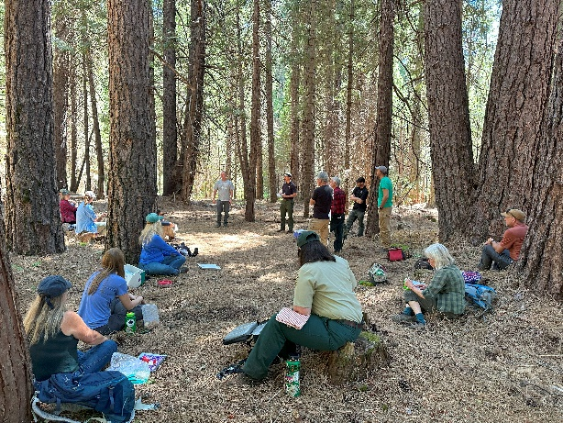Stop 3 was located within a CSO PAC (unburned) located outside the Caldor Fire footprint within the WUI. Roadside fuels treatments were conducted within the PAC with 10” dbh limit using a drum-based boom-mounted masticator, with some hand cutting. Adjacent unit had a 16” dbh limit and work was contracted out, but only partially completed.

Participants asked about the use of prescribed fire follow-up treatments on the Scottiago project. FS staff reiterated the capacity issues related to implementing prescribed burning (e.g., staff, small burn windows, access/safety). The ACCG’s pyrosilviculture shared vision was mentioned. Group agreed that prescribed fire was an important tool to include in the MAC project.

Group also discussed funding challenges to perform service work when there is little timber revenue, and also the tradeoff between FS and contractors performing forest thinning work. Something for the ACCG and MAC project team to consider further.

Mastication followed by mulching was used in this area. Benefits of this approach includes increasing decomp rate of fuels remaining on the ground and also increased firefighter access to the unit. Potential concerns of mulching were raised, including higher erosion potential leading to potential aquatic and other resource impacts, especially at higher elevations. Was added that this method is so new there’s little monitoring on ecological benefits and impacts. Suggestion was made that maybe this approach be only used at lower elevations on ridgetops. More discussions needed as it pertains to this tool for the MAC project.

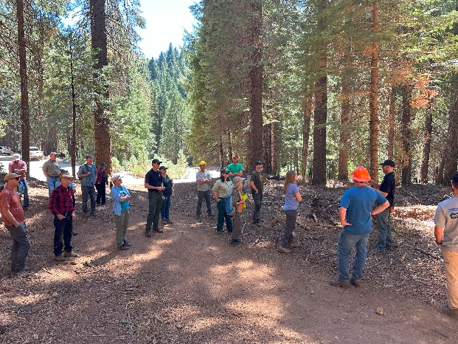Photos on this page are of two different fuels reduction treatment locations within the PAC at Stop 3 (photos courtesy of Megan Layhee).

**Stop 4: Highway 88 Fuelbreak, herbicides as fuelbreak maintenance tool**

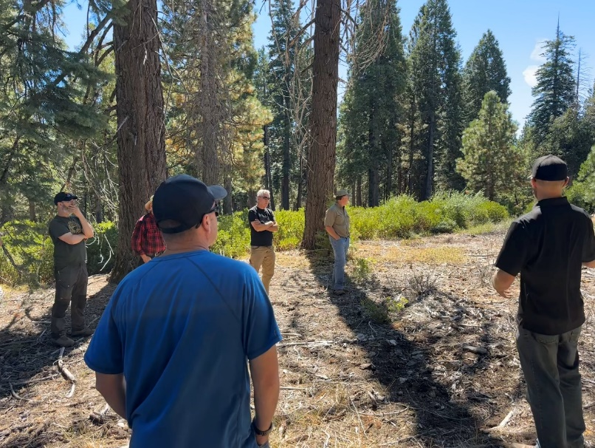Stop 4 was located within the Highway 88 shaded fuelbreak just adjacent to the highway. This location of the fuelbreak was masticated followed by application of herbicides to sprouting shrubs. Benefits being low cost, feasible to implement with limited staffing, and successfulness of treatment. Photo to the right is of field tour participants standing in the section of the fuelbreak that was treated with herbicides and in the background with the dense shrubs is the outer section of the fuelbreak were herbicides were not used.

Concerns were raised about the potential impacts of herbicides to wildlife and water quality.

Question was asked about what the typical brush response is in a shaded fuelbreak and to what degree might herbicides me needed to minimize shrub regrowth within the fuelbreak. The answer was that response is highly variable and based on site conditions (e.g., growing space).

Participants noted that as an alternative to herbicides, and the capacity issues surrounding maintaining fuelbreaks, partners could secure funding and perform the mechanical fuels maintenance of the fuelbreaks.

It was noted that monitoring is critical component to continue to perform to understand the ecological trade-offs of herbicide use for fuelbreak maintenance, and that a decision framework might be useful to help determine where these treatments might be performed.

It was noted that ACCG Planning work group discussions so far have reached a tentative work group recommendation of supporting herbicides as a last, third-tiered option for invasive species management, but are still undecided on whether the work group will provide a recommendation for any amount of herbicide use for fuelbreak maintenance. It was noted that one of the differences between herbicides used for invasive species management (ISM) versus herbicides use for fuelbreak maintenance is a matter of spatial scale: herbicides for ISM will be at a very small scale. So, then the discussions shifted into what spatial scale of proposed herbicide use for fuelbreak maintenance might be acceptable to the ACCG: 100 acres/year/district, or 200-300 acres/year/district. MAC project team will continue to have internal conversations about this topic and then continue discussion with ACCG (action item).

**Stop 5: Panther Fuelbreak, fuels reduction, ACCG/MAC Monitoring Program**

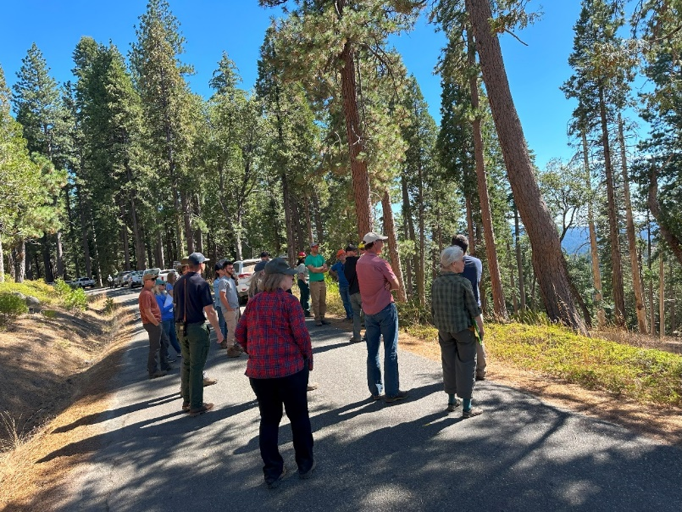The final stop of the ACCG field tour was another location on the Highway 88 Panther fuelbreak network. This section of the fuelbreak is very open and had been masticated and mulched a year ago.

Question about fuelbreak specs for MAC, including green tree and snag retention. Project team members noted that the MAC fuelbreak specs need to be developed soon to help aid in fuelbreak discussions with the ACCG (action item).

Mastication and mulching treatment discussion was revisited (originally discussed at Stop 3). FS staff mentioned that mulching was effective here at reducing the surface fuels and minimizing the brush response. It was noted that targeted herbicide application was also used here. Question about whether the mastication and mulching approach is more costly per acre- not necessarily, it depends on the contractor and their equipment capabilities. FS Resource Specialists noted that the condition of the soils at this stop are better compared to Stop 3, and that this issue is probably very site specific. It was noted that a follow up conversation with the IDT Soils Specialist would be a good next step.

Participant asked why this stop looks so much different than Stop 3. FS responded that: 1) biomass was hauled off and 2) equipment used at Stop 3 was not pushing mulching head into soil. FS staff suggested that MAC project design this work to 1) construct large piles instead of scattering fuels and 2) that prescribed fire needs to happen.

Becky Estes concluded the field tour with an overview of the ACCG Monitoring Program and how this program is transitioning into the MAC Project Monitoring Program. She gave some initial, high-level insights in the data collected to date through the ACCG Monitoring Program, including in the Panther Project area, including seeing decrease in tree density of smaller trees and decrease in shade tolerant species. Becky added that the ACCG Monitoring WG will be reevaluating the monitoring strategy and the MAC Monitoring Coordinator (who will be hired soon) will lead that effort. Also discussed the utility of remote sensed data for use in addressing large-scale monitoring questions. Suggestion to develop this program so it’s consistent with other forest and what the region is doing.

**Action items**

|  |  |
| --- | --- |
| **Actions** | **Responsible Parties** |
| Look into using canopy bulk density in NEPA analysis for MAC project, Phase 2. | MAC Project Team |
| Provide ACCG with publication looking at fuels treatment effectiveness in Caldor Fire. Look into having one of the authors of the publication as a guest presenter at a future general meeting. | Becky Estes, Megan Layhee |
| Continue internal discussion on mastication and mulching and ecological tradeoffs. | MAC Project Team |
| Continue discussions on potential spatial scale of potential use of herbicides for fuelbreak network: 100/acres/year/district, 200-300 acres/year/district.  Also consider developing a decision framework for herbicides for fuelbreak maintenance. | MAC Project Team, ACCG Planning WG |

**Field Trip Participants**

|  |  |  |
| --- | --- | --- |
| **Count** | **Name** | **Affiliation** |
| 1 | Megan Layhee | Acting ACCG Administrator, UMRWA |
| 2 | John Buckley | CSERC |
| 3 | Chelsea | CSERC |
| 4 | Stan Dodson | CSERC |
| 5 | Luke Hunt | SNC |
| 6 | Michael Pickard | SNC |
| 7 | Rich Farrington | UMRWA Board, AWA |
| 8 | Richard Sykes | UMRWA |
| 9 | Chuck Loffland | USFS, ENF, Amador RD |
| 10 | Linda Helm | USFS, ENF, Amador RD |
| 11 | Marc Young | USFS, ENF |
| 12 | James Thornock | USFS, ENF, Amador RD |
| 13 | Jesse Plummer | USFS |
| 14 | Linda Diesem | Private citizen |
| 15 | Kelsey Retich | USFS, STF, Calaveras RD |
| 16 | Becky Estes | USFS |
| 17 | Jeff Brown | USFS, ENF |
| 18 | Matt Brown | USFS, ENF |
| 19 | John Davis | USFS, STF |
| 20 | Zeev | USFS, STF |
| 21 | Coleen Shade | Stantec |
| 22 | Kevin Whitlock | Stantec |
| 23 | Regine Miller | Headwaters Environmental, UMRWA |
| 24 | Susan | STF |